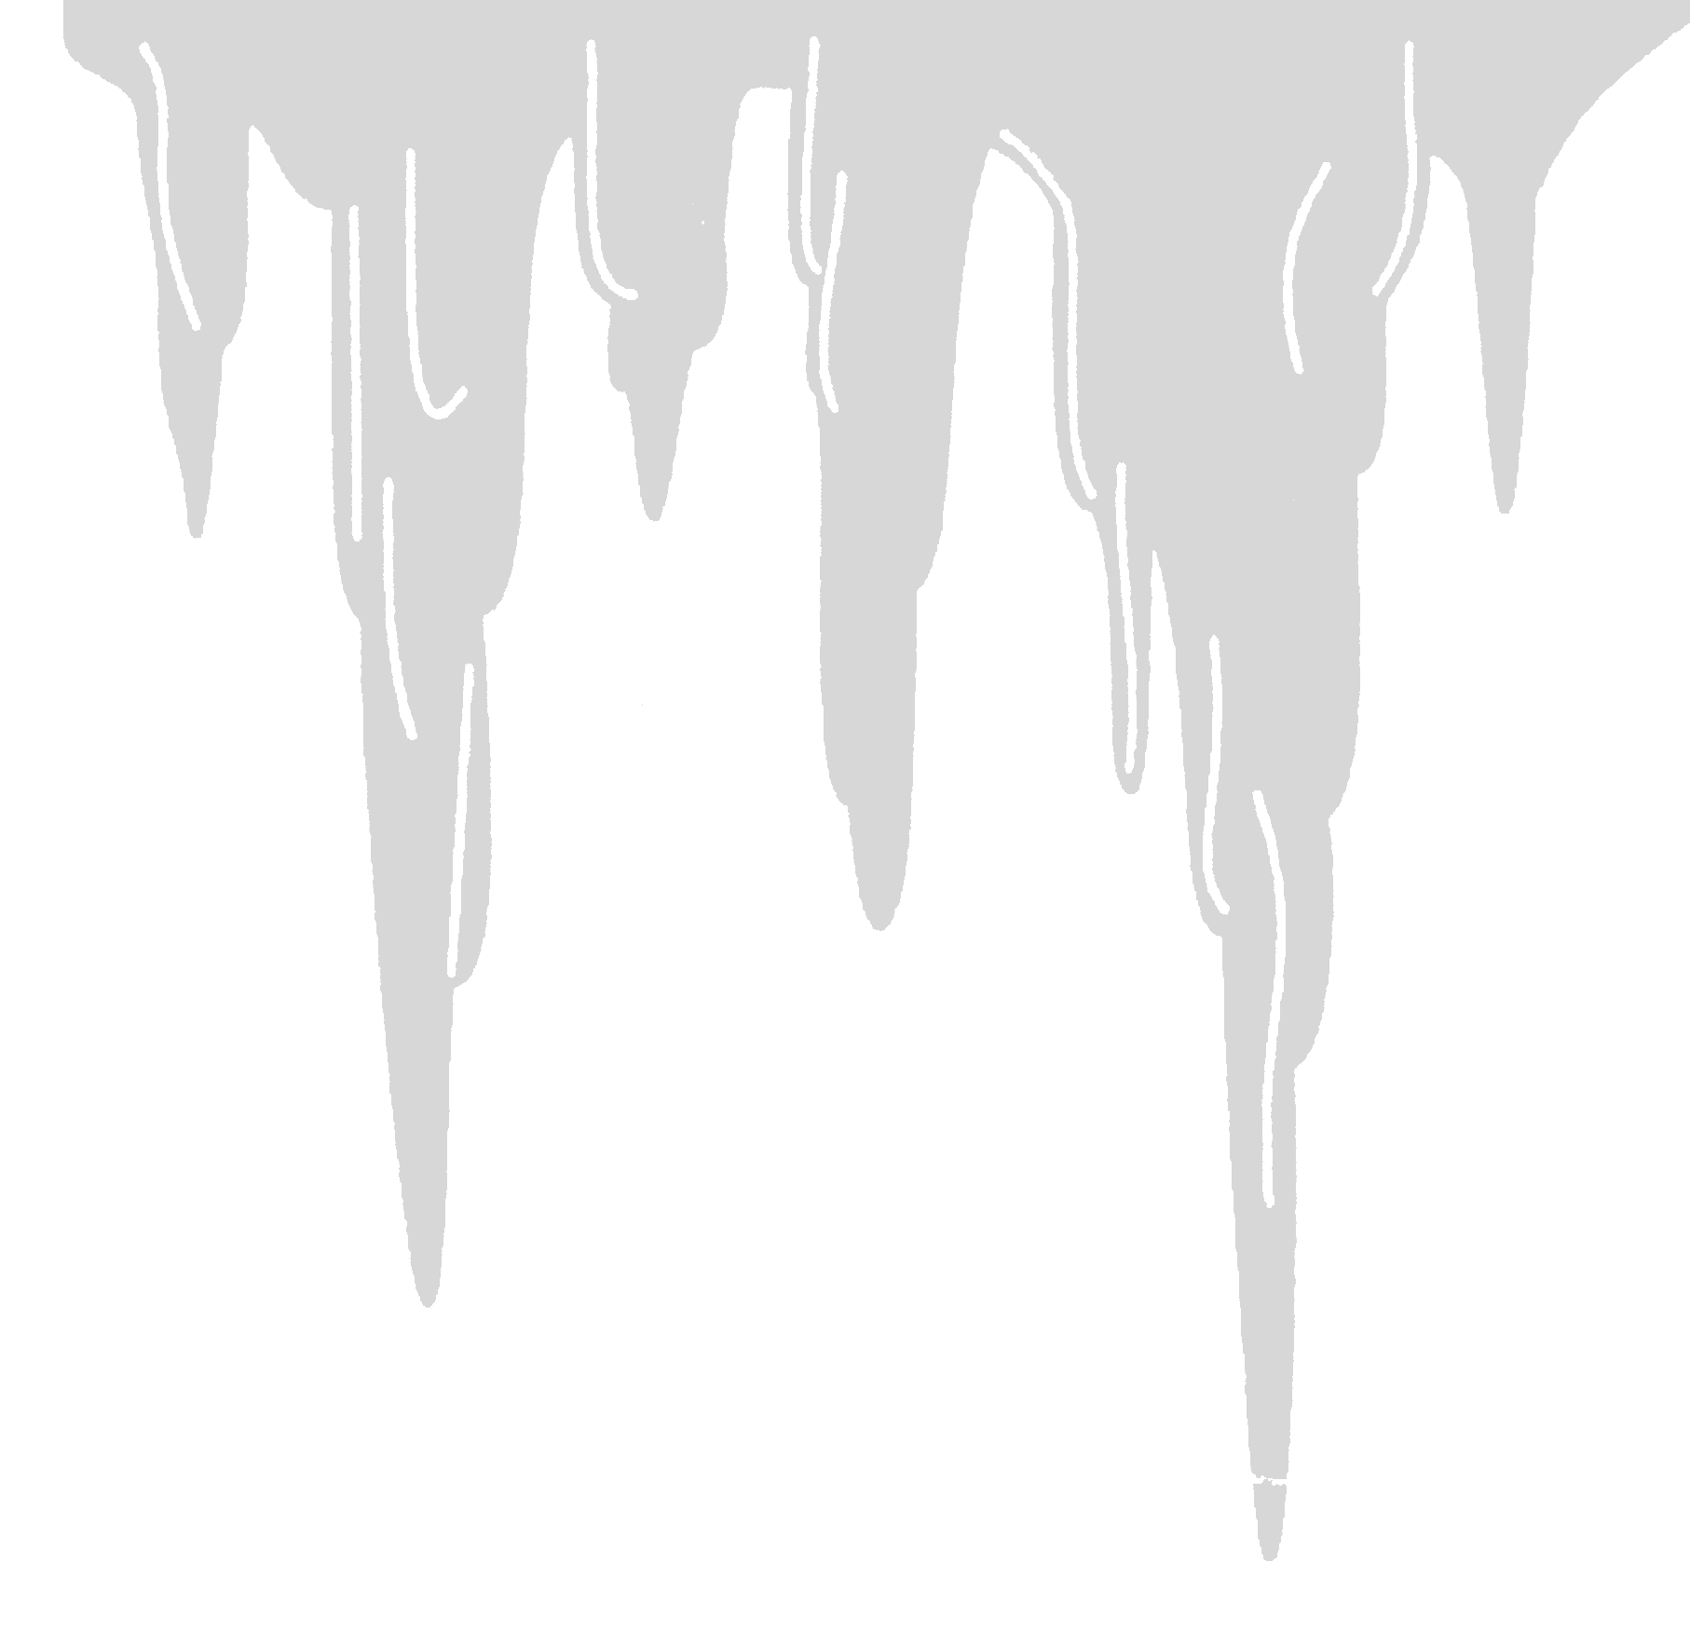

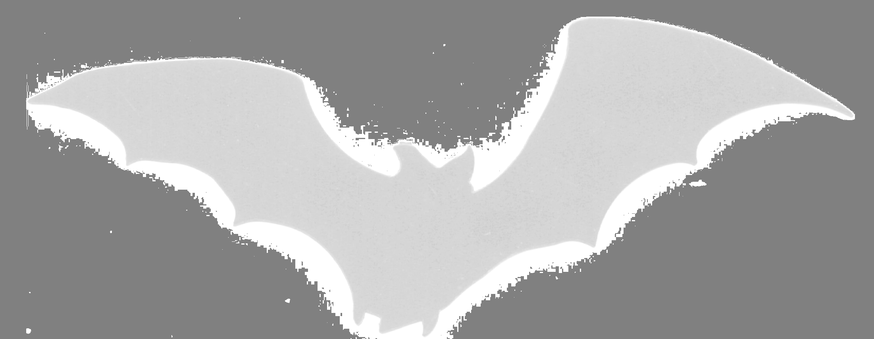
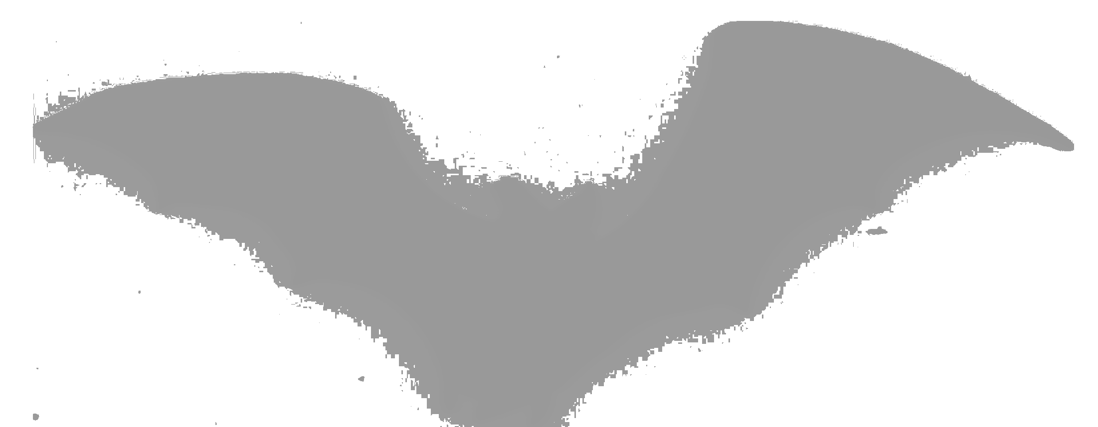
CARLSBAD FIELD OFFICE

BACKCOUNTRY
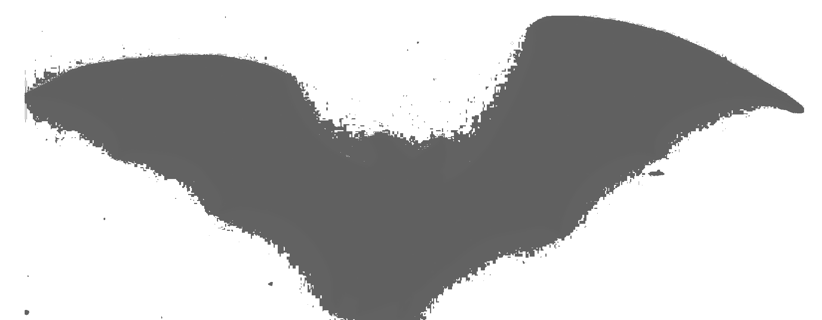
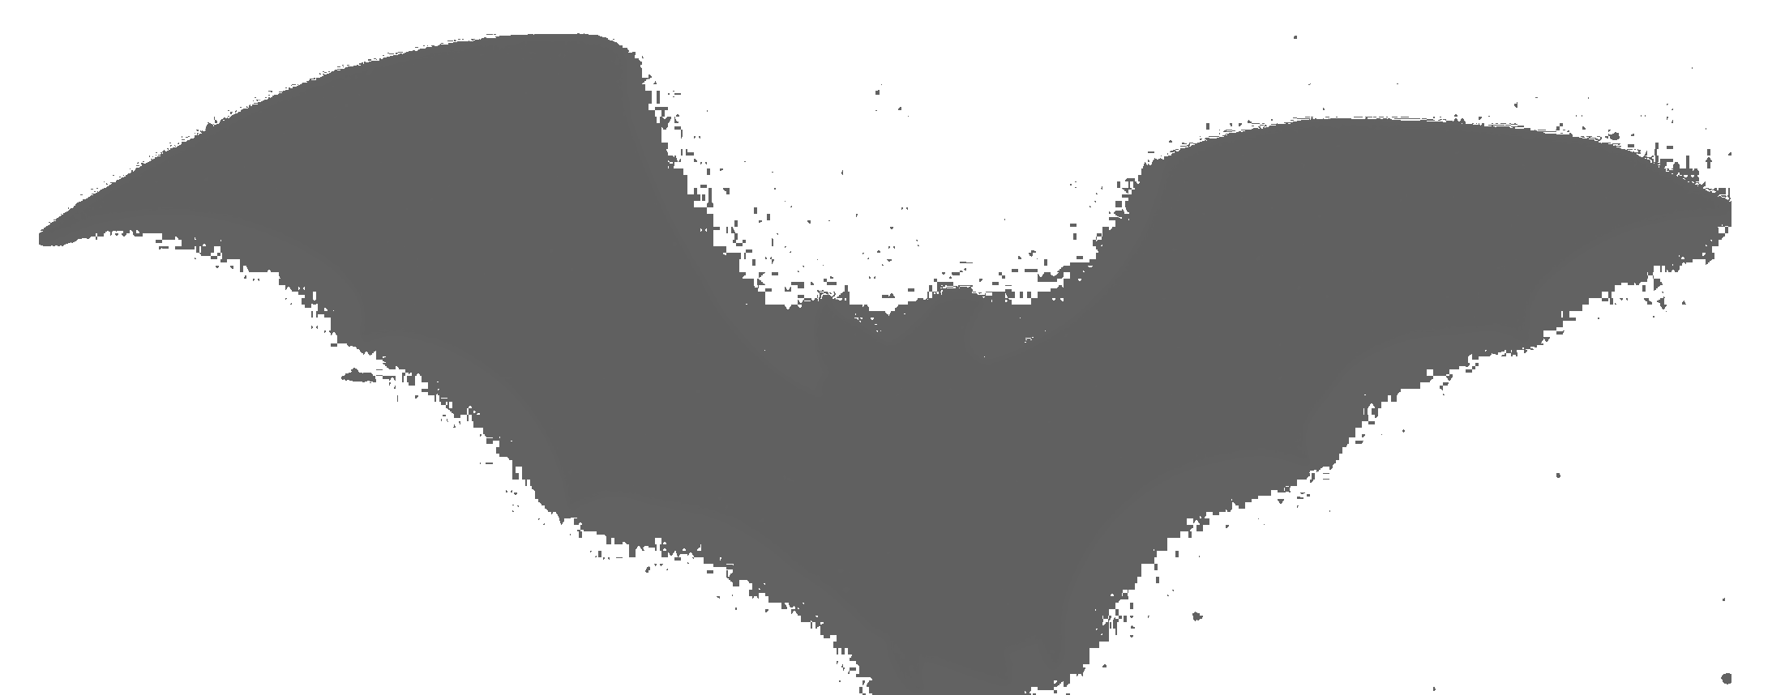
CAVING

Bureau of Land Management
US Department of Interior

Caving Opportunities

You may be able to enter one of several undeveloped caves on Bureau of Land Management lands in the Carlsbad Field Office by obtaining a special permit from the Cave Resources division. This brochure provides information to help you decide which cave to visit based upon your caving experience, interests, and abilities. Some caves are difficult to locate and enter, requiring technical climbing skills, experience in reading topographic maps, extended hiking in very rough and potentially hazardous terrain, and adjusting to the extremes of a desert climate. Therefore, we suggest you acquire this type of experience before you visit the caves in this area.


Many caves require up to a one to two mile hike from the nearest road. Be sure to carry plenty of water, particularly in the summer when daily requirements may exceed a gallon a day per person.

Any entry into a wild cave may result in irreparable damage to the cave. All BLM permitted caves will be carefully monitored for impacts. Caves impacted by careless users will be closed. Please support our backcountry caving program by caving in a safe manner, taking care to preserve cave features and resources.

Entry into any BLM backcountry cave that is gated requires a permit. Entry into any permit-required cave other than that specified on the permit is illegal.
Fees

Entry to BLM Carlsbad Field Office caves by the general public does not require fees at this time. Organized groups such as outing clubs or Boy/Girl Scouts may require a fee based permit. All commercial outfitters and guides will require a Special Recreation Permit.

Special Recreation Permits require at least 180 days notice for processing the permit. Special Recreation Permits require an $80 application fee and 3% of the gross revenues received for commercial users and $4 per person per day for organized groups.
Cave Permits

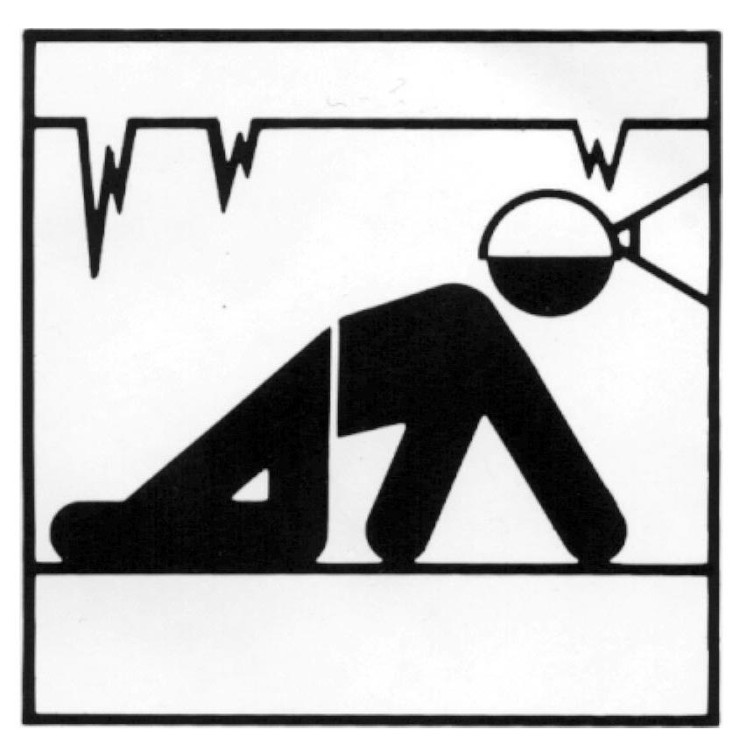
At least two weeks advance notice, in writing, is required for scheduling a trip. Reservations are on a first-come, first-served basis, available by telephone. The BLM may deny a permit to any individual or group that does not have proper equipment and / or experience. Once the permit application is approved, it will be returned to you by mail or you may arrange to pick it up in person. To receive a permit application, write to:
Cave Resources
Bureau of Land Management
620 East Greene Street
Carlsbad, NM 88220
Or call (505) 234-5929, (505) 234-5972 leave your name, address, phone number, and what caves your would like to visit and when.

e-mail: James_Goodbar@blm.gov

Note: Reservations for caves that require BLM approved trip leaders must be coordinated with the trip leaders. The permit will be issued to the trip leader.

Age Limits

Trip leaders must be at least 18 years of age. Visitors under 18 years of age must have a parent or legal guardian signature on the application before they will be allowed to enter a permitted cave. This written permission must be received by the Carlsbad Field Office Cave Resource section before the trip may take place.
Safety

These caves are preserved in their natural state; therefore, inherent risks exist that require certain safety precautions:
** Always watch for Rattlesnakes
** Leave word with someone stating what cave you will be visiting and an approximate return time.
** Take three dependable and independent sources of light.
** Wear sturdy shoes that protect the ankle and have non-leather, non-skid, non-marking soles
** Gloves and kneepads may be necessary in some caves.
** Wear a helmet to protect against low ceilings and falling rocks. Use of a chinstrap prevents losing your helmet and light.
** Mount your main source of light on your helmet to free your hands for climbing.
** Three is the minimum safe group size.
** Stay within your abilities and experience level to avoid injuring yourself and possibly damaging the cave.
** Do Not enter gypsum caves or other storm drain type caves if there is a threat of rain. Do not become a drowning victim.

Note: For caves requiring rope work, each person must have their own ascending and descending devices and be experienced in their use.

Natural History

Rocks of the Guadalupe Mountains were deposited about 250 million years ago when this area was adjacent to the deep Delaware Basin, a large inland arm of the Permian Ocean. On the shelf surrounding this basin, limestone formed from the accumulation of vast numbers of the limy skeletons of various marine organisms and by direct precipitation from sea water. Eventually, water circulation in the basin was restricted, the water became very salty from evaporation, the reef organisms died, and the basin was filled with sediment including salts and anhydrites.

About 15 to 25 million years ago the Guadalupe Mountains began to uplift. Caves developed deep in the ground as fresh waters beneath the mountains mixed with briny basin water and formed sulfuric acid that dissolved the limestone.

Continued uplift of the Guadalupe Mountains elevated some caves above the level of the ground water, causing them to drain and dry. Erosion by water removed the deposits above the limestone and cut deep rugged canyons into the rock and opened entrances to some caves. Water seeping through the rock into caves precipitated the dissolved minerals to create the fantastic array of beautiful cave formations that make Guadalupe caves world famous.

The anhydrite deposits in the Delaware Basin have been altered near the surface by hydration to form gypsum. Other gypsum deposits exist in the Seven Rivers Embayment area to the north of the City of Carlsbad. These areas demonstrate examples of classic karst development containing such features as sinkholes, solution collapse, blind arroyos, subterranean stream passages, resurgences, and few if any surface streams. Numerous caves exist in the soft gypsum rock. These karst features provide point sources for groundwater recharge. The caves and karst features serve as the primary storm-water drainage systems for the area. As such, they are subject to flash flooding and extreme caution should be used when entering these caves if there is any chance of rain. Don’t become a drowning victim. Be sure to check the weather before entering the cave.

Cave Trail Markers
Some routes are marked with flagging tape to reduce impact on delicate formations or floor material. Please stay on these routes; do not disturb the tape.

Conservation
Every entry into a cave, by any person, creates disturbance. The cumulative impact of even slight changes and disturbances, even innocent ones, can lead to dramatic alterations of the cave environment, or to people’s enjoyment. It is important to remember this fact as you enter and enjoy caves. Your actions while caving will be one of the greatest determining factors in the condition of cave resources and enjoyment of the caves by future generations. It is everybody’s responsibility to respect the cave environment. Boot scuff marks on rocks are one of the more unsightly signs of human usage. They are very difficult if not impossible to remove. The use of non-marking boots is encourages. It is important not to track mud through the cave. Periodic cleaning of hands and boot soles can contribute greatly to the wild caving experience for everyone else that follows.

Most of the caves have been used, at one time or another, by bats. Five of these caves are routinely used by various bat
species. Several of these species are extremely sensitive to the mere presence of humans. To reduce stress and mortality levels in bats, please do not disturb them. To accomplish this; reduce the amount of time near bats, do not shine lights directly on them, and do not make any sudden movements or loud noises.
Besides bats and cavers, other creatures inhabit caves. Often neglected or overlooked, cave invertebrates are as, or more sensitive than many other dwellers of the cave environment and no less interesting or deserving of respect. There are over 130 species of invertebrates found

in caves on BLM caves in the Carlsbad area, several being true troglobites.

These caves are being managed to perpetuate the cave and its associated values, and to provide for educational and recreational and scientific uses now, as well as in the future. You can affect not only the cave environment, but also future management decisions. If you are to affect caves, make it a positive one. People can impact caves far faster than nature can repair them, or create new ones—please cave softly and Leave No Trace.

Tips on Cave Conservation & Ethics:
Plan Ahead and Prepare; Know what to expect from the cave you are visiting. Choose the right clothing, equipment, and safety gear.
Move carefully through the cave to avoid damaging cave features. Stay on established trails.
Pack it in, Pack it out; Take out everything you take in. Leave nothing in the cave. You should plan on packing out all human waste. Carrying an extra “pee bottle” is strongly recommended.
Leave what you find; Never remove natural or historic features from a cave. These resources are protected under the Federal Cave Resources Protection Act of 1988.
Respect Wildlife; Avoid disturbing or killing cave wildlife. This includes bats, cave Crickets and all other living things in the cave.
Respect Other Visitors; While in the area stay quiet and keep a clean camp.

Horizontal Caves
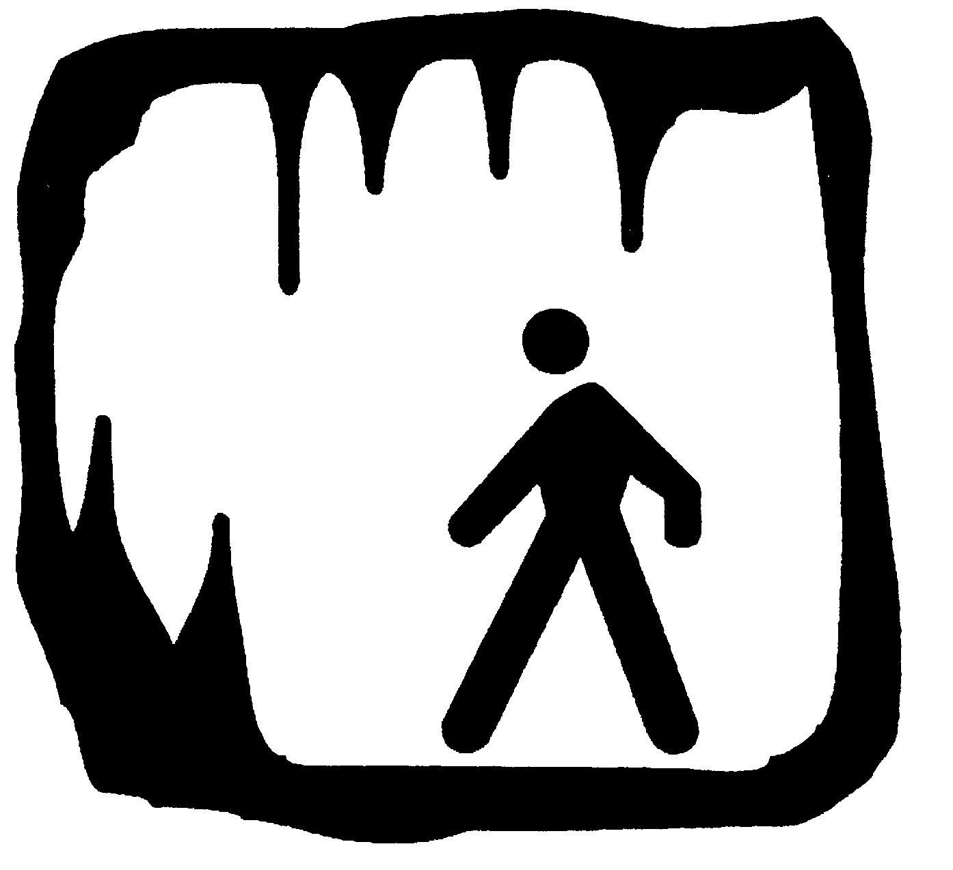
McKITTRICK CAVE
Elevation: 4,200 feet
Distance from trailhead: .3 mile
Approximate walking time:20 minutes
Group size: minimum 3, maximum 8

This cave requires a permit. It is a summer roost site for a colony of bats and is closed from April 15th to October 15 while the bats are there. It is well suited for cavers with minimal experience. It has multiple entrances and is a two level maze. There are several areas with low ceilings and numerous crawlways. There is a 12 foot pit in the interior of the cave. People with minimal climbing experience should be belayed. Portions of the cave are delicate.

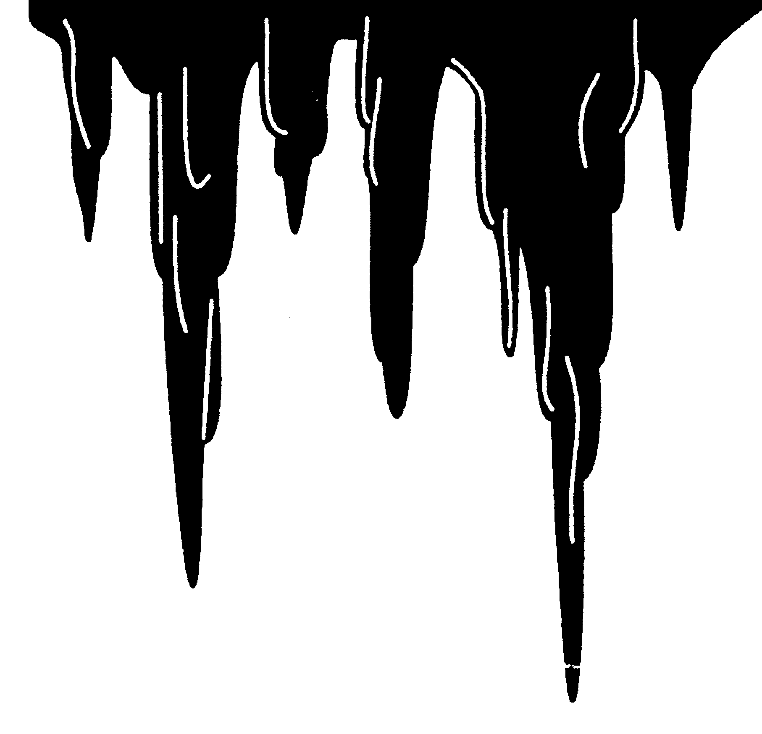
SAND CAVE
Elevation 4,200 feet
Distance from trailhead: .2 miles
Approximate walking time: 15 minutes
Group size: minimum 3, maximum 6
This cave requires a permit. It is a summer roost site for sensitive bat species and is closed from April 15th to October 15 while the bats are there. It is suited for cavers with a moderate experience level. It has an upper and lower entrance and is a complex three level maze with several areas of low ceilings and numerous crawlways. There are several climbs in the cave. People with minimal climbing experience should be belayed. Portions of the cave are delicate and care should be taken to stay on marked trails.

ENDLESS CAVE
Elevation: 4,200
Distance from trailhead: .1 miles
Approximate walking time: 5 minutes
Group size: minimum 3, maximum 6

This cave requires a permit. It is a summer maternity roost for sensitive bat species and is closed from April 15th to October 15th while the bats are there. It is suited for cavers with a moderate experience level. It has one entrance and is a very complex three level maze with several areas with low ceilings and numerous crawlways. There are several climbs in the cave. People with minimal climbing experience should be belayed. Portions of the cave are delicate and care should be taken to stay on marked trails.

YELLOWJACKET CAVE
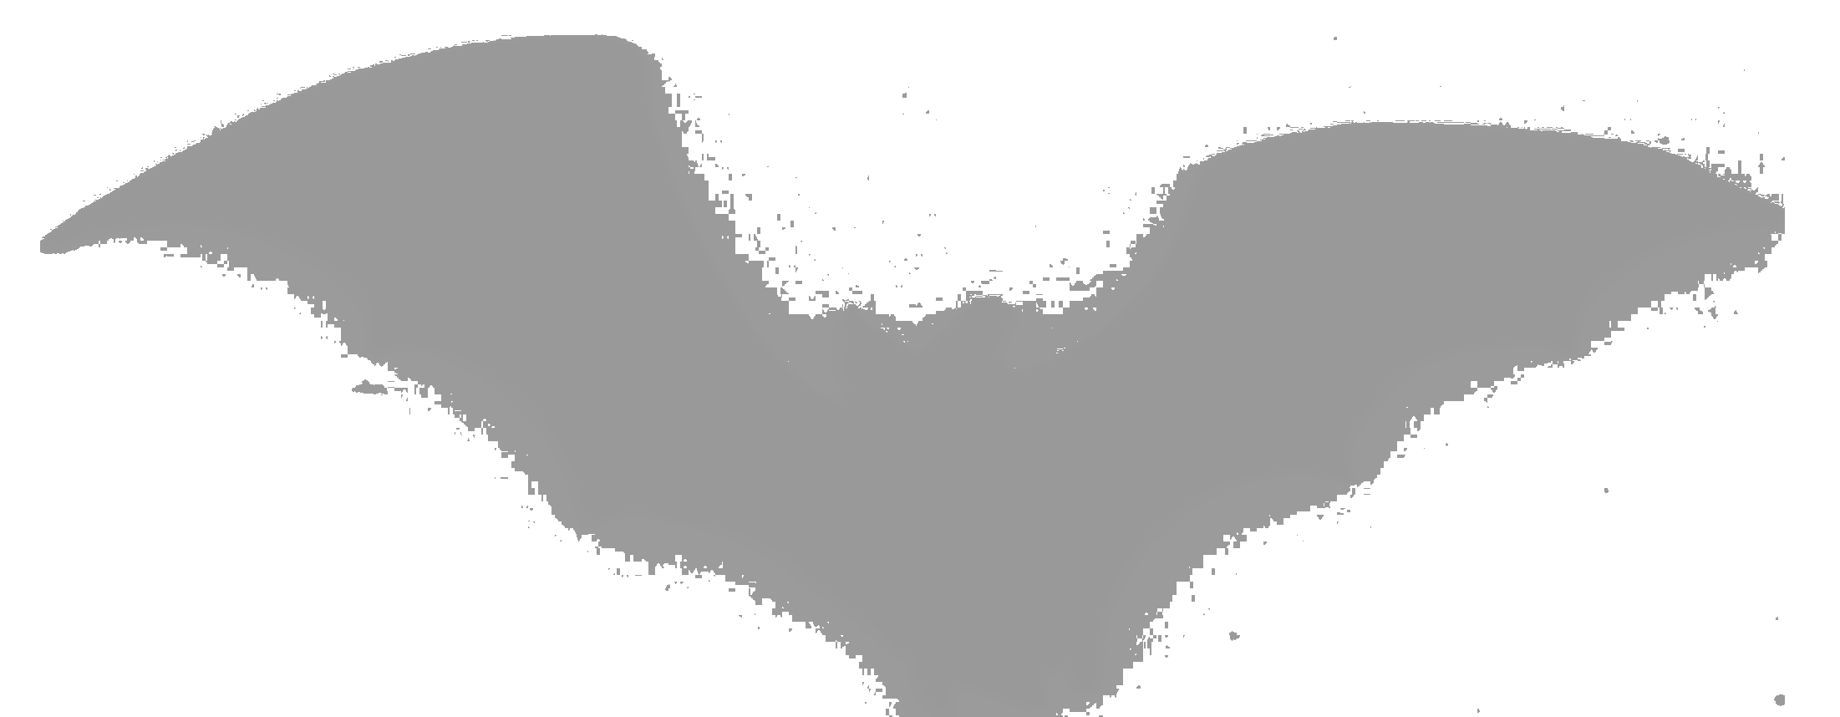
Elevation 3,800 feet
Distance from trailhead: 1.25 miles
Approximate walking time: 30 minutes
Group size: minimum 3, maximum 6

This cave requires a permit. It is a summer maternity roost for sensitive bat species and is closed from April 15th to October 15th while the bats are there. It is suited for cavers with a moderate experience level. It has one entrance and is an extremely complex single level maze. Much of the cave contains areas with low ceilings and numerous crawlways. Portions of the cave are delicate and care should be taken to stay on marked trails. Rattlesnakes frequent the entrance.

PARKS RANCH CAVE
Elevation: 3,550 feet
Distance from trailhead: 300 feet
Approximate walking time: 3 minutes
Group size: minimum 3, maximum 10

This cave does not require a permit so there may be other groups visiting the cave. Respect other visitors. This cave is subject to flash flooding during heavy rains. DO NOT BECOME A DROWNING VICTIM, check the weather before entering the cave. This is a good cave for beginning cavers. The cave system is in gypsum karst lands and contains at least 18 different entrances and over 4.5 miles of passage. Some passages in the cave contain water.

The land surrounding Parks Ranch Cave is in a fragile gypsum soils area. Vehicular traffic is limited to designated roads. Please do not drive off roads for any reason.
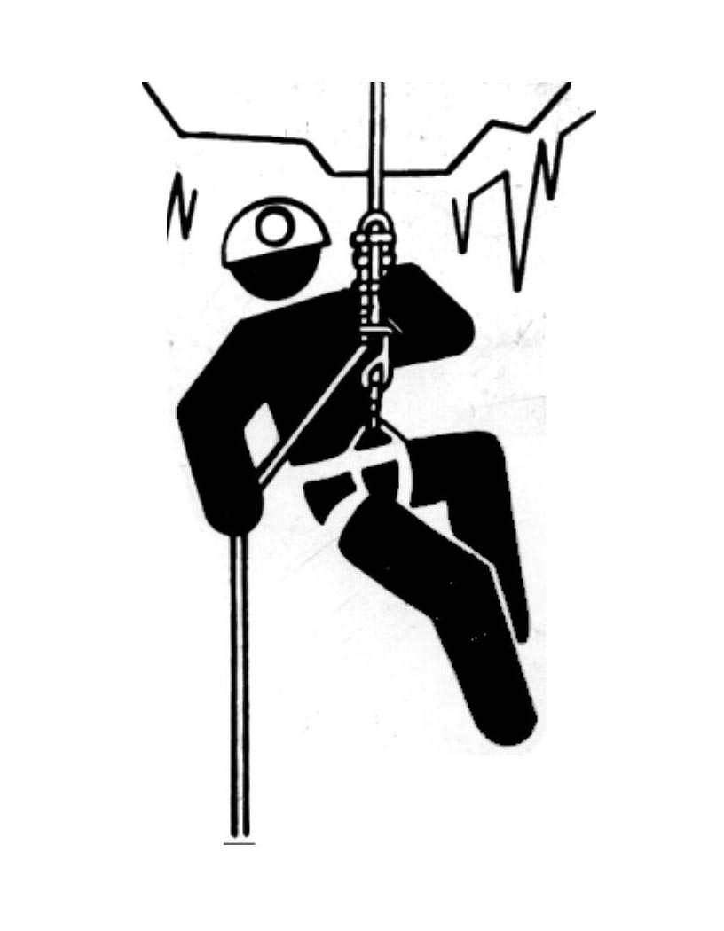

MUDGETTS CAVE
Elevation: 4,500 feet
Distance from trailhead: 1.5 miles
Approximate walking time: 1.5 hours
Group size: minimum 3, maximum 6
Special equipment needed: Dust Mask

This cave does not require a permit. It does require a steep 600 foot climb from the canyon bottom up to the cave entrance. The first half of the cave floor is covered with burned goat manure and bat guano; this ash can easily be kicked up and interfere with breathing. If bats are roosting, please do not disturb them.

WIND CAVE
Elevation: 3,650 feet
Distance from trailhead: .25 miles
Approximate walking time: 15 minutes
Group size: minimum 3, maximum 6
Equipment: 50’ rope is required

This cave requires a permit. Only two permits are issued each month. Groups should be experienced cavers in good condition. The cave is 240 feet deep mostly accessed by climbing. It is a very complex multi-level maze containing very tight passages and crawlways. Near the entrance is a short drop that requires rigging.

JURNIGANS CAVE #2
Elevation: 3,600 feet
Distance from trailhead: .25 miles
Approximate walking time: 20 minutes
Group size: minimum 3, maximum 6
Equipment: 30’ rope is recommended

This cave requires a permit. The entrance is a 21 foot pit that can be climbed by experiences cavers. A 30 foot rope may be used as a handline or the entrance pit can be rigged for full vertical gear. Rattlesnakes are often found at the bottom of the drop. USE CAUTION.

DOC BRITO CAVE
Elevation: 3,500 feet
Distance from trailhead: .25 miles
Approximate walking time: 20 minutes
Group size: minimum 3, maximum 6
Equipment: 100’ rope is required

This cave requires a permit. The entrance is a narrow 20 foot chimney which leads to a series of three rooms that are connected by very tight crawlways. In the back of the cave is a 40 foot blind pit. The only rigging points are on the far side of the room. A 100 foot rope is needed to rig the drop. Rope padding is highly recommended.

Vertical Caves
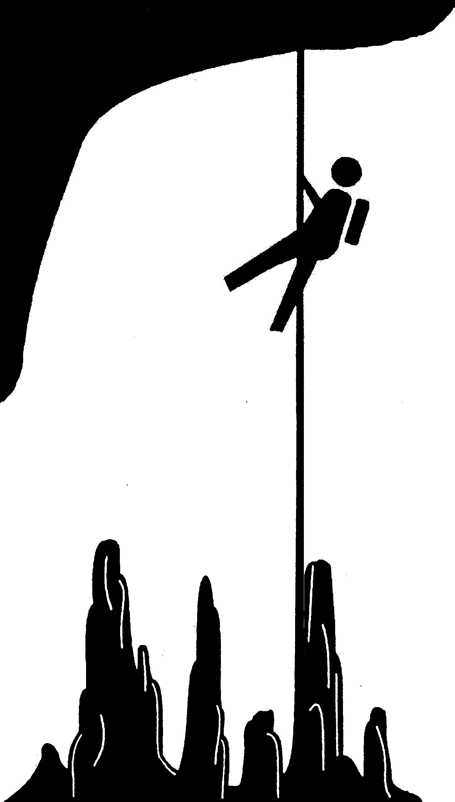

LOST CAVE
Elevation: 3,300 feet
Distance from trailhead: 50 feet
Approximate walking time: 1 minute
Group size: minimum 3, maximum 10

This is a trip leader cave and is co-managed by the Pecos Valley Grotto. Permits are issued to the Grotto who will serve as your trip leader. The cave requires a descent down a 21 foot entrance ladder. The cave contains replicas of cave paintings from the painted caves in France and Spain. It has been the site of NASA space science experiments.

LITTLE MANHOLE CAVE
Elevation: 4,720 feet
Distance from trailhead: 25 feet
Approximate walking time: 1 minute
Group size: minimum 3, maximum 6
Special equipment needed: 70 foot rope

This cave requires a permit. All visitors should be experienced vertical cavers in good condition. It has a 48 foot freefall entrance drop. The entrance joint is a maximum of 10 inches wide and very difficult to negotiate. Live rattlesnakes have been found in the entrance crevice and at the bottom of the drop. Use Extreme Caution.

Incase of EMERGENCY Contact:

STATE POLICE (505) 885-3137
or Call 911

