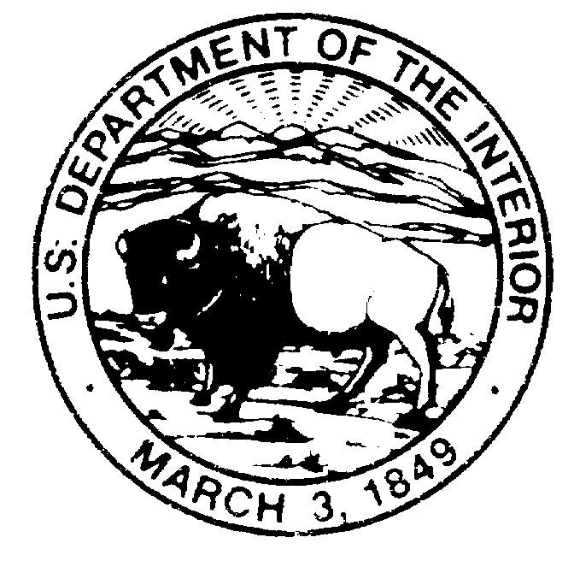
United States Department of the Interior

BUREAU OF LAND MANAGEMENT
Carlsbad Field Office
620 E. Greene Street
Carlsbad, New Mexico 88220

IN REPLY REFER TO:

8380

MEMORANDUM

To: State Director, New Mexico
From: Field Office Manager, NM 080
Subject: MOU with NM Firefighters Training Academy

Attached is a draft of a Memorandum of Understanding between the Bureau of Land Management and the New Mexico Firefighters Training Academy. The Academy was created as a section of the State Government in 1985 with an ultimate goal of protecting the lives and property of the citizens and guests of New Mexico.

Their expertise and knowledge in and high angle rope rescue techniques combined with their ability to conduct training on these subjects at little or no cost to the BLM makes this MOU very attractive. The MOU comes at a time when we need this type of training to help implement the BLM Cave Safety Standards, IM No. 96-104, Change 1.

We have been working with the Academy for several years in high angle rope rescue and cave search and rescue practice sessions as well as preplanning for rescue missions. Their personnel have been very helpful in our training exercises and very easy to work with. This MOU will facilitate our continued cooperation in search and rescue training exercises and enhance our ability to help coordinate safe, efficient, and effective search and rescue missions by assisting in the training of our personnel.

I hope this MOU meets with your approval and can be implemented to all our benefits as early as possible. If you have any questions please contact me or Jim Goodbar of my staff.

Gary Bowers
Carlsbad Field Office Manager
MEMORANDUM OF UNDERSTANDING
between
UNITED STATES
Bureau of Land Management
and
NEW MEXICO
Firefighters Training Academy
to provide
Assistance in Search & Rescue Training and Missions

BACKGROUND

The purpose of this Memorandum of Understanding (MOU) is to facilitate future cooperation and assistance in cave and high angle rescue training and missions. The ultimate goal is to reduce response time and increase efficiency during search and rescue missions. The New Mexico Firefighters Training Academy has responsibilities for providing training in emergency services and search & rescue (SAR) operations. There is an existing Interagency Agreement between the Bureau of Land Management (BLM), The National Park Service (NPS), The U.S. Forest Service (USFS) and the Department of Energy for interagency cooperation in search & rescue training and missions for cave and high angle incidences. The New Mexico Firefighters Training Academy maintains an Emergency Services Group that is trained and equipped to respond to high angle rescue situations. All of these agencies have worked together on SAR training exercises.

OBJECTIVES

1. Promote interagency cave and high angle training,
2. Provide assistance as requested during Search and Rescue Missions,
3. Coordinate the use of resources during rescue training and missions including:
a. Locations for training exercises
b. Equipment
c. Personnel

STATEMENT OF WORK

Each party will participate, depending on availability and request, in SAR training and missions. Each party will provide available personnel and equipment for these functions. Each party will maintain and exchange a list of personnel with their qualifications and telephone numbers for use in SAR mission call outs. The BLM will provide locations such as caves and cliffs for rescue training and practice. The New Mexico Firefighters Training Academy will provide rope rescue training opportunities, when available, to BLM personnel.

REPORTS

Any reports, critiques, or other coverage of SAR training or missions will be automatically distributed to the parties involved in that operation. Copies will be sent to other parties upon request.

PAYMENT

No exchange of funds is anticipated.

TERMINATION

Any of the Participating Agencies may terminate this agreement upon 30 days written notice of such termination.

_____________________________________________ __________
BLM New Mexico State Director Date

_____________________________________________ __________
New Mexico State Corporation Commission Date
Chief Clerk

_____________________________________________ __________
New Mexico State Fire Marshal Date

_____________________________________________ __________
New Mexico Firefighters Training Academy Date
Director

ECONOMY ACT DETERMINATION

(31 U.S.C. 1535 and 48 CFR 17.503)

1. The Bureau of Land Management has responsibility for supporting search and rescue operations on lands within their jurisdiction and encourages the training of their personnel in conjunction with other. The New Mexico Firefighters Training Academy also has responsibilities for search and rescue training operations. Both parties have trained personnel and equipment available to respond to search and rescue missions. No exchange of funds is anticipated in this agreement.

2. This agreement is in the best interest of the United States Government.

3. There are no other sources available in the area with the capability and the equipment to appropriately train and respond quickly to cave and high angle emergency rescue situation.

4. It is more cost and time effective to cooperate with other agencies in search and rescue training and missions because of the availability of existing equipment and trained personnel. These agencies are especially suited to this type of cooperation because they have trained and work together in practice rescue situations in the past and know each others capabilities.

5. This action does not conflict with any Federal Agency authority or responsibility.

______________________________ __________
Signature of Requester Date

______________________________ __________
Signature of CO Date

______________________________ __________
Signature of Reviewer Date

