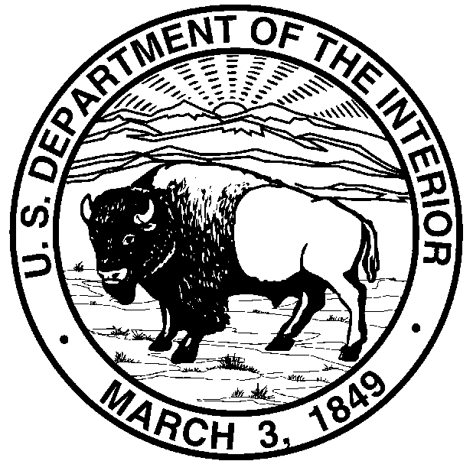
United States Department of the Interior
BUREAU OF LAND MANAGEMENT
Oregon State Office
P.O. Box 2965
Portland, OR 97208

In Reply Refer to:
OR-54087
2300 (936.1)

Director
Oregon Division of State Lands
775 Summer St, NE
Salem, OR 97310-1337

Dear Sir:

The Bureau of Land Management (BLM) proposes to withdraw 80 acres of public land within Lake County, Oregon, to protect the vegetative material to be planted at the Desert Springs Seed Orchard and to protect a proposed Federal investment and related facilities at the site. Jurisdiction over this parcel will be transferred from the BLM to the U.S. Forest Service. Enclosed is a copy of the Federal Register notice closing the land for up to 2 years from surface entry and mining while the BLM and the USFS complete an analysis of the proposed withdrawal to support a recommendation to the Department of Interior. The land has been and will remain open to mineral leasing.

A copy of this letter with the enclosure is being sent to the appropriate Federal, State, and local officials and other parties of interest.

Sincerely,

Edward W. Shepard
State Director

Enclosure (as stated)

cc: (This is a list of all Federal, State, and Local Officials in addition to all other interested parties who might have an interest in the proposed withdrawal.)

