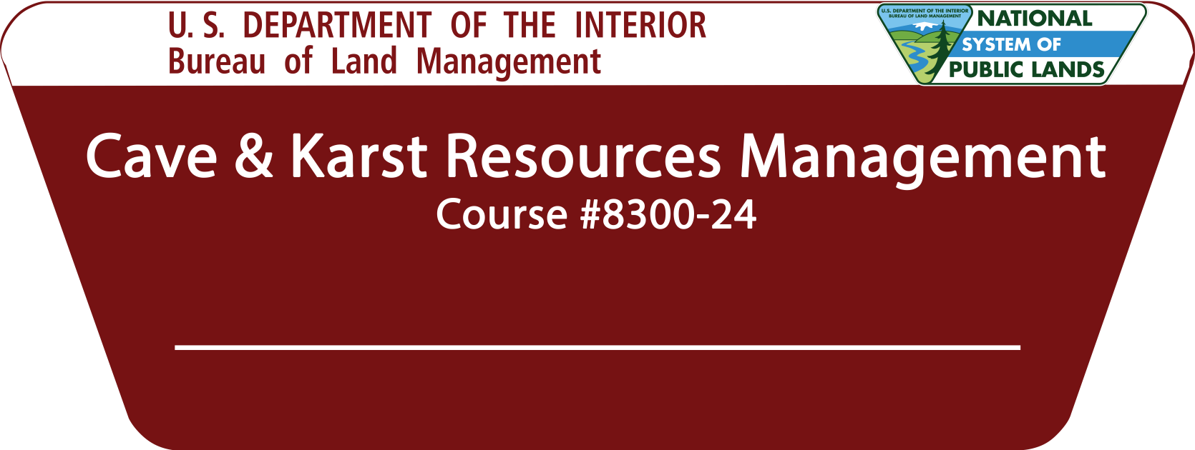
Silt, Colorado
August 13th – 15th, 2019

TRAINING ANNOUNCEMENT

The BLM-National Training Center is offering Cave and Karst Resources Management training in Silt, Colorado August 13th-15th, 2019. The course covers current cave and karst management policies and practices in the BLM and the importance of integrating surface and subsurface resources. The course will explain, explore, and identify the unique challenges of protecting, restoring, conserving, interpreting, and applying resource inventory and monitoring techniques to develop cave management programs and plans. This course will also discuss the future needs of the BLM Cave and Karst Resources Management program with limited staff and resources.
Class Title: Cave and Karst Resources Management
(8300-24)

Dates: August 13th – 15th, 2019

Hours: 8:00 a.m. – 5:00 pm

Hotel: Holiday Inn Express
1535 River Frontage Road
Silt, CO 81652

Link to Holiday Inn Express

Per Diem Rate: $94/night

Phone: (970) 876-5100

Booking Code: “Bureau of Land Management”
(Deadline for Hotel Reservations is 08/10/2019)

Training Location:
BLM-Colorado River Valley Field Office
(Conference Room)
2300 River Frontage Road
Silt, Colorado 81652

Field Trip:
There will be a field trip on the second day of the training. Participants will have the opportunity to experience a day underground while learning and practicing cave conservation and ethics. They will use the appropriate equipment and safety standards for visiting caves and conduct all required White Nose Syndrome (WNS) decontamination procedures. Opportunities will be provided for cavers with beginner, intermediate, and expert skills and knowledge. An alternate trip not involving caving but visiting a site via vehicle will also be provided for those interested.

The BLM will provide Tyvek disposable coveralls. However, participants should bring footwear, clothing, and gear (helmets, two headlamps, packs) that can be decontaminated according to:
https://www.whitenosesyndrome.org/mmedia-education/united-states-national-white-nose-syndrome-decontamination-protocol-april-2016-2
Do not bring footwear or gear from states where White Nose Syndrome has been confirmed or suspected. To discuss loaner gear options, contact Kimberly Leitzinger at 970-876-9075. For the latest spread map, go to: https://www.whitenosesyndrome.org/
Target Audience: BLM employees who are Cave/Karst State Leads, are considered Subject Matter Experts in cave and karst resources, and/or have current high priority workload related to cave and karst resources.
Course Objectives: This course will enable participants to:
- Describe BLM's cave management program, the Federal Cave Resources Protection Act and other applicable laws, regulations, and policies.
- Recognize the importance of integrating pertinent surface and subsurface components of cave and karst systems.
- Identify and evaluate the significance of natural, cultural, and social values of cave and karst systems.
- Apply appropriate resource inventory and monitoring techniques to cave and karst management.
- Develop and implement specific strategies to protect, conserve, and restore cave and karst resources, in accordance with appropriate laws, policies, regulations, and best management practices.
Registration: You must use DOI-Talent to register for this course using the below steps.
How to Register in DOI-Talent:

- Login https://doitalent.ibc.doi.gov/.
- Go to Find Learning and from drop menu click Courses. Within Course Name (second box to the right – not Contains) type “Recreation – Cave & Karst Resources Management.” then click Search
- Click on “Recreation Permits on Public Lands.”
- Once you identify the desired class, click Sign-up on the far right.
- From this screen, please identify your Choose Manager, Method Payment (no payment required), and Receive Confirmation by (email only) and click Request Approval.
- Once the request form is submitted, an email notification is sent to the supervisor\manager telling them they have a training request to approve.
- Once the request is approved, the Learner (you) will receive a notification email and a second email notification with their appropriate class status (i.e., Enrolled or Waitlisted.)

Contact Mike Brown (m55brown@blm.gov) at (602) 906-5605 if you have any questions regarding registration through DOI-Talent. If you have any questions regarding the course content, please contact Kimberly Leitzinger (kleitzinger@blm.gov) or (970) 309-0348. You will need to have your supervisor’s approval to take this class. Be sure to discuss this training opportunity and commitment of time with them in advance.

Contacts

National Training Center

Mike Brown
Recreation & Visitors Services Training
m55brown@blm.gov
(602) 906-5605

Training Location Point of Contact

Kimberly Leitzinger
BLM - Outdoor Recreation Planner
kleitzinger@blm.gov
(970) 309-0348

