Example Project Management Plan
for Training Purposes

Version 2: 10 September 2008

For

Bureau of Land Management

Resource Management Plan (RMP) / Environmental Impact Statement (EIS)

Table of Contents

Bureau of Land Management Example Project Management Plan
 | Page
Introduction, Usage, and Limitations | 3
Basis & Qualifications Document | 4
Work Breakdown Structure (Levels 1, 2, and 3) | 9
Risk Management Plan | 11
Critical Path Schedule | 17
Helpful Hints | 25
Project Management on Contracts | 28
Change Control Process | 31
Change Control Form | 32
Example of Completed Change Control Form | 33

Introduction, Usage, and Limitations
Introduction

The Bureau of Land Management (BLM) has developed examples of several documents that would be included in a Project Management Plan (PMP). The type of project selected as the basis for the PMP is the development of a Resource Management Plan (RMP) / Environmental Impact Statement (EIS).
The Example PMP includes the following documents:
- Basis & Qualifications Document
- Work Breakdown Structure (WBS) – Levels 1, 2, and 3
- Risk Management Plan
- Critical Path Schedule
- Helpful Hints
- Project Management on Contracts
- Change Control Process
- Change Control Form
- Example of Completed Change Control Form
Usage
The primary usage of the Example PMP is to enhance the learning process for students in the Project Management for Planners class. The documents are BLM specific examples that replace/augment generic examples that are currently included in the class materials.
A secondary usage of the Example PMP is to provide a reference that can be used by Interdisciplinary Teams (IDT) to develop the PMP for a specific RMP/EIS.
Limitations
The Example PMP was developed by BLM subject matter experts and is considered to be “reasonable” under the specific circumstances and conditions that are stated in the Basis & Qualifications portion of the Example PMP.
However, any project (and especially the development of an RMP/EIS) has a set of unique circumstances and conditions that will significantly impact any or all of the following:
- How much of the work will be contracted
- Level of detail included in the WBS (from a few dozen activities to hundreds of activities)
- Risks identified and strategies to deal with significant risks
- Estimated effort hours and/or duration to complete individual activities
- Staffing assigned to work on individual activities
- Percent of time staff has available to work on the RMP/EIS
- Sequencing of activities
The Example PMP must only be used as a reference and each IDT must adequately understand the unique aspects of their project and change all the affected items within the Example PMP accordingly.
Using the Example PMP directly without modification to represent the PMP for a specific RMP/EIS would result in inaccurate estimates and results that would not be useful to the project.
Basis & Qualifications Document
Background

A. Introduction: The Bureau of Land Management (BLM) requires revision of the Boyne Mountain Resource Management Plan. The planning area will include all of the public land, and federal mineral estate managed by the Boyne Field Office in W, X, and Y Counties in the northeastern area of the state.
B. Objectives: The overall objective of the RMP planning effort is to provide a collaborative community based planning approach to update the existing management decisions and resource allocations by addressing new data, changing resource conditions, and changes in the use of public land that have occurred since the RMP was completed. The BLM expects that numerous partners and cooperating agencies will become involved in this process and will assist in providing a wide variety of data in support of this effort. The primary objective is to revise the RMP to comply with those determinations required in the Bureau of Land Management “H -1601-1 Land Use Planning Handbook,” Appendix C: Program-Specific and Resource-Specific Decision Guidance Requirements for all affected resource management programs.

C. Scope: Develop a comprehensive RMP that will address a wide variety of issues and subsequent analysis of a reasonable range of alternatives for the BLM managed surface, and mineral estate within the planning area. The area includes about 1,300,000 acres of surface estate lands and 2,100,000 acres of mineral estate lands within W, X, and Y Counties, and also 200,000 acres of mineral estate lands within the Boyne Creek Extension of the Chippewa Indian Reservation. Within the Boyne Creek Extension, the surface is held in trust for the benefit of the Northern Chippewa Indian Tribe, but the mineral estate was reserved to the federal government, and all of these split estate lands are within X County.

D. Preliminary Areas of Issues: The following is a preliminary list of areas where issues may occur:
- Air Quality
- Cultural, Paleontology and Natural History
- Fire Management
- Woodland Harvest
- Hazardous Materials and Wastes
- Lands and Realty
- Rangeland Management and Health
- Minerals Management
- Off Highway Vehicle Use and Transportation
- Recreation Resources and Management
- Visual Resource Management
- Watershed Management, Soil, and Vegetation
- Wild Horse Management
- Wilderness Character
- Wild and Scenic Rivers
- Other Special Management Designations
- Wildlife Habitat and Fisheries Management

E. Assumptions: The PMP is based on the following assumptions:
Subject | Assumptions
Contracting | - A portion of the RMP/EIS process will be contracted.  - Key contractor personnel that will be assigned to the project are experienced in preparing an RMP/EIS.  - BLM will interview contractor proposed personnel and have final approval of all key contractor personnel.  - Contractor will be required to meet project management standards as well as technical standards.  - Contracts will have active oversight and management by designated and trained CORs.
BLM Staff | - Due to other BLM responsibilities, IDT staff will only be able to work on the RMP/EIS approximately 40% of the time.  - Project Lead will be dedicated 100% to the RMP.  - BLM staff with the required skill sets will be available on a timely basis to support the scheduled work.
Data | - Data is accurate.  - No additional significant data is required.  - Scenic/Wild River data will be contracted and completed within 1 field season.  - Archaeology data will be contracted and completed within 1 year.  - State/Cooperating Agencies will provide wildlife data.  - USGS will provide mineral potential report.
Reviews | - Local review cycle for BLM developed documents will be as follows: IDT draft, FO review/comment, IDT incorporate FO comments, FO approve.  - Local review cycle for Contractor developed documents will be as follows: Contractor Draft, IDT review/comment, Contractor incorporate IDT comments, FO approve.  - State office review cycle will be as follows: SO review/comment, IDT incorporate comments, SO approve.  - Washington office review cycle will be as follows: WO review/comment, IDT incorporate comments, WO approve.  - Reviews for all documents will be completed in a timely manner:  IDT Reviews – 10 work days  IDT Incorporate Comments – 5 work days  Contractor Incorporate Comments – 5 work days  Field Office Reviews – 20 work days  Field Office Approval – 5 work days  State Office Reviews – 10 work days  State Office Approval – 10 work days  Washington Office Reviews – 40 work days  Washington Office Approval – 20 work days
Assumptions (cont.)
Subject | Assumptions
Project Management | - Formal project management methods, techniques, and tools will be used to improve performance, meet schedule milestones, and stay within budgets.  - IDT status meetings will be held weekly.  - Contractor status meetings will be held at least monthly.
Team Composition | - Management Team (MT): State Director, District Manager, Field Manager (3 people)  - Project Leader (PL): Planning & Environmental Coordinator (1 person)  - Core Team (CT): GIS Specialist, Natural Resource Specialist, Outdoor Recreation Planner, Management Support Specialist, Park Ranger (5 people). Note: PL is a member of the core team but is listed separately in order to allow a different percentage of work for the PL associated with specific tasks.  - Interdisciplinary Team (IDT): All of the resource specialists (10 people)  - Contractor (CONTR): The contractor will determine composition of teams assigned to individual tasks.  - All cooperating agencies will provide consistent staff and direction.
Work Week | - The PMP is based on a standard 40-hour workweek.  - There are 10 Federal holidays included.  - Overtime will be authorized if needed.
Budget | - Adequate funding will be available each fiscal year to accomplish the work scheduled for that year.
Protests | - Protests will need to be resolved but protest resolution will not result in a “Notice of Significant Change”.
Other | - RMP will be approximately 2,000 pages (with maps and tables).  - There will be 1,000 unique, viable, substantive comments from public scoping.  - Collaboration with Northern Chippewa tribe will be on their terms.  - Collaboration with tribe will result in agreement with the final document.

F. Constraints: The PMP is based on the following constraints:
- The RMP/EIS will be completed in compliance with NEPA, FLPMA, Endangered Species Act, BLM Wilderness Interim Management Policy, and all other applicable laws and policies.
- The planning process will encourage public participation and a collaborative process that strives to incorporate community, visitor, and other agency needs and values while protecting the resources of the area.
- Cooperating agencies will meet their commitments to support the schedule.
- E-Planning will be used.
- Air quality compliance with state laws and regulations.
- Surface area is 1.3 million acres.
- Mineral area is 2.1 million acres.
- Native American trust is 200 thousand acres.
- There are five WSAs (Wild and Scenic Areas).

G. Exclusions: The PMP excludes the following items (if any of these items occur during the RMP/EIS, impacts will be analyzed and significant adjustments to scope, schedule, and/or budget may be necessary):
  - Failure of the contractor to provide high quality documents in accordance with the contractor’s schedule commitments
  - Unexpected loss of key personnel (due to retirement, transfer, etc.)
  - Delays in reviews or approvals (FO, SO, and/or WO)
  - Reduction in funding
  - Federal Register delays
  - Change in Washington administration
  - New legislation, regulations, procedures, litigation
  - Change in Field Office management, priorities, and internal reorganizations
  - Changes in land status
  - New OHV trails
  - Any change in technology that redefines OHV
  - New T&E species
  - Significant new data collection
  - Significant new science
  - Notice of Significant Change

H. Interrelated Projects: The RMP and the following projects are interrelated:
- Fire Management Plan
- Forest Plan
- Land Exchanges
- Wildlife Reviews from State Game & Fish and USFWS
- State Wildlife Plan
- HAZ/MAT
- Weed Plan

I. Key Milestones: A list of key milestones for the RMP/EIS planning process is outlined below. The time line considers a portion of the RMP/EIS process will be contracted. The milestones are based on the detailed critical path schedule and BLM staffing availability (for the RMP/EIS), which is approximately 40%.
Milestone | Deliverable / Acceptance Criteria | Day - Month | Year | Approximate Total Elapsed Time
Start Plan Groundwork | N/A | 5 Jan | Year 1 | 0
Start Preplan | Assemble IDT | 2 Apr | Year 1 | 3 Months
Preplan Complete | Final Preplan Approved by WO | 9 Jul | Year 1 | 6 Months
NOI complete | NOI Published in Federal Register | 24 Aug | Year 1 | 7.5 Months
Award Contract | Contract signed | 11 Oct | Year 1 | 9.5 Months
Scoping Report Complete | Scoping Report approved by FO | 25 Feb | Year 2 | 1 Year,  2 Months
Alternatives Matrix Finalized | Alternatives Matrix sent to FO for review | 23 Aug | Year 2 | 1 Year,  8 Months
Alternatives Formulated | Alternatives Matrix and Narrative Descriptions of Alternatives Approved by SO | 2 Nov | Year 2 | 1 Year,  10 Months
Preferred Alternative Selected | Preferred Alternative approved by SO | 26 Jan | Year 3 | 2 Years,  1 Month
Issue NOA for Draft RMP/EIS | NOA published in Federal Register | 11 Nov | Year 3 | 2 Years,  10.5 Months
Public Review & Comment Period | Public Review & Comment Period ends | 9 Feb | Year 4 | 3 Years,  1 Month
Draft Plan Revised for Public Comments | Plan changes based on public comments incorporated | 3 May | Year 4 | 3 Years,  4 Months
NOA for Proposed RMP/FEIS Published | NOA published in Federal Register | 4 Jan | Year 5 | 4 Years
Governor’s Consistency Review Complete | Comments received from Governor’s Consistency Review | 5 Mar | Year 5 | 4 Years,  2 Months
Protests Resolved | Decision on protests approved by BLM Director | 14 May | Year 5 | 3 Years,  4.5 Months
Record of Decision (ROD) | ROD approved by SO | 6 Jun | Year 5 | 4 Years,  5 Months
Work Breakdown Structure
Work Breakdown Structure – Levels 1 & 2
WBS | Name
1 | Example Resource Management Plan (RMP)
1.1 | Project Management
1.2 | Plan Groundwork
1.3 | Scoping
1.4 | Draft RMP/EIS
1.5 | Proposed RMP/Final EIS, NOA for Proposed RMP/Final EIS, Governor's Consistency Review
1.6 | Resolve Protests, Sign Record of Decision
1.7 | Project Closeout
1.8 | Implementation Plan
Work Breakdown Structure – Levels 1, 2, & 3
WBS | Name
1 | Example Resource Management Plan (RMP)
1.1 | Project Management
1.1.1 | Develop Project Management Plan
1.1.2 | Internal Status Review Meetings
1.1.3 | BLM/Contractor Status Review Meetings
1.1.4 | Change Management
1.2 | Plan Groundwork
1.2.1 | Existing Plan Evaluation
1.2.2 | Pre-Plan
1.2.3 | Start Collecting Baseline Data Identified in Data Gaps
1.2.4 | Develop On-Going Communication Strategy
1.2.5 | Initiate On-Going Collaboration
1.2.6 | Contracting
1.2.7 | Notice of Intent (NOI)
1.3 | Scoping
1.3.1 | Public Review & Comment Period
1.3.2 | Analysis of the Management Situation (AMS)
1.3.3 | Scoping Meetings
1.3.3 | Consultation/Coordination/Collaboration
1.3.4 | Scoping Report

Work Breakdown Structure – Levels 1, 2, & 3 (cont.)
1.4 | Draft RMP/EIS
1.4.1 | Analysis of the Effected Environment
1.4.2 | Formulate Alternatives
1.4.3 | Estimate Environmental Impacts (Impact Analysis)
1.4.4 | Initiate Draft Biological Assessment (BA)
1.4.5 | Select Preferred Alternative
1.4.6 | RMP Chapter on Purpose & Need
1.4.7 | RMP Chapter on Consultation & Coordination
1.4.8 | RMP Appendices, Glossary, References
1.4.9 | Complete Internal Draft of RMP/EIS
1.4.10 | Internal Reviews of Draft RMP/EIS
1.4.11 | Issue Draft RMP/EIS, Notice of Availability
1.4.12 | Print & Distribute Draft RMP
1.5 | Proposed RMP/Final EIS, NOA for Proposed RMP/Final EIS, Governor's Consistency Review
1.5.1 | Public Review and Comment
1.5.2 | Comment Analysis & Resolution
1.5.3 | Finalize BA
1.5.4 | Internal Reviews of Proposed RMP/Final EIS
1.5.5 | Issue Proposed RMP/Final EIS, Notice of Availability
1.5.6 | Print & Distribute Proposed RMP/ Final EIS
1.5.7 | Governor's Consistency Review
1.5.8 | Protest Period
1.6 | Resolve Protests, Sign Record of Decision
1.6.1 | Resolve Governor's Consistency Review Comments
1.6.2 | Resolve Protests
1.6.3 | Notice of Significant Change (NOT Required)
1.6.4 | Sign Record of Decision (ROD) Approving RMP
1.7 | Project Closeout
1.7.1 | Project Lessons Learned
1.8 | Implementation Plan
1.8.1 | Develop implementation and tracking system
Risk Management Plan
Risk Identification
The PL, CT, and IDT held a brainstorming session to identify risks (threats and opportunities) for the RMP/EIS. The original list was then rearranged by category.

Threats
Category | Initial Threat Description | Probability | Cost Impact | Schedule Impact | Severity
Contracting | Contractor personnel lack RMP/EIS experience
 | Poor quality of documents from contractor
 | Contractor key personnel changes
 | Contractor does not fully staff RMP
 | Contractor does not meet deadlines
 | Bankruptcy of contractor
 | No contractor responds to bid request
Organization | Change in Washington administration
 | New legislation
 | New regulations
 | New procedures
 | Changes in documentation requirements
 | Change in SO management
 | Change in FO management
 | Change in FO priorities
 | Internal reorganizations
 | Unreasonable public
 | Tribes don’t respond
Funding | Funding reduced
 | Planning partner does not fund
 | No travel budget
 | Economic recessions
Staffing | BLM personnel changes
 | BLM personnel retirements
 | BLM personnel can not work on RMP due to other priorities (work overload)
 | BLM personnel lose motivation due to length of RMP
 | BLM personnel have never worked on RMP before
 | Inadequate technical skill of BLM personnel
 | Inadequate project management skill of BLM personnel
 | Inadequate training
 | Key BLM personnel pulled off for fire duty.
 | Personality conflicts
 | Poor team communication

Threats (cont.)
Category | Initial Threat Description | Probability | Cost Impact | Schedule Impact | Severity
Scheduling | Collaborator delays
 | Federal Register publishing delays
 | Printing delays
 | Lack of equipment
 | Poor Interagency coordination
 | Poor Native American coordination
 | Protests & appeals
 | Conflicting priorities
 | Important federal stakeholder doesn’t respond
 | Poor project management
Data | Unknown cultural, T&E, and other resources
 | New research, different interpretation of science, dueling science
 | Lack of GIS support
 | New data needed
 | Data lost
 | Data incompatible
 | Inaccurate data
Technology | Lack of IRM support, new software releases, etc.
 | Computer downtime
 | Website downtime
 | E-Planning
Scoping | More comments received during scoping
 | Key information withheld by other agency
 | Unable to hold enough public meetings
 | Meeting locations not available
 | Meeting times conflict with other community events
 | All cooperators not identified
 | Memorandum of Understanding (MOU) not developed for cooperators
 | Cooperators don’t understand their role
 | Lack of participation by partners
 | Coordination with USFWS initiated too late
 | Urban interface issues
 | Public Affairs office misses deadlines for public notification
Legal | Pending lawsuit prohibits a specific alternative

Opportunities
Category | Initial Opportunity Description | Probability | Cost Impact | Schedule Impact | Severity
Contracting | Contractor can assign additional personnel to speed up development of contractor deliverables
 | Contractor can provide skill sets that are not available within BLM
 | Contracting a portion of the RMP will result in BLM personnel being available to work on other high priority work
Organization | Collaborative meetings with public accelerates RMP/EIS
 | Internal reorganizations
 | New economic benefits for the public
 | Reasonable public
Funding | Funding increased
 | Partners add funding
Staffing | FO revises priorities and BLM personnel available to work on RMP/EIS approximately 60%
Scheduling | Improved project management increases productivity
Data | Mineral report shows future development
 | Available data promotes mitigation measures
 | Synthesize data
 | Use data from other agencies
Technology | New technology improves productivity
Risk Analysis & Prioritization
The PL, CT, and IDT then determine the probability and impact of each identified risk (threats and opportunities) to the project.
Probability | Value | Definition (% Likelihood)
High | 3 | 70% or higher
Medium | 2 | 35% To 69%
Low | 1 | Less Than 35%

Cost Impact | Value | Definition
High | 3 | Additional funding required is 2% or more of current levels
Medium | 2 | Additional funding required is greater than 1% but less than 2% of current levels
Low | 1 | Additional funding required is less than 1% of current levels

Schedule Impact | Value | Definition
High | 3 | Preplan milestone delay is more than 4 weeks
Medium | 2 | Preplan milestone delay is more than 2 weeks but less than 4 weeks
Low | 1 | Preplan milestone delay is less than 2 weeks
Risk Response
From the list of identified threats, “Key BLM personnel pulled off for fire duty” was evaluated as High probability and High impact. Therefore, it was one of the threats that required a detailed risk response.
(1) Restate the risk in more specific language and indicate areas of impact.
If key personnel (PL, CT, or IDT) are not available during the fire season to work on the RMP for 3 months, then: (1) key milestones in the RMP Preplan may be delayed; (2) budget allocated for the year may not be spent; (3) work with the contractor may be delayed; (4) team morale may negatively impacted.
(2) Identify (by name) which team members on the RMP may be requested to go on Fire detail and evaluate probability and impact for each person (high, medium, low).
Person | Probability | Impact | Severity
Floyd | H | H | Extreme
Jane | M | H | High
Dan | M | L | Low
(3) Determine which team members need to have individual risk response plans developed. Based on the above evaluation, just Floyd & Jane need individual risk response plans.
(4) Brainstorm potential risk strategies in general:
Key person removed from availability to go on fire if it conflicts with RMP assignments
Transfer replacement person from another office that is not on fire duty list
Replace person during fire season with person from this office that is not on fire duty list
Hire new person
Extend schedule for completion of RMP & Reduce yearly budget requirement
Have contract personnel replace key person
Authorize compensation/overtime for other team members
Authorize compensation/overtime for replacement person in this office
Ignore
Team building to improve morale of other team members
Assign a different person from this office that is not on fire duty list
Rearrange RMP schedule
Compress RMP activities prior to fire season
(5) Select the appropriate strategy (or strategies) for each person’s risk response plan.
(5a) For Floyd, Select the strategy: “Authorize compensation/overtime for replacement person in this office.” Identify who in the office has the skill set to replace Floyd (i.e. Range Conservationist) that will not go on fire duty. Train this person as backup for Floyd. Work with the designated person to schedule their overtime during the predicted fire season. Update the detailed schedule to reflect the new resource name on specific work packages. Update the yearly budget if additional budget is necessary to pay for OT portion.

(5b) For Jane, Select the strategy: “Assign a different person from this office that is not on fire duty list.”
Identify who in the office has the skill set to replace Jane. Replace Jane with designated person on the RMP team (Jane will no longer be a member of the team). Update the detailed schedule to reflect the new resource name on specific work packages.
Additional Risk Response Examples for Threats:
The following are additional examples of threats and potential responses:
If the Contractor does not meet commitments, then quality, cost, and schedule may be impacted.
- Determine what work should be contracted.
- Develop PM specifications the contractor must meet.
- BLM review qualifications and BLM interview all contractor proposed personnel. BLM has final decision on contractor personnel.
- Contractor cannot replace staff without BLM approval.
- Develop “samples” of expected format and content for all contractor deliverables.
- Hold regular conference calls with contractor.
- Travel to contractor site for interim review of deliverables.
- Hold monthly status review meetings with the contractor.
- Contractor will provide corrective action plans for all significant cost and/or schedule variances.
- Incentives for contractor performance.
- Penalties for contractor non-performance.
- BLM will work with contractor to develop “optimum” Critical Path Method (CPM) schedule.
- Have contractor personnel attend BLM training.

If BLM staff is not available to work on the RMP, then cost and schedule may be impacted.
- Contract some of the RMP.
- Contract other field office work to free up BLM personnel to work on the RMP.
- Work overtime.
- Extend end date of RMP.
- Send personnel to training to increase productivity.
- Conduct team building activities to improve team performance.
- Purchase productivity improvement tools.
- Assign subject matter experts to work on the RMP.
- Hire additional staff.
- Internal transfer of staff.
- Prioritize work on the RMP and delay other work.

Additional Risk Response Examples for Threats (cont.):
If there is miscommunication within the team, then team motivation, cost, and schedule may be impacted.
- Full disclosure via e-mails to all team members.
- Weekly meeting of key stakeholders.
- Develop rules of engagement for meetings.
- Meeting notes with action items delivered to all interested parties.
- Monthly teleconference.
- Use facilitators.
- Team building sessions.
- Define clear roles and responsibilities for all team members.
- Change work environment (field trips).
- Keep team as small as possible.

If there is a protest/appeal by stakeholders, then cost and schedule may be impacted.
- Include enough time and budget to resolve anticipated protests.
- Identify and work with potential protesters.
- Develop “bullet proof” administrative records.
- Develop “bullet proof” documents.
- Include second party analysis to verify BLM analysis and decisions.
- Protest/Appeal training.
Critical Path Schedule
Duration estimates are in WORK DAYS based on BLM personnel dedicated approximately 40% to the RMP and a standard 5-day workweek (except where indicated as Calendar Days). The calendar year includes 10 Federal holidays.
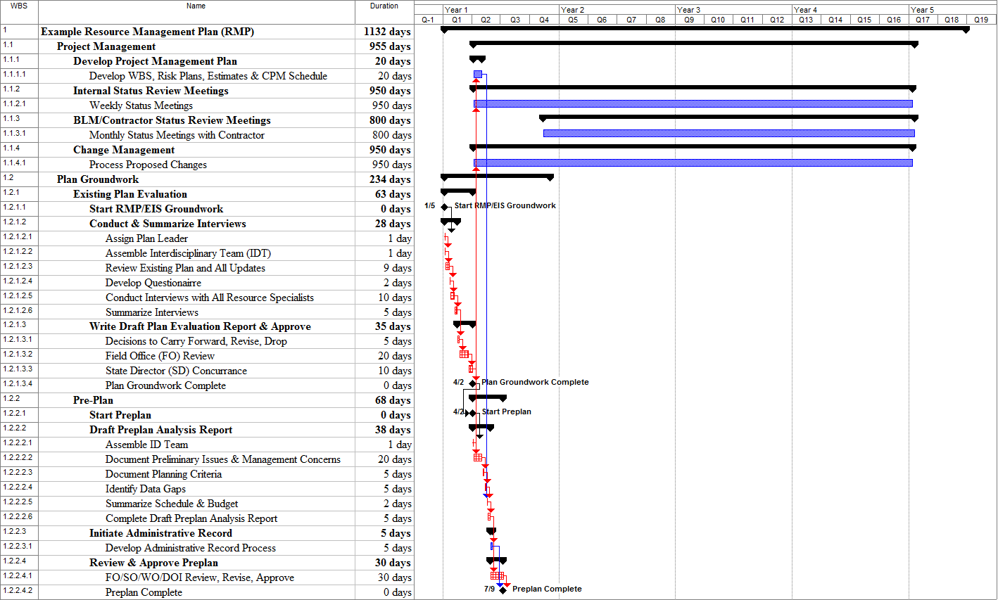
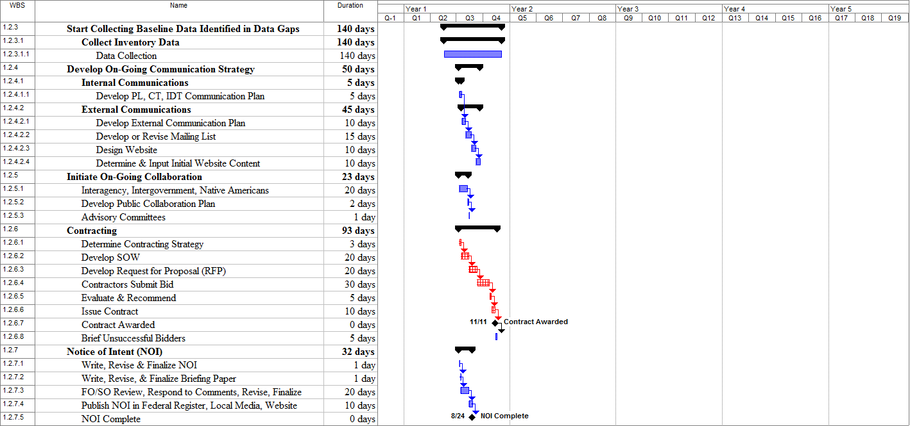

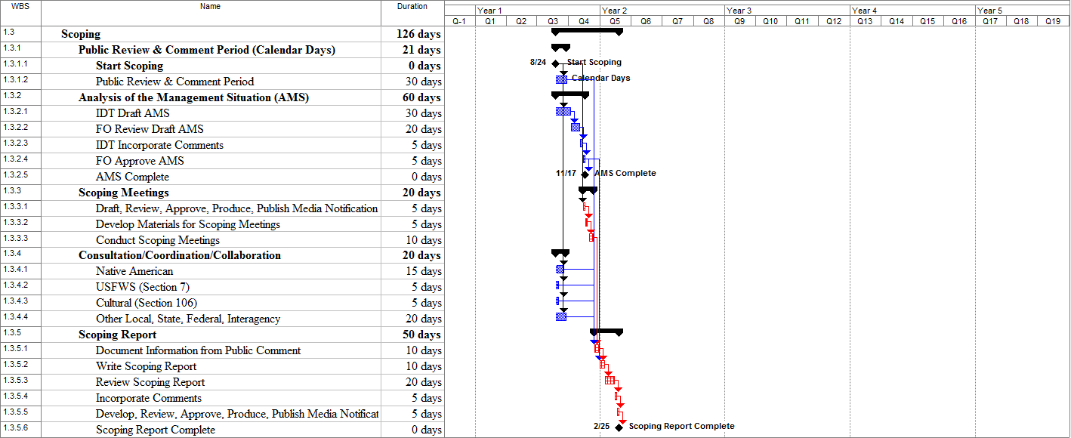

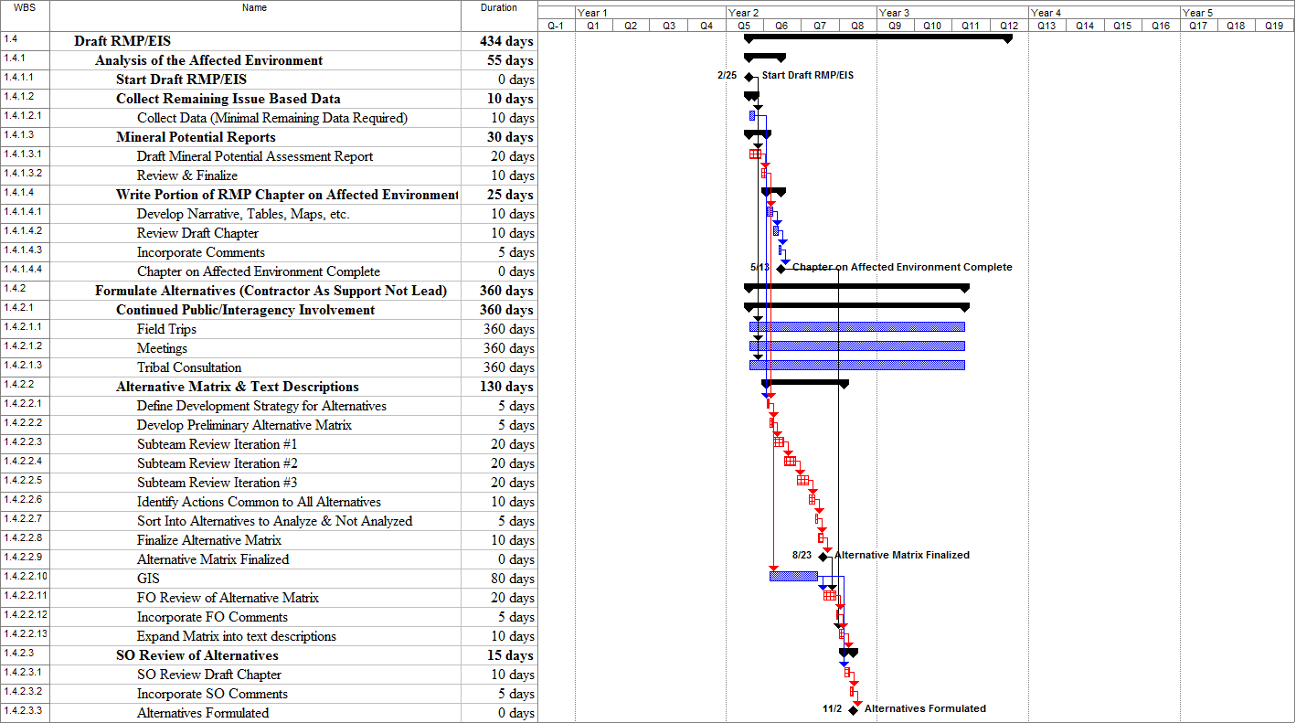

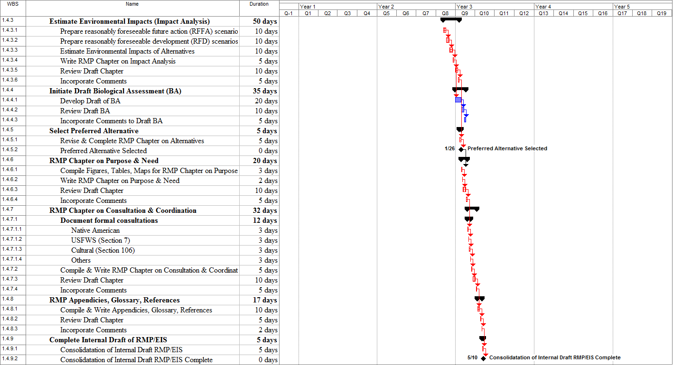
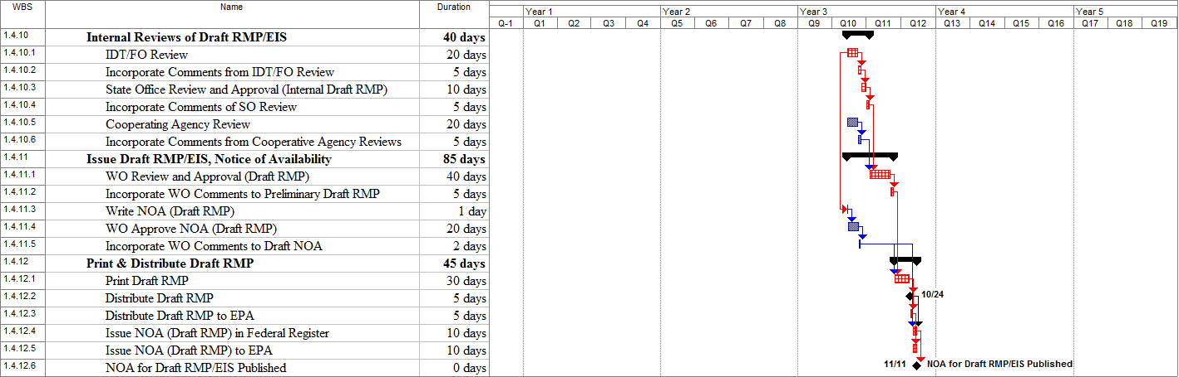

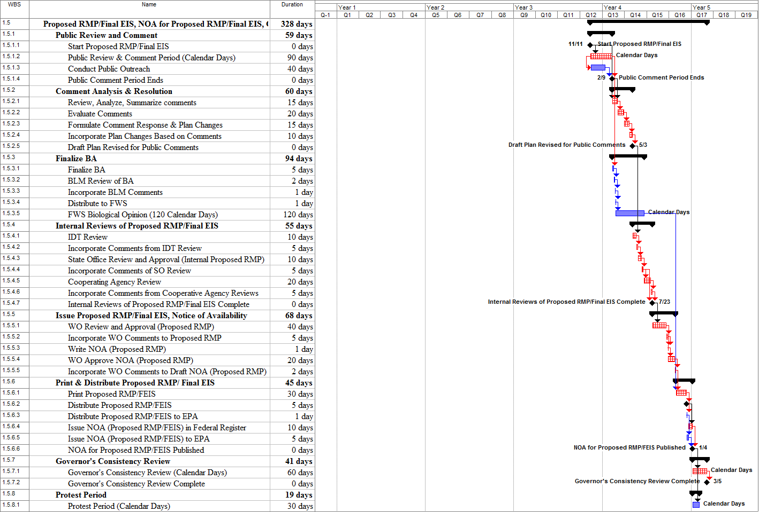

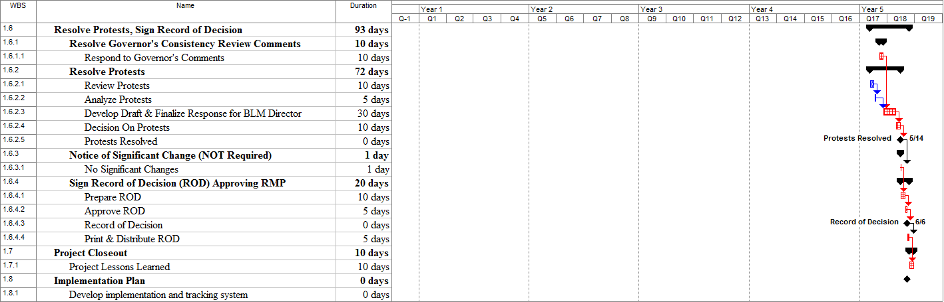

Helpful Hints
WBS Number & Description Helpful Hints
1.2 Plan Groundwork Don’t underestimate the work involved! There are several months of work prior to the NOI. Significant work includes the following: Existing Plan Evaluation, Draft & Approve Preplan, Develop Communication Strategy, Develop Collaboration Strategy, Develop Contractor SOW/Contractor Bids/Evaluation/Award Contract, and Write/Review/Finalize/Publish NOI.
1.2.2.3 Initiate Administrative Record Process Review possible IM’s for administrative records that may have suggested administrative record process. Determine how to do administrative records before hand – e.g. electronically? How organized? (e.g. by resource, etc?)
1.2.3 Data Collection Get the GIS person involved early to produce GIS maps as early as possible (don’t wait until later).
1.2.4.2 Develop External Communication Plan Includes a variety of communication methods with the public such as: bulletins, website, mailings, press releases, early bird information releases, etc.
1.2.5.2 Develop Public Collaboration Plan Determine types of outreach such as: public meetings, workshops, field trips, info-mobile, MOU, etc. Identify collaborators. Identify training requirements (Working In Partnership series, etc.).
Look at your RMP. Analyze to what extent the Plan and specific decisions lend themselves to collaboration (some items lend themselves to collaboration more than others). Collaboration should be used per the goals of the plan. The right mix should be chosen to align with overall plan goals.
1.2.6.2 Develop SOW (RMP Contractor) In plans that are contracted – with some burden taken off staff, staff can become more highly motivated/excited. Leaves the creativity for the BLM staff.
Important to require the contractors under RFP to develop proposed project management plan – breakdown of major work packages – staffing, etc – not full blown but fairly detailed. This helps to analyze each bid and realistic nature of the bid. Need enough detail for analysis. Don’t forget the details – there are little things that come back to haunt – e.g. who’s buying refreshments at a meeting; all little details should be accounted for and written explicitly.
1.2.6.5 Evaluate & Recommend Have a systematic and documented process to select successful bidder; separate debrief from that for unsuccessful bidders.
1.2.6.8 Brief Unsuccessful Bidders Give enough time to successfully debrief bidders (those who don’t win the bid). Those unsuccessful bidders still comprise pool of future contractors.
1.2.7 Notice of Intent Timeframe can vary significantly. Time required for FO/SO/WO/DOI reviews and incorporating comments may vary significantly. Can take as long as 3 months. Avoid putting any specific dates in the NOI (if review process takes longer than expected, dates in the NOI may not be valid).
1.2.7.4 Publish NOI in Federal Register Develop working relationship with “process people” at state and WO level. Don’t assume it’s going through the system just because you sent it in. Lotus Notes Federal Register database?
Anything you Fed Ex – follow up with recipient due to mailroom process that may backlog.
“RAG” Regulatory Affairs Group – very helpful group.

WBS Number & Description Helpful Hints
1.3 Scoping Put the scope in scoping. Sideboards for what plan is and isn’t. Must inform public what is wanted/needed
1.3.2 Analysis of Management Situation Different states have different requirements; some have AMS incorporated into draft; others as separate document. Here the PL needs to be very clear with expectations – especially if working with contractors. Tons of information that must be synthesized; AMS are budget eaters. It’s a good thing to assign to contactors – they can learn about the area. Many plans can in fact get more than needed in AMS – careful cost control item here.
1.3.3.3 Conduct Scoping Meetings Timeframe can vary significantly. Number of meetings, location, timing, set up of meetings, etc. must be considered. Size of resource area can affect meetings due to varied geographical area that needs to be covered.
1.3.4 Consultation/Coordination/Collaboration Timeframe can vary significantly. Note: these are ongoing processes throughout much of the planning process. It can vary based upon location -- some areas deal with marine, coastal commissions, state dept of natural resources. Initiate informal consultation with USFWS at this point. Request species list and framework for how BA will be accomplished.
1.4.1.2 Collect Remaining Issue Based Data Most data should be collected by now (you should have started to collect any data as soon as data gaps were identified in preplan). This is just to collect data that was unanticipated – this is data collected as a result of public scoping.
1.4.1.4.1 Develop Tables, Maps, etc. Make sure maps are on track at this point.
1.4.2 Formulate Alternatives Contractor should be in more of a support role rather than the lead role depending on nature of the plan. If this is single issues driven plan (e.g. oil and gas) – contractor can take more of a lead role. If broader plan then this is key part of process where IDT team needs heavy involvement (i.e. Lead). IDT as the lead ensures IDT buy-in. This is a stressful process for all involved. Decision of what to implement and what not to implement is “personal” – different views also as to what’s happened in the past. Passions, personality, etc. can come out and this stage gets “personal”. Possible frustration from budgets not necessarily being tied to plans.
List of IM’s that link to/relevant to WBS?
1.4.2.2 Alternative Matrix & Text Descriptions Not everyone uses the “matrix” idea. There are many forms of putting together and recording alternatives. This is an extremely complex area. It will take several iterations that are hard to predict and display in a schedule. (The example RMP assumes 3 iterations.) This is the heart of the RMP – this is the creative part of the plan. Subteams are smaller work groups that tackle specific issues. Number and size of subteams vary depending on issues.
1.4.5 Select Preferred Alternative Advisable to start thinking about land use decisions as opposed to implementation issues/decisions at this point. These will have to be separated out in the final plan.
1.4.4.1 Develop Draft BA Timeframe can vary significantly based upon wildlife biologist’s rapport with local FWS office – better to start this even earlier. Can always then figure out where to fit Draft BA in based upon an early consultation. Some fish/wildlife offices don’t want to see plan until final RMP stage.
1.4.7.1.1 Native American Consultations Ensure that the SHPO involved. Protocol may vary slightly between states.
1.4.8.1 Compile & Write Appendices, Glossary, References Other reports to include here like Wild/Scenic study, other separate reports.

WBS Number & Description Helpful Hints
1.4.10.1 IDT Review (of draft RMP/EIS) Make sure PL has some quality control here – can get unruly without QC between contractors and staff. Make sure staff goes through chain of command for communications.
1.4.12 Print & Distribute Draft RMP/EIS Many Federal Register notification requirements including requirement for document control #’s, publication sequence, copies to which office…account for these and similar requirements early in the process. When using GPO for printing – note that time for printing may be extensive. Having contracted printing/distribution can save much time at this process point. NOA requires departmental approval – ensure at least 6 weeks allowed – more if subject matter is controversial. If NOA is kept general it may pass easier (more is not always better). Knowledge of what’s hot; what’s not – key buzzwords (both positive and negative) are helpful.
1.4.11.1 WO Review and Approval (Draft RMP) Allow 6-8 weeks’ lead-time to set up WO briefings. Normally they don’t review the plan but PowerPoint presentation that highlights issues, decisions, etc. State office briefing likely to be required before the WO briefing.
1.5.1.3 Conduct Public Outreach Schedule public comment meetings in middle of review period if possible. This gives people chance to digest plan and get comments in post meetings.
1.5.3 Finalize BA Remember FWS has between 60-100 days to respond with Bio Opinion depending on region.
1.6.2 Resolve Protests Protests can be very formal in process – may be best done internally?
1.7.1 Project Lessons Learned Could have debrief meeting with WO or SO for lessons learned, etc.
1.8.1 Implementation Plan Some RMP contracts are developing a business plan/implementation plan to determine costs, personnel to implement – not part of formal RMP process.
Project Management on Contracts
Description of Contract
A contract is any procurement item involving technical, cost, or schedule risks that requires more comprehensive management control than is necessary on other material or labor purchases. Contracts require interim assessment of contractor performance and usually include progress payments to the contractor for services rendered.
The two categories of contracts are described in Table 1.
Table 1
Category | Description
External | Work that is assigned to an organization outside of BLM.
Internal | Work that is assigned to another organization within BLM.
Both external and internal contracts must be effectively managed. The approach to managing external and internal contracts is similar.
Types of Contracts
Contracts can be subdivided into two general types as described in Table 2.
Table 2
Type | Description
Fixed price | A predetermined total price for a well-defined product or service. To the extent the product or service is not well defined, both the buyer and the seller are at risk. The buyer may not receive the desired results and the seller may not receive the desire profits.
Cost reimbursable | Payment to the seller for actual costs incurred plus payment of profit.
Procedure for Contract Management
To ensure that you select qualified contractors, that the contractors agree to their commitments, and that the contractors meet their commitments, use the steps in Table 3.
Table 3
Step | Action
1 | Identify work to be contracted in the WBS and WBS Dictionary.
2 | Develop a Contractor Summary WBS.
3 | Develop a request for quote (RFQ) that includes the project management requirements the contractor must meet.
4 | Review proposals, select contractor, and sign an agreement with the contractor.
5 | Incorporate contractor information into the appropriate project plan components.
6 | Conduct periodic surveillance of the contractor.

Step 1: Identify work to be contracted in the WBS and WBS Dictionary.
For work that is to be contracted, you should not develop detailed work packages (the contractor will do this). Identify which elements of the WBS are included in each contract and document this in the WBS Dictionary.

Step 2: Develop a Contractor Summary WBS
Decide the level of detail that the contractor will report information back to the BLM. Develop a Contractor Summary WBS at this level that the contractor must adhere to. This summary WBS would usually go to level 3 or 4 but could go to lower levels if necessary.
Step 3: Develop a request for quote (RFQ) that includes
the project management requirements the contractor must meet.
The RFQ documents both the technical and non-technical requirements the contractor must meet. Project management requirements you should consider are:
- Contractor will provide BLM with a list of proposed contractor personnel. BLM will interview proposed contractor personnel and BLM will make final decision on contractor personnel assigned.
- Contractor will provide documentation of its project management standards and procedures to demonstrate adequate planning and management of the work.
- Contractor will provide a quality assurance plan for its scope of work.
- Contractor will report all project management data/information to BLM according the Contractor Summary WBS supplied in this RFQ.
- Contractor will plan work below the Contractor Summary WBS in as much detail as appropriate to adequately plan and manage the work. Generally, work should be planned so that work elements are no longer than one to two weeks in duration.
- Contractor will provide a WBS and WBS Dictionary for their scope of work.
- Contractor will provide an organization chart for its scope of work.
- Contractor will determine risk items for its scope of work and provide documented risk plans for the 10 most significant risk items.
- Contractor will use the Critical Path Method (CPM) for schedules. Microsoft Project is the preferred software for CPM schedules.
- Contractor will review the detailed CPM schedule with BLM to ensure it is complete and reasonable.
- Contractor will provide a summary schedule at the level of the Contractor Summary WBS (or in more detail if they desire) with appropriate interim milestones and status the schedule at least monthly.
- Contractor will provide a monthly billing/expenditure plan. Actual expenditures/billing will be reported against these plans at least monthly.
- The contractor will provide a time-phased staffing plan of effort hours. Actual effort hours will be reported against these plans at least monthly.
- The contractor will coordinate/explain all proposed changes and make sure they are mutually agreed to before being incorporated.
- The BLM has established variance thresholds of +/-10% (for cost) and +/-10 working days (for schedule) for the contract. At least monthly, the contractor will provide written analysis of all variances that exceed these thresholds. Variance analysis will include: the magnitude of the current variance, ultimate impact if no action is taken to correct the variance, causes for the variance, actions planned or taken, anticipated results, and impact on any other areas.
- The contractor will submit revised forecasts when appropriate.
Step 4: Review proposals, select contractor, and sign an agreement with the contractor.
Although cost is an important consideration in selecting the contractor, other factors to consider are: schedule, technical capability, project management capabilities, staffing availability, geographical location, infrastructure availability to perform the work, and prior performance on similar work.
Step 5: Incorporate contractor information.
The contractor must report project management information monthly. The contractor information should be entered at a summary level into the project plan without modification. After the contractor starts work, actual and forecast data should also be entered without modification or adjustment. If there is a disagreement with the contractor data, the contractor should be notified but the data should not be adjusted. The project management reports should contain a note indicating that a disagreement does exist.
If there are significant contractor variances, the contractor must submit a corrective action plan. The contractor must also submit a revised forecast if appropriate.
Step 6: Conduct periodic surveillance of the contractor.
The project should conduct an initial surveillance of the contractor to ensure that the contractor has adequate project management standards and procedures in place. It may also be necessary to conduct future surveillance if problems exist with the contractor project management data.
Change Management Process
Planning Lead (PL) or Other Team Member
Initiates Change Request Form
⇩
PL, CT, IDT Evaluates Impacts and Potential Solutions
         
Cost Impact: Yearly Budget Increase Less Than 2%  and/or  Schedule Impact: Preplan Milestone Delayed By Less Than 30 Days |  | Cost Impact: Yearly Budget Increase 2% or Greater  and/or  Schedule Impact: Preplan Milestone Delayed By 30 Days or More
         
FM Approves/Rejects |  | FM Sends to SO for Approval/Rejection
         
       |  | SO Decides If Change Needs To Be Elevated to WO for Approval/Rejection
         
Incorporate Approved Changes Into PMP |  | Incorporate Approved Changes Into PMP
         
If Change Impacts Contractor, Contract Change Order May Be Required by CO |  | If Change Impacts Contractor, Contract Change Order May Be Required by CO
Change Control Form
Project Name:
Case File Number:
Project Manager:
Date of Request:
Name of Person Requesting Change:
Organization:
Organization Address:
E-Mail / Phone / Fax:
Status of Project:
Describe Change Requested:
Scope Change (Yes or No, and Explanation):
Technical/Deliverable Impact:

Cost Impact:

Schedule Impact:

Decision:

Approval Signature: Date:
Example of Completed Change Control Form
Project Name: Example RMP/EIS
Case File Number: ST-3345
Project Manager:
Date of Request: March 10, 2007
Name of Person Requesting Change: President
Organization: Boyne County Livestock Association
Organization Address:
E-Mail / Phone / Fax:
Status of Project: Draft RMP/EIS being reviewed. Draft RMP/EIS is scheduled to be to the printer on
April 6, 2007.
Describe Change Requested: Have a third party (professors at the State University) prepare the Ranching and Ranch Economics sections for the RMP/EIS.
The County Livestock Association has questioned the validity of BLM’s information for the RMP/EIS as pertains to the Ranching and Ranch Economics sections. The State Cattlemen’s Association, County Manager, and County Extension Agent along with 7 of the 10 ranchers whose allotments could be affected by the RMP/EIS support this concern. They have requested that a third party (professors from the State University) prepare the Ranching and Ranch Economics sections for the RMP/EIS.
Scope Change (Yes or No, and Explanation): No, the concern is about the objectivity of the information prepared by BLM.
Technical/Deliverable Impact: If the State University analysis is significantly different than the BLM analysis, the decisions made in the RMP/EIS may have to be modified.
Cost Impact: State University analysis will add $15,000 to the budget.
Schedule Impact: If Draft RMP/EIS were put on hold, the NOA for the Draft RMP/EIS would be delayed 3 months. State University cannot start work for 1 month and estimates it will require 2 months to complete their report. An additional 2 weeks would be necessary to make changes in the Draft RMP/EIS.
Decision: BLM is confident that the BLM analysis is valid and will be validated by the State University analysis. However, refusals to consider the request will likely result in a Protest or Litigation from the County Livestock Association. The potential delay and cost of resolving a protest or litigation is far greater than the estimated cost of the study. The schedule delay will be avoided by sending the Draft RMP/EIS to the printer and issued as scheduled. The cover letter will state that the State University is performing a study and results will be in the Proposed RMP/FEIS.
Approval Signature: FM Signature with SO Concurrence Date:

