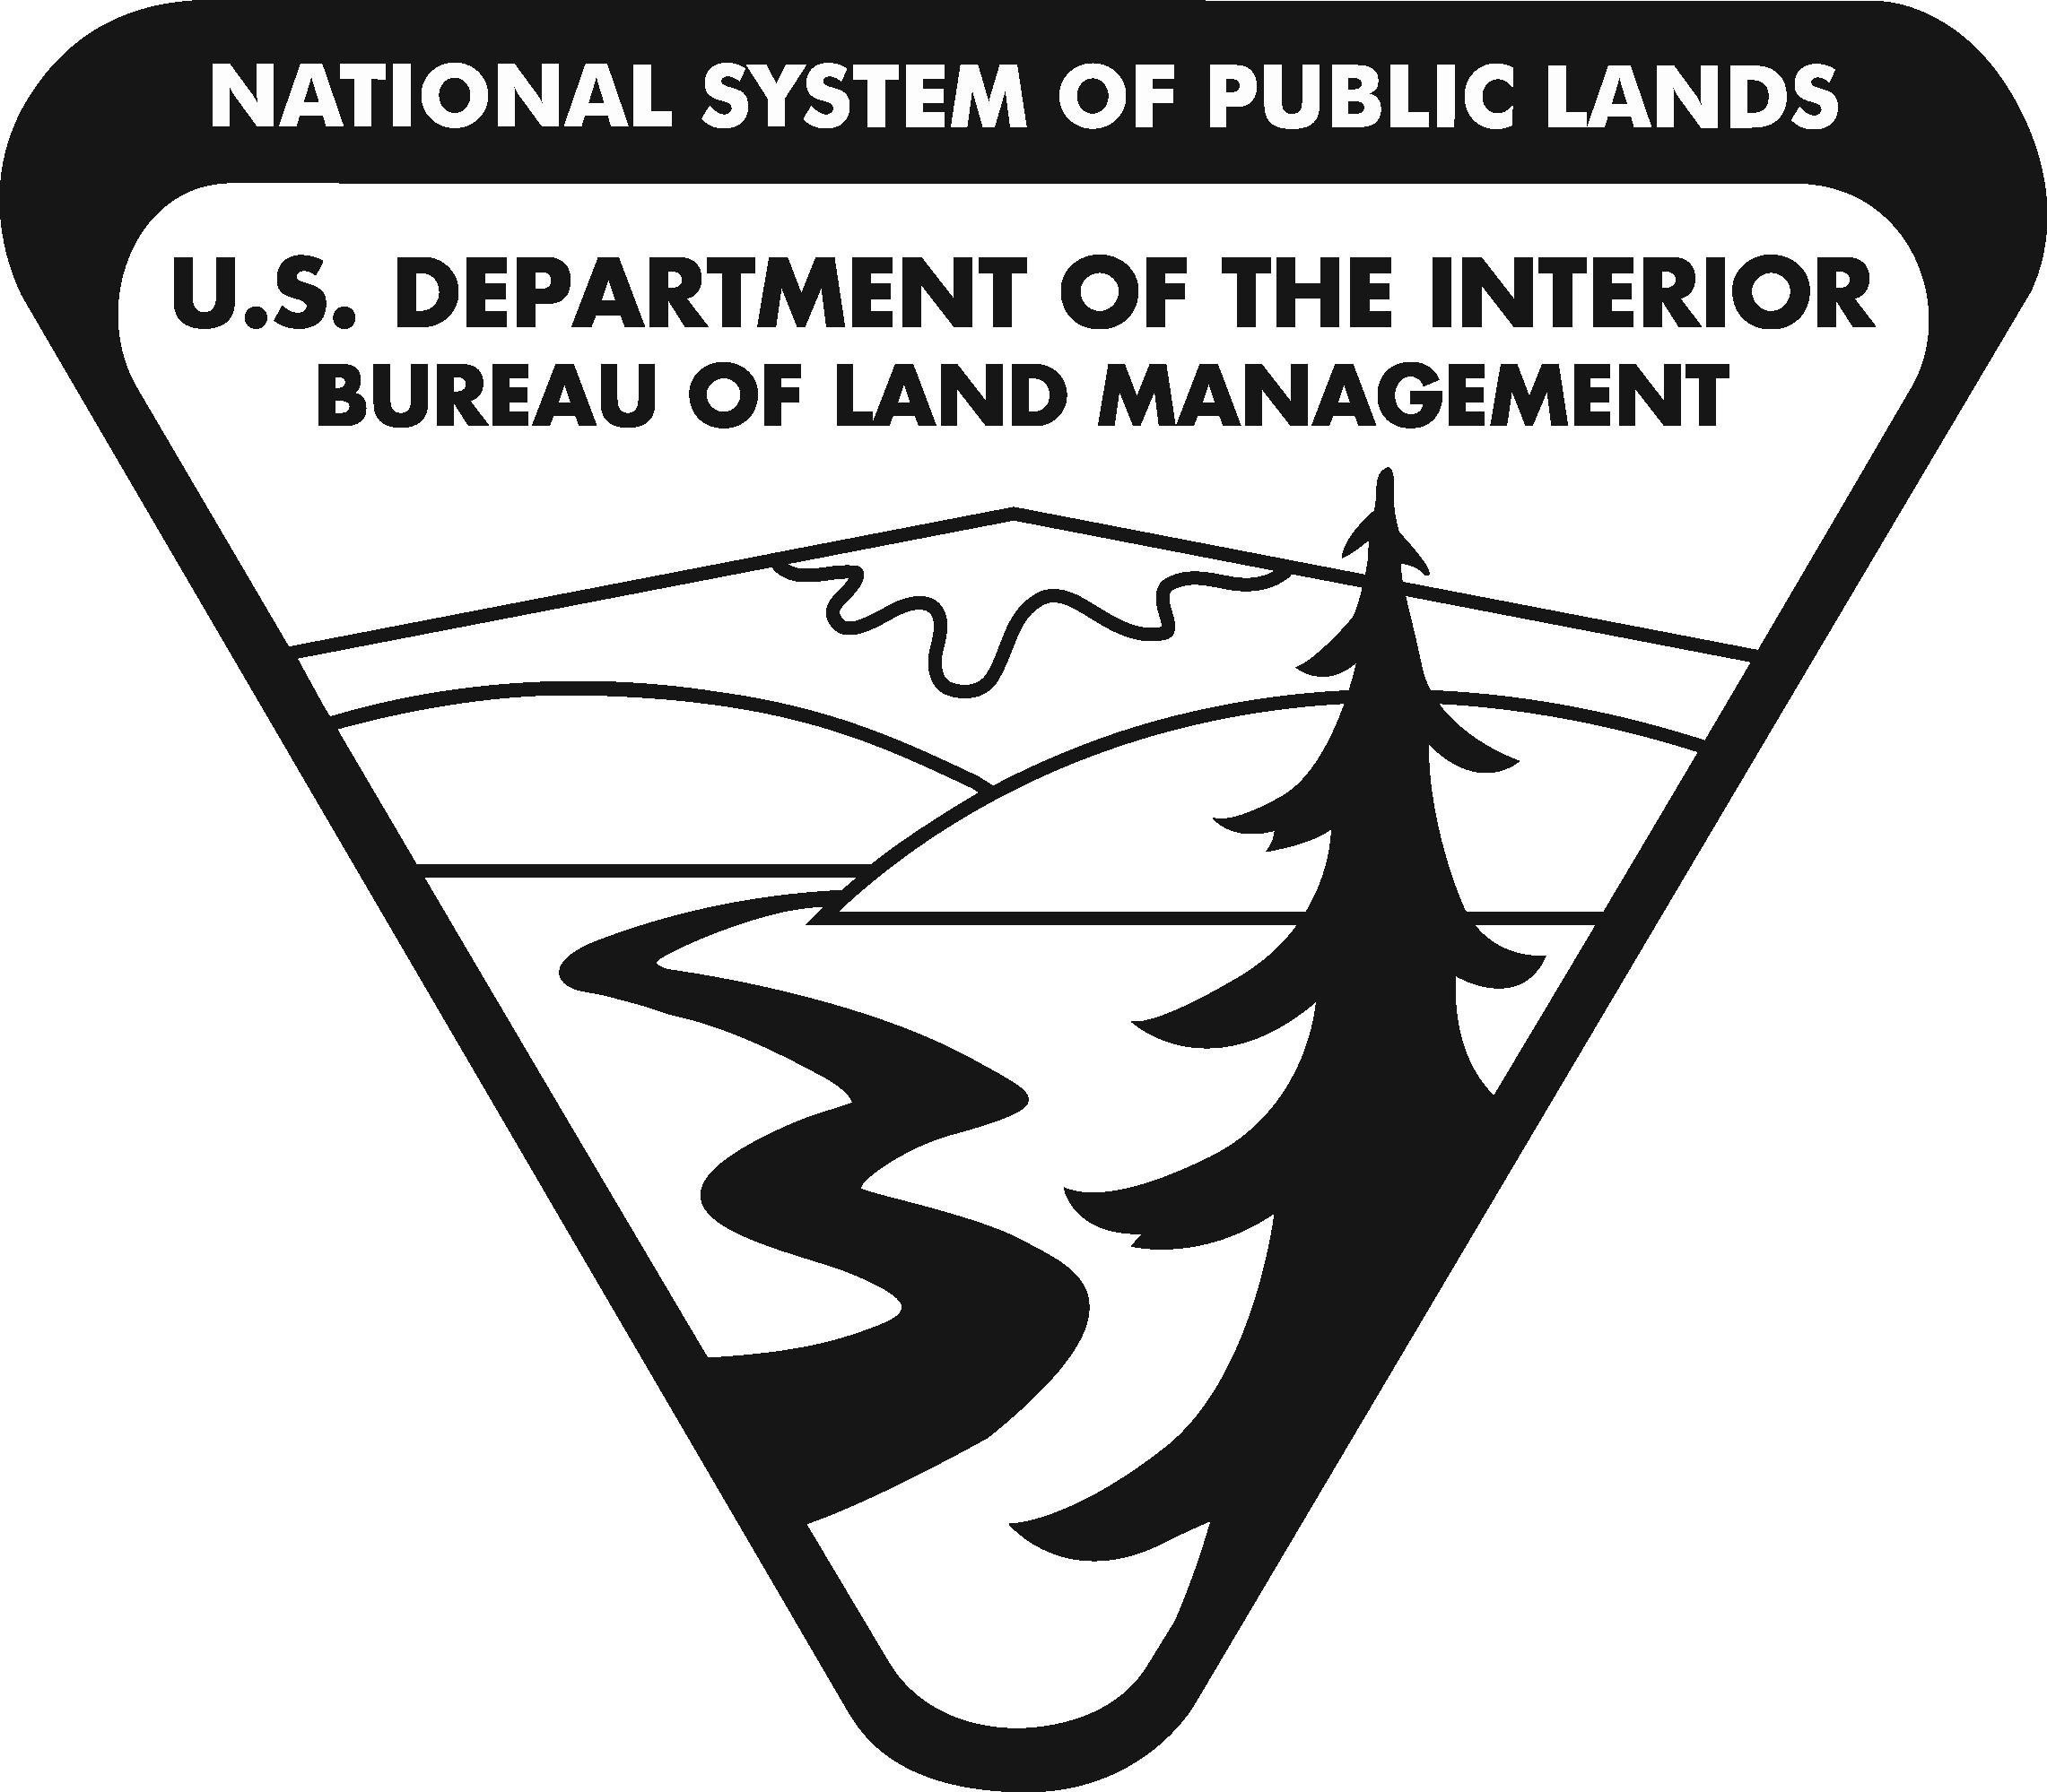
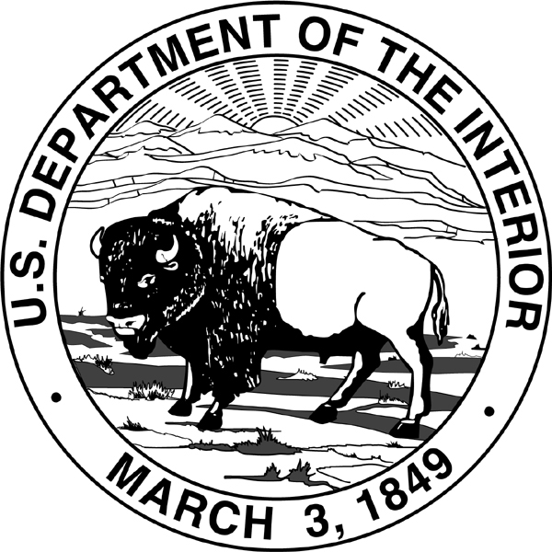
United States Department of the Interior
BUREAU OF LAND MANAGEMENT
Washington, DC 20240
http://www.blm.gov

In Reply Refer To:
2310 (350)
CACA 052573

Memorandum

To: Janice M. Schneider
Assistant Secretary – Land and Minerals Management

From: Neil Kornze
Director – Bureau of Land Management

Subject: Proposed Withdrawal, North and Middle Fork of the American River, California

We are transmitting a Public Land Order (PLO) that would withdraw 6,737.42 acres of public lands from location and entry under the United States mining laws for a period of 20 years to protect and preserve the riparian areas, wildlife habitat, scenic quality and high recreation values of the the North and Middle Fork of the American River and to protect the congressionally designated Auburn Dam and Reservoir Site and the Auburn State Recreation Area located in Placer and El Dorado Counties. The lands have been and will remain open to leasing under the mineral and geothermal leasing laws.

An environmental assessment determined this action would not have a significant impact on the quality of the human environment, and a detailed statement pursuant to Section 102(2) (C) of the National Environmental Policy Act of 1969 is not required. We recommend your approval.

Attachments

cc: Sec. Ofc.:MIB, Rm. 1416
Sec. RF(2):MIB, Rm. 1416
AS-LM(2):MIB, Rm. 6327
LLM:350:MS 4th FloorMS:350cf; 350rf; 350 hold
LLM:OR936:MLBarnes:9/8/2014:503-808-6155:Sec Memo

