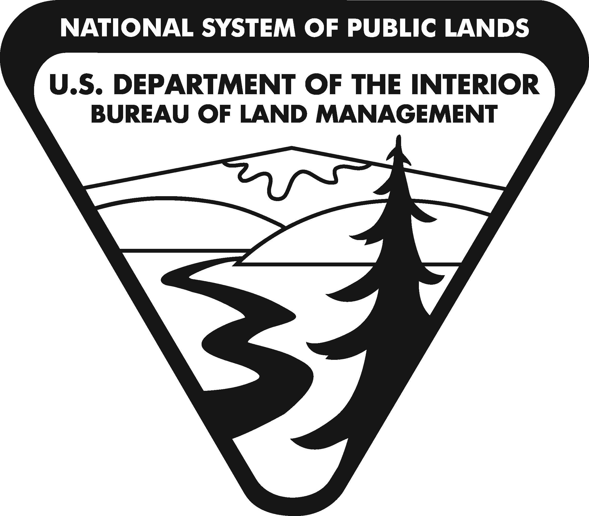
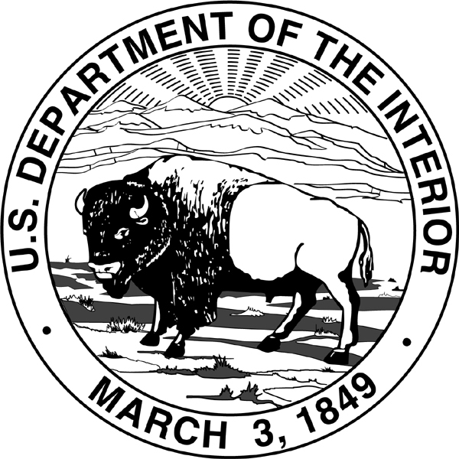
United States Department of the Interior
BUREAU OF LAND MANAGEMENT
Washington, DC 20240
http://www.blm.gov

In Reply Refer To:
2310 (350)
MTM 102716

Memorandum

To: Rhea S. Suh
Asstant Secretary – Policy, Management and Budget

Through: Marcilynn A. Burke
Assistant Secretary – Land and Minerals Management

From: Mike Pool
Acting Director, Bureau of Land Management

Subject: Petition/Application for Withdrawal Modification and Transfer of Jurisdiction, Fort Howes Fire Facility, Montana

We request your approval to file a petition/application to partially modify Public Land Order No. 1843 to transfer jurisdiction of approximately 5.16 acres of National Forest System land to the Bureau of Land Management (BLM). The land is currently withdrawn from all forms of appropriation under the public land laws, including the United States mining laws, and reserved for use of the Forest Service as the Fort Howes Administrative Site. The proposed modification would protect a significant Federal investment in the building of an administrative and fire facility. The BLM would be the administering agency responsible for all uses and activities affecting the facility. Consent has been received from the U.S. Forest Service for the proposed modification.

Attached is the information required for submission of a petition/application. Your approval is recommended.

Approved:

______________________________________
Rhea S. Suh Date
Assistant Secretary – Policy, Management and Budget

Attachment

