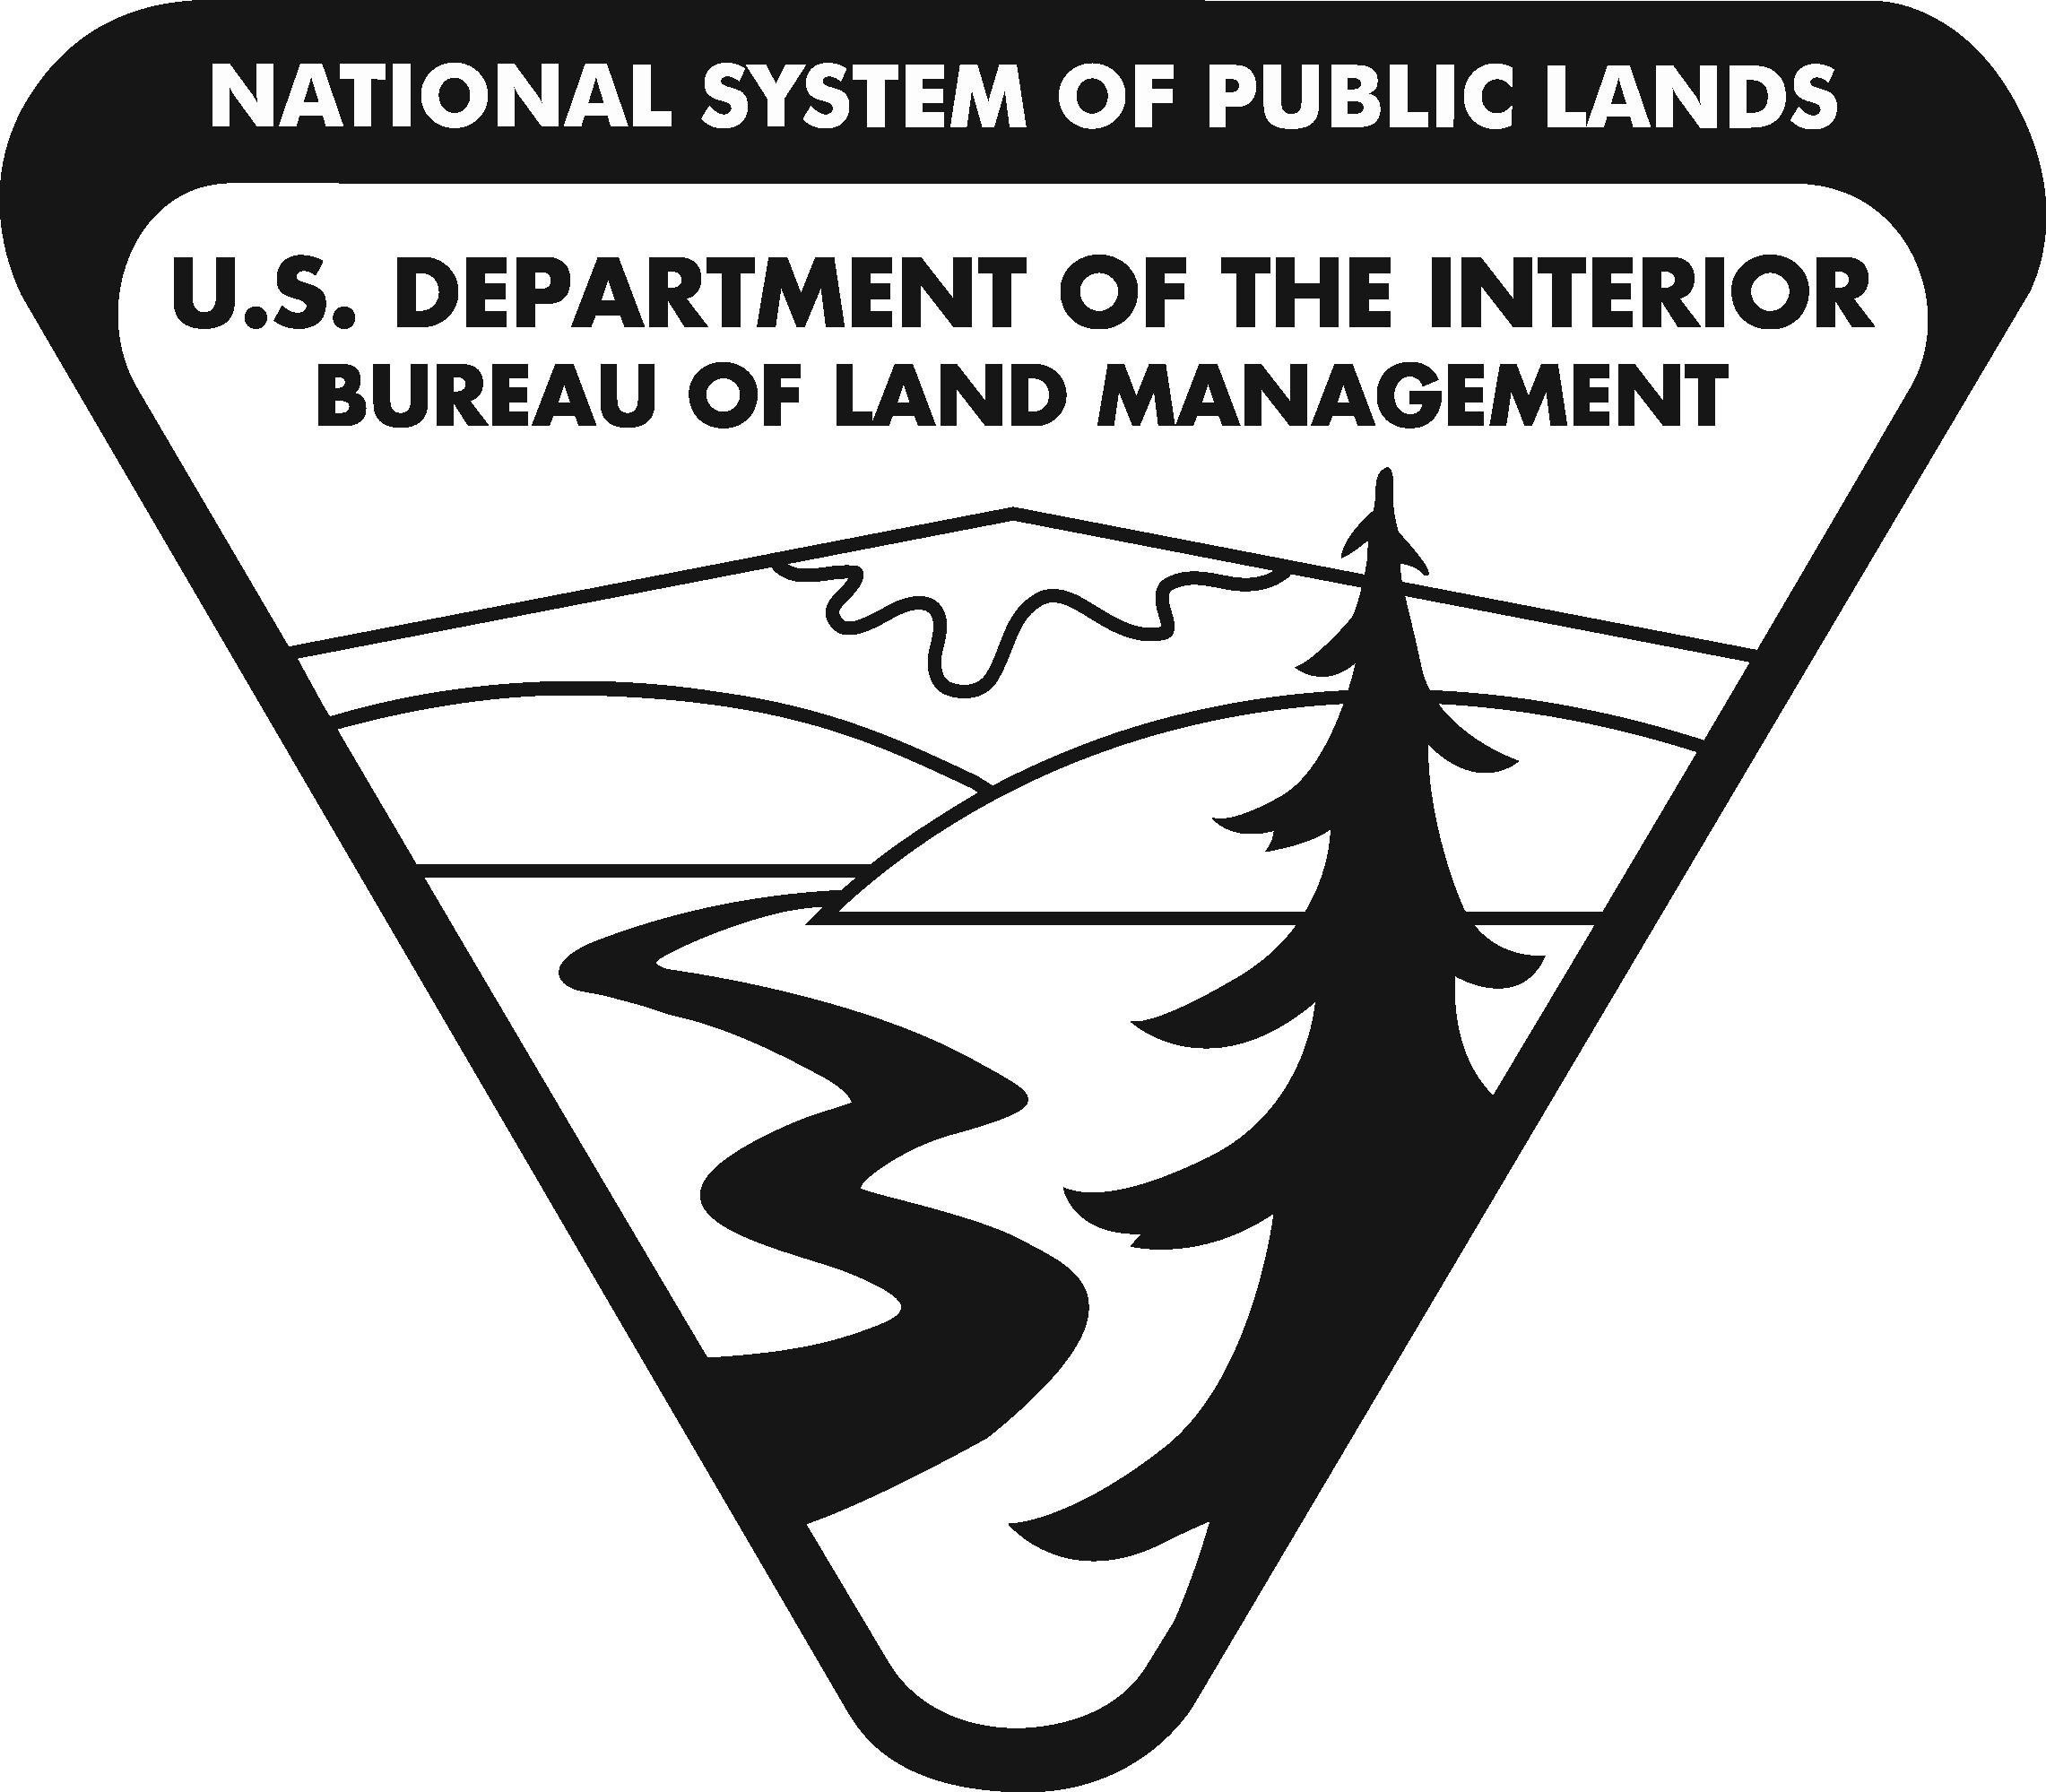
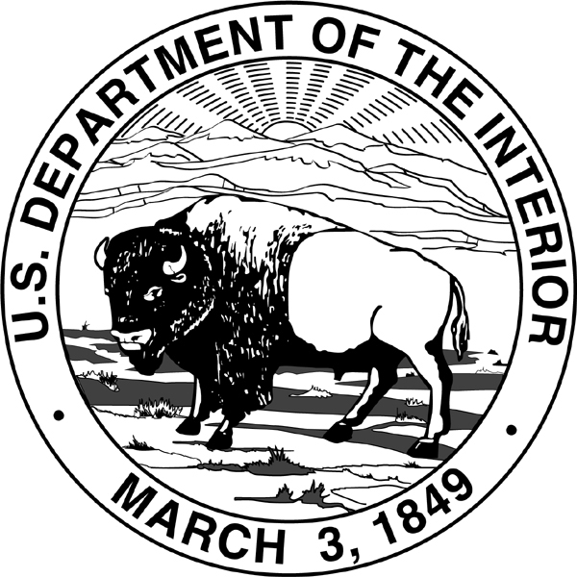
United States Department of the Interior
BUREAU OF LAND MANAGEMENT
Washington, DC 20240
http://www.blm.gov

In Reply Refer To:
2310 (350)
MTM 102716

MEMORANDUM

To: Rhea S. Suh
Assistant Secretary – Policy, Management and Budget

Through: Tommy P. Beaudreau
Acting Assistant Secretary – Land and Minerals Management

From: Acting Deputy Director, Bureau of Land Management

Subject: Proposed Withdrawal Modification and Transfer of Administrative Jurisdiction, Fort Howes Fire Facility, Montana

We are attaching a proposed Public Land Order (PLO) transmitted on behalf of the Bureau of Land Management (BLM). The PLO would partially modify PLO No. 1843 to transfer administrative jurisdiction of 5.16 acres of withdrawn land to the BLM from the U.S. Forest Service for the construction, operation, and protection of the Fort Howes wildland fire suppression facility.

An environmental assessment determined this action would have no significant impact on the quality of the human environment, and a detailed statement pursuant to Section 102(2)(C) of the National Environmental Policy Act of 1969 is not required. We recommend your approval.

Attachment

cc: Sec. Ofc.: MIB, Rm. 1416
Sec. RF (2):MIB, Rm 1416
AS-LM(2):MIB, Rm. 6628
AS-PMB:MIB, Rm. 6110
LLM:350:MS 4th Floor MS:350 cf; 350 rf; 350 hold

