Sacramento Pass
Sacramento Pass Recreation Area is located along Highway 50 about 40 miles east of Ely or 15 miles west of the Utah border and approximately 30 miles from Great Basin National Park. The recreation area was initially constructed in 1993 with federal highway funding obtained through the Safe, Accountable, Flexible, and Efficient Transportation Equity Act – A legacy for Users program.
The Sacramento Pass Recreation Area (SPRA) is centrally located on the crest of the Snake Range with Great Basin National Park (GBNP) for a backdrop. SPRA is popular with day travelers using the site for a quick stop (restroom/rest), as well as with those that make the site a destination for primitive camping, biking, fishing and horseback riding. From the site, travelers recreate at GBNP, visit Lehman Caves, Mt. Wheeler, the Baker Archaeological Site, the town of Baker, and Mt. Mariah. During peak visitor periods SPRA serves as an overflow camping site for GBNP. Trails exiting the southern boundary of SPRA traverse over 3.5 miles of BLM land and into the northern GBNP boundary. Nearby, Weaver Creek is located in a beautiful canyon drainage offering wildlife viewing, mountain biking, hiking and horseback riding opportunities. To the southwest of the recreation site lies the town site of Osceola. Osceola is still an active mining community that has unique modern and historic infrastructure and mining equipment. Across the highway to the north the Blackhorse Mining District ghost town still has remains to explore. A network of signed two-track roads allows hikers, bicyclists, horseback riders and OHV enthusiasts a chance to explore beautiful scenic country and historic mining ruins. There is also a signed trail system (3 trail loops various lengths: 6.5 miles total / 10.4 km) that explore the unique rock formations near the campground. There are two trailheads, one at the lower campground and one at the upper campground. These trails are not open to motorized use. SPRA also has a small pond at the lower campground open for fishing. This pond is stocked with trout from the nearby Spring Creek Fish Hatchery.

The recreation area is subjected to several restrictions: Camp Stay Limit is 14 days, campfires must be contained in provided fire rings and BBQ’s, gathering of dead and down wood for firewood is acceptable, however, cutting of any vegetation within the campground boundary is prohibited, digging within the campground boundary is prohibited, OHV travel is to remain on existing roads and trails but is prohibited on “The Sac Pass Trail”, any fishing and hunting requires a license, dogs must be under owners control at all times, all trash will be picked up and disposed of in the trash cans provided, discharging of firearms within campground boundary is prohibited and pumping water from the pond is prohibited.

The Sacramento Pass Recreation Area is currently being reconstructed through a Round 12 Capital Improvement project of the Southern Nevada Public Land Management Act, or SNPLMA. The reconstruction is expected to cost about $375,000. The Sacramento Pass Recreation Area was closed to the public as of Monday, July 8, 2013, to allow the Ely District to finish renovating the site to improve visitor access and safety. When reopened in spring 2014, the improved facilities will more closely comply with Americans with Disabilities Act requirements and be designed to be environmentally friendly.

The remodeled site will include 10 new “pull-thru” and/or “back- in” campsites with low maintenance furnishings, interpretive kiosks and displays, toilet buildings and concrete walkways, pond-accessible trails and fully-accessible fishing deck, a hiking and biking trail, and an equestrian trailhead, as well as road improvements.

The new Pond Campground Loop will include six new campsites and a double vault toilet building, interpretive displays and a trailhead area. Five of the sites will provide single family sun-shelters and furnishings, and the larger group campsite will include a group shelter, multiple tables and other furnishings. One of the single family units will be fully-accessible.

The Upper Trailhead/Campground will offer four new camp sites, a double vault toilet building, interpretive displays and a trailhead area. The trailhead/campground was especially designed to accommodate equestrian trail users with easy access to a multitude of trails just outside Great Basin National Park boundaries. There is plans to work with the Backcountry Horseman’s Association to design and build better equestrian oriented trails and facilities. One of the four campsites will be fully accessible.

There is no actual data on visitor use numbers. Based on staff observation, during the season from April to November there are typically 3-7 of the 10 campsites being used. There are many groups (Mining Clubs, Family outings) that use the campground annually. There are also 2-4 vehicles parked at the trailhead either using the picnic table or hiking/biking the trail system. The pit toilets get use from campers, trail users as well people traveling on Hwy 6/50. The pit toilet gets about 20-50 uses per day during the season. The trash cans are emptied weekly by Nevada Department of Transportation.

The upgrades currently being implemented increase facilities at SPRA by 50%, allowing a greater number of users. They also introduce handicap access, group use and facilities for greater use of the pond. Project planning and construction has invited interaction with the Nevada Department of Transportation regarding highway access and site use, and with the Great Basin National Park and Nevada Department of Wildlife on interpretive materials. In addition, users and user groups have expressed an interest in future development of trails and other facilities at the site that would promote equestrian and mining recreation.

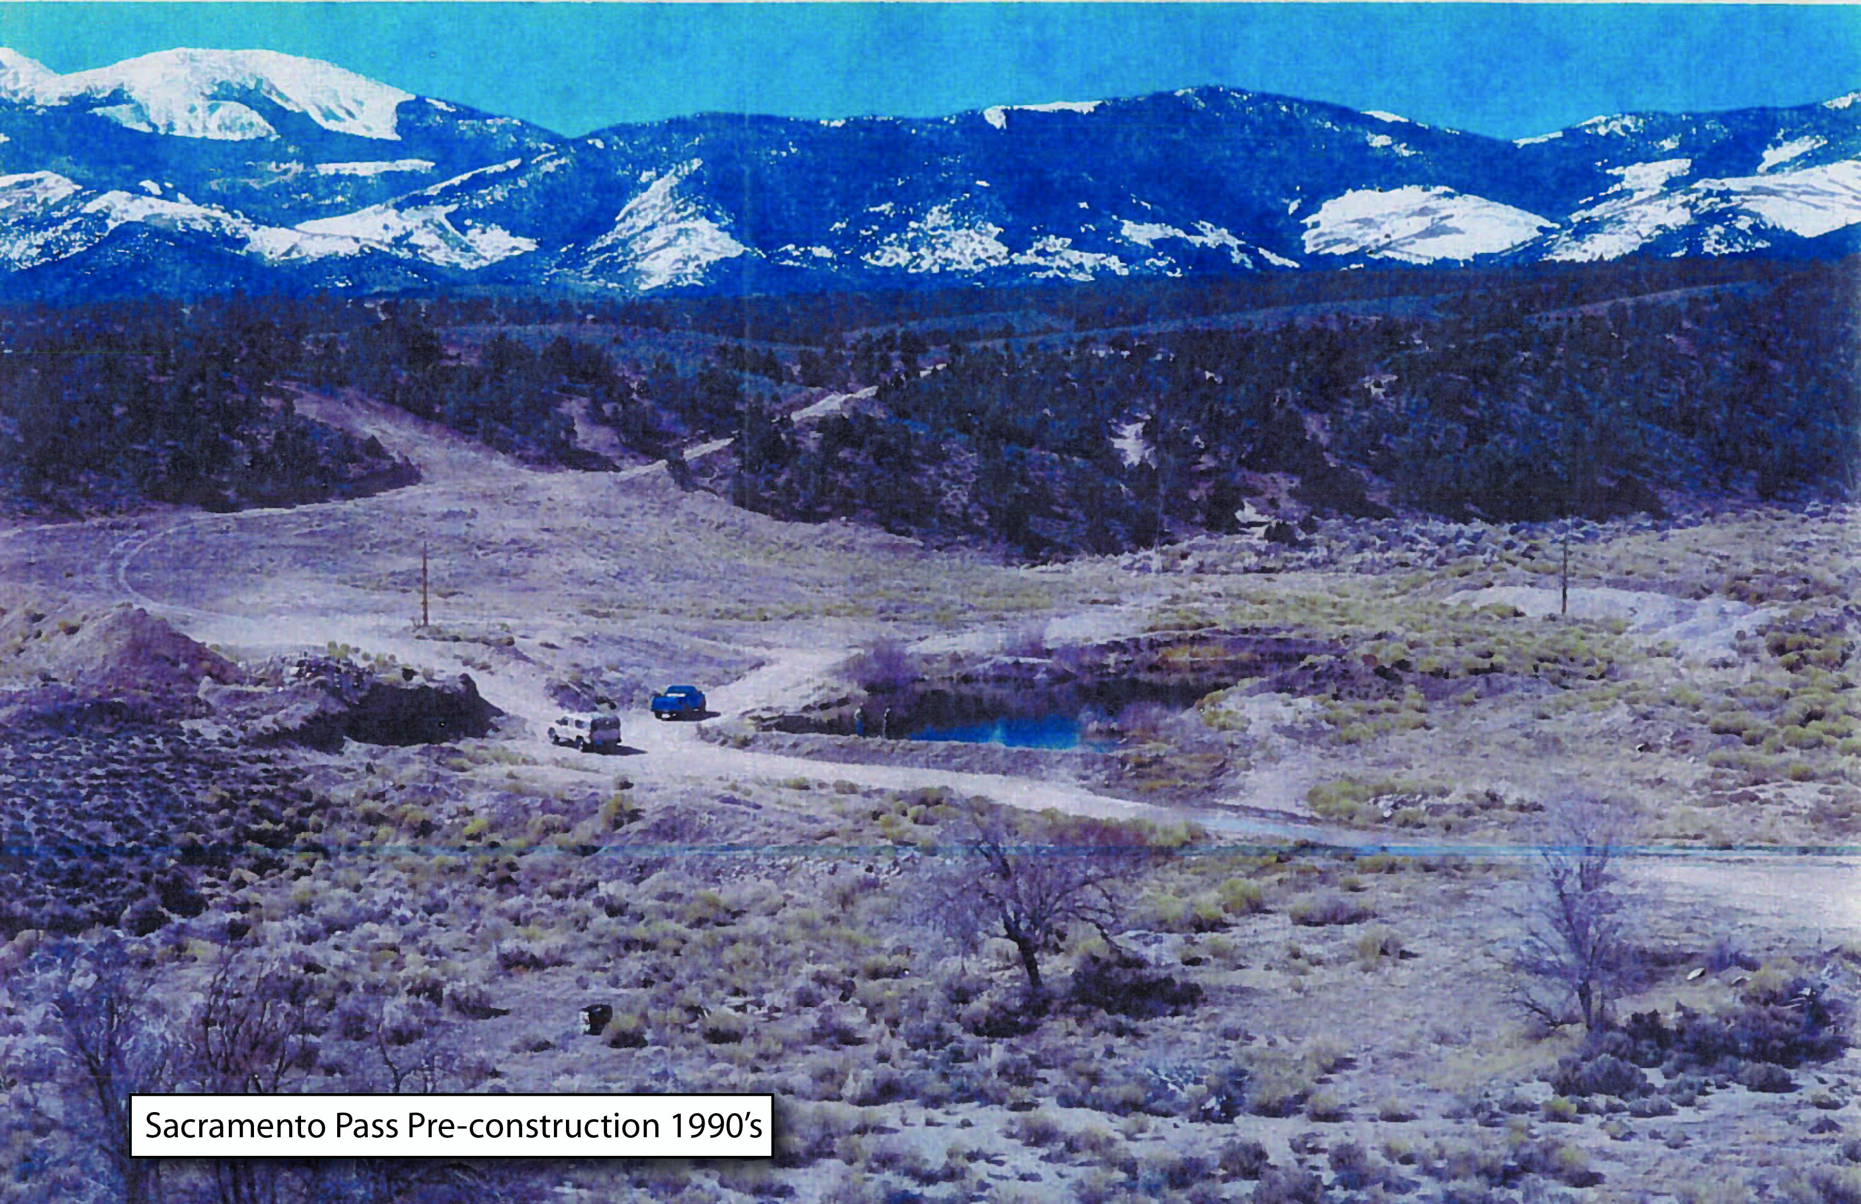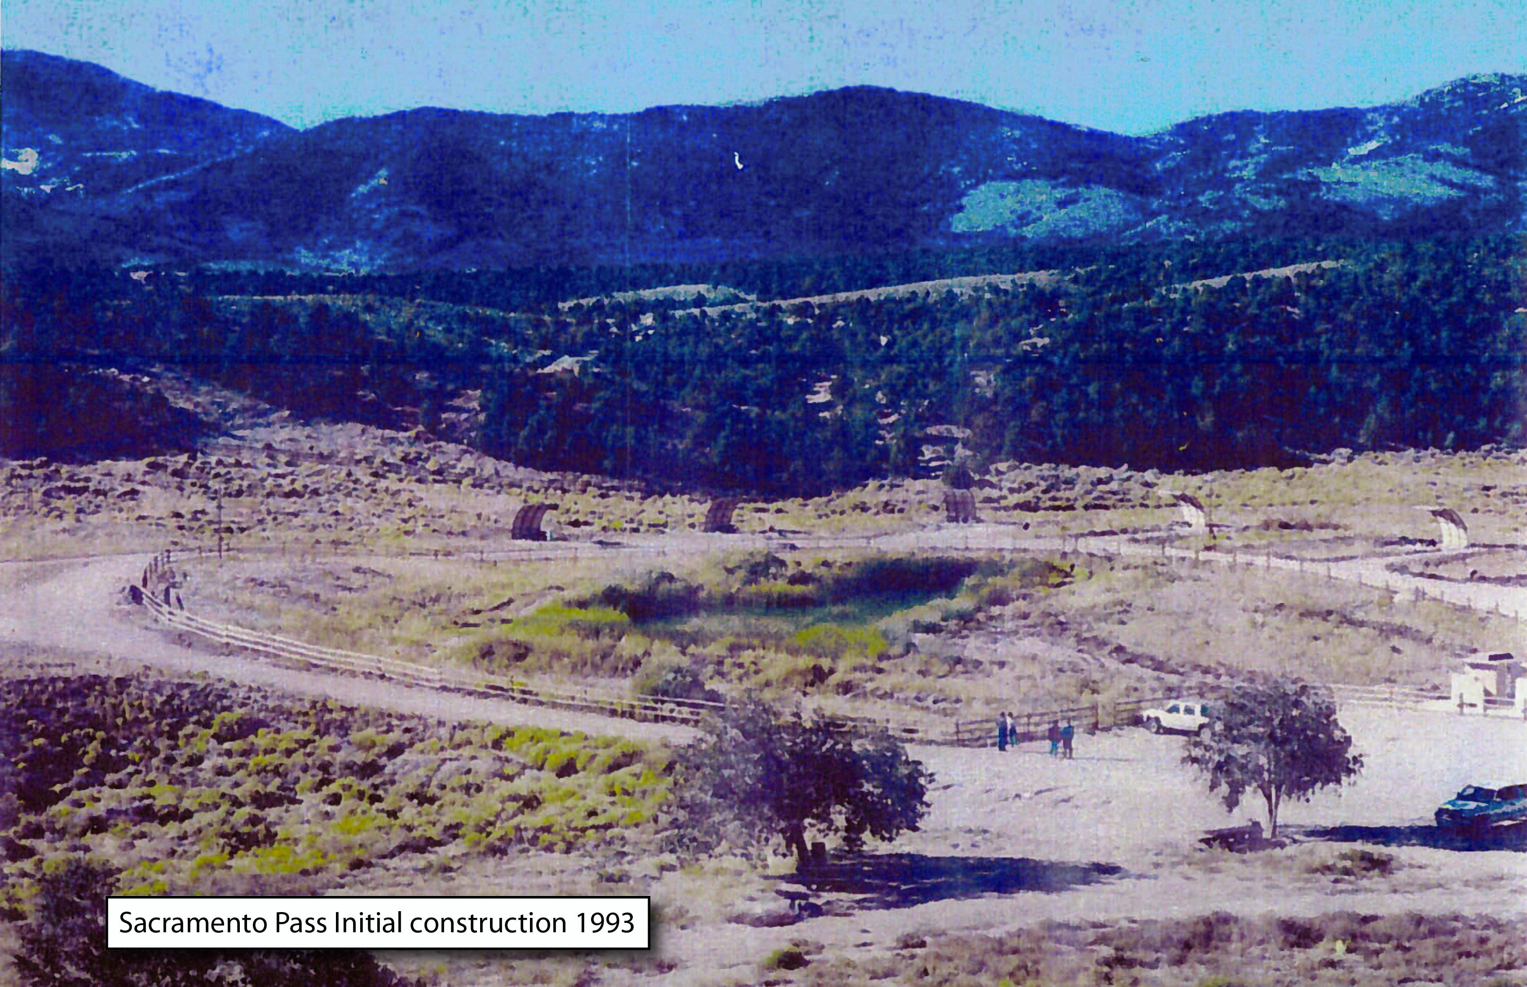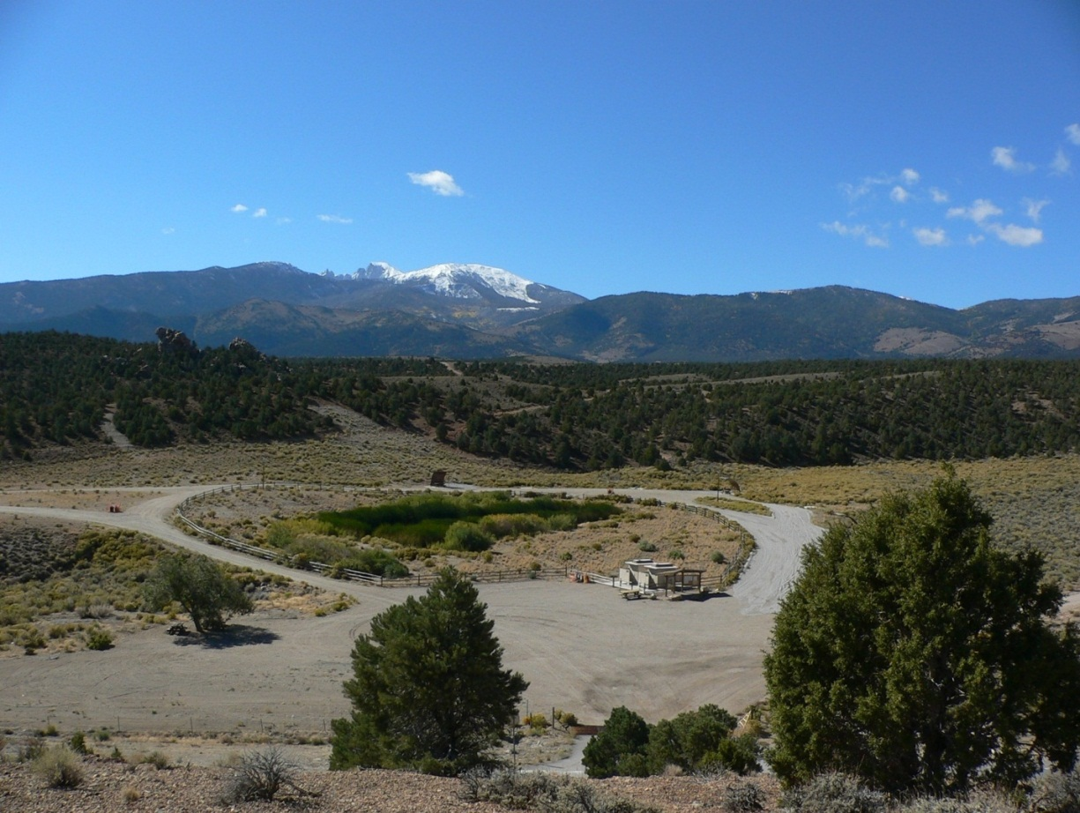

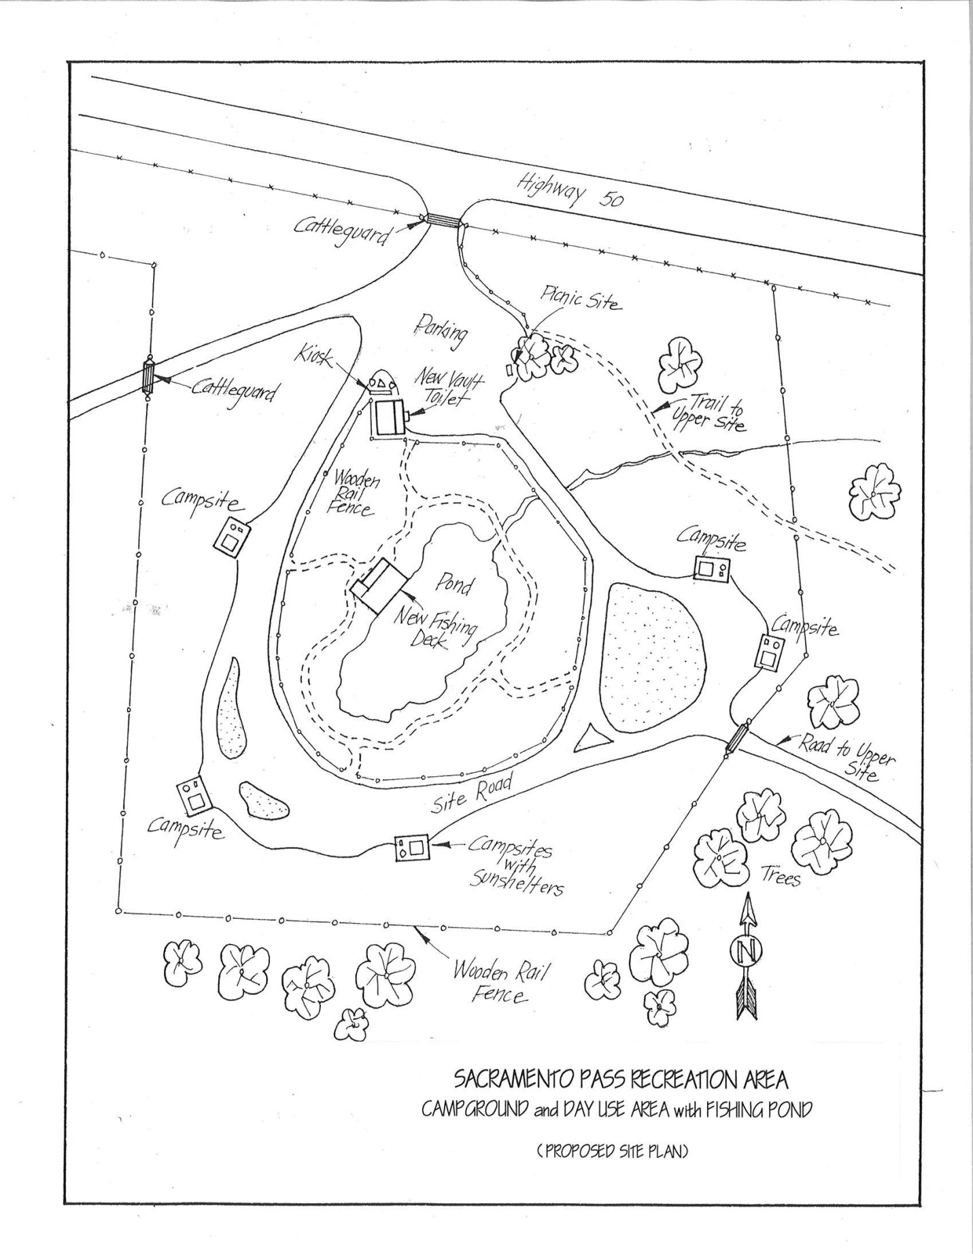

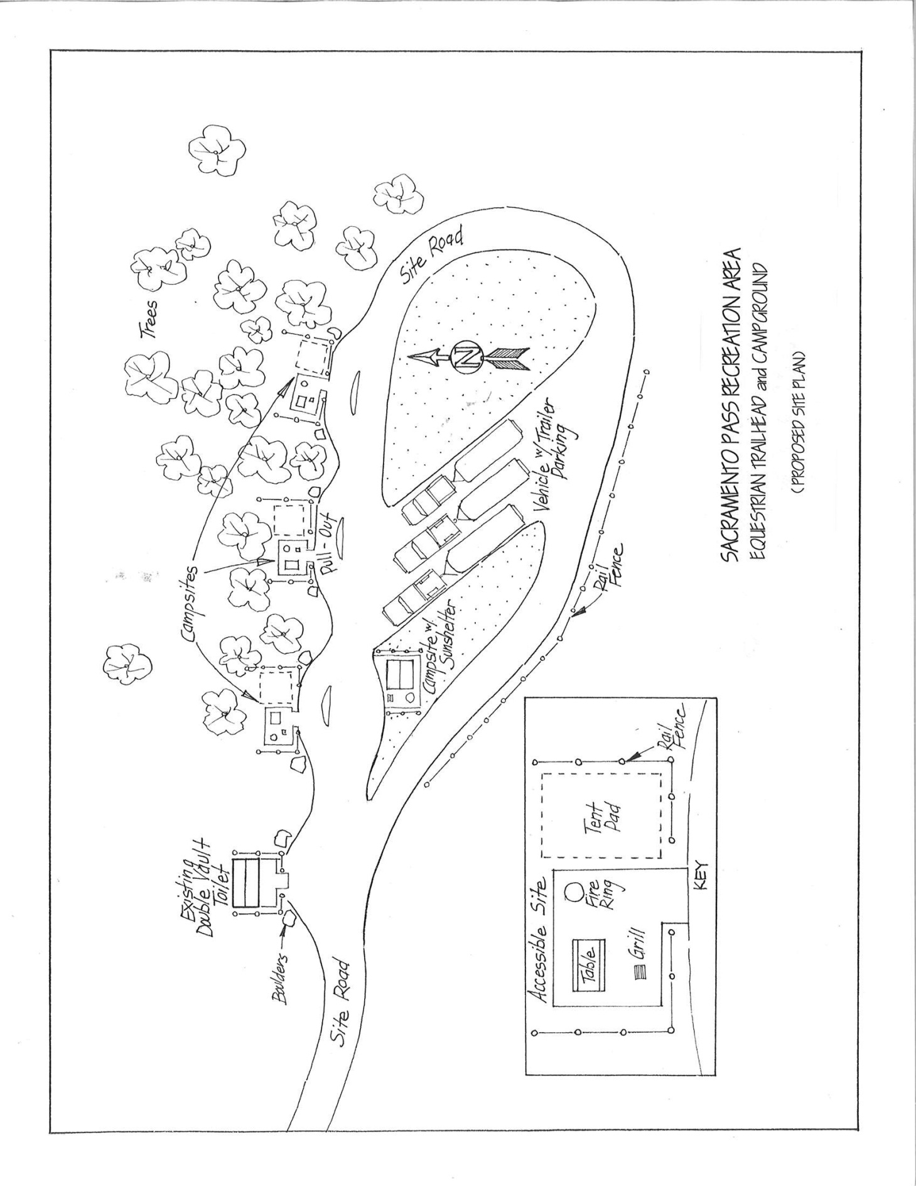

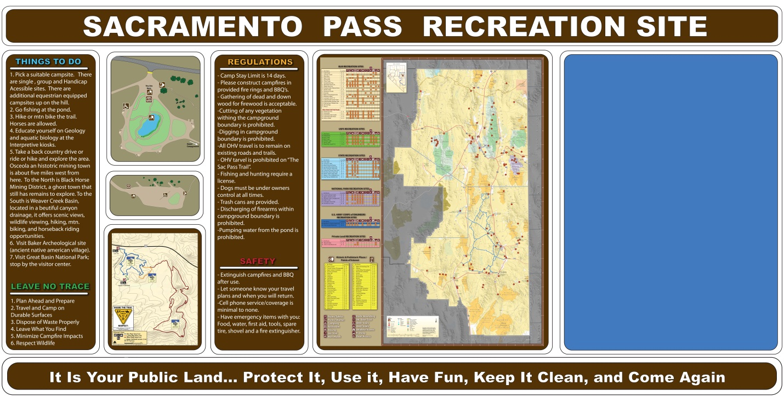“Working Draft” of lower campground interp signage (4ft x 8ft ) to be placed on new Kiosk.There will be a smaller (4ft x 4ft) kiosk/interp sign at the upper campground.

.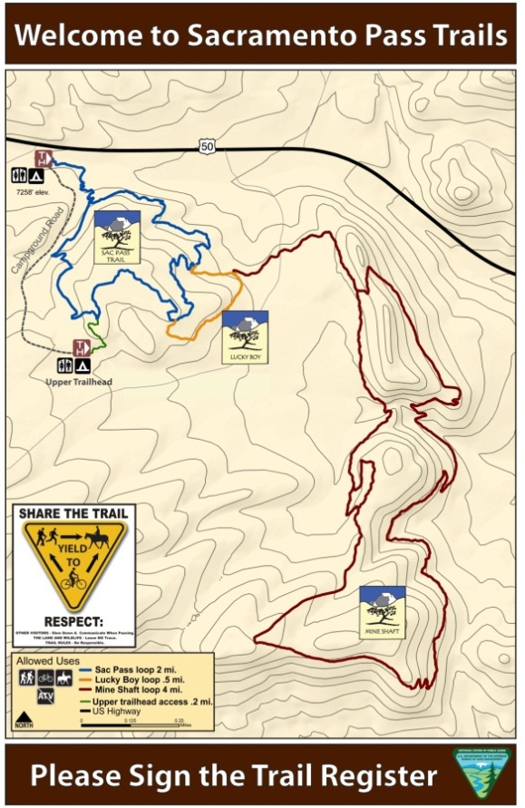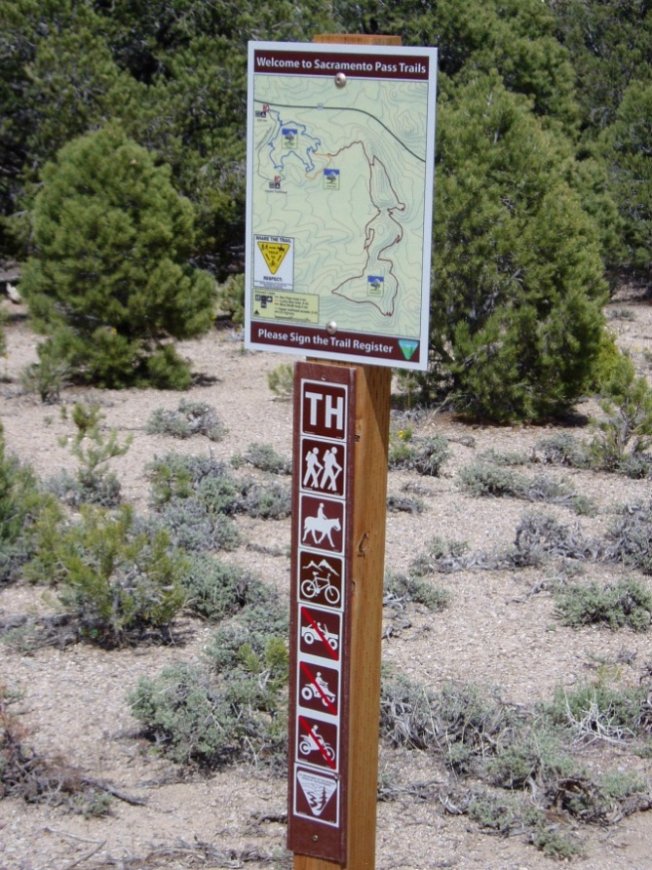
Actual signs in place at “Upper and Lower Trailheads”.

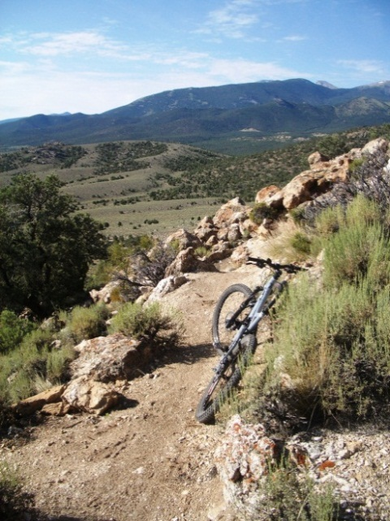 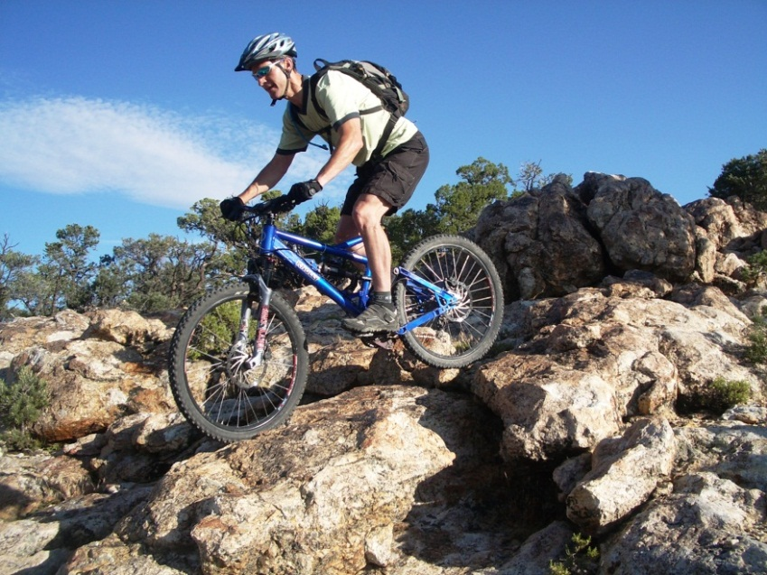Photos of mtn biker and view from “Sac Pass Trail”.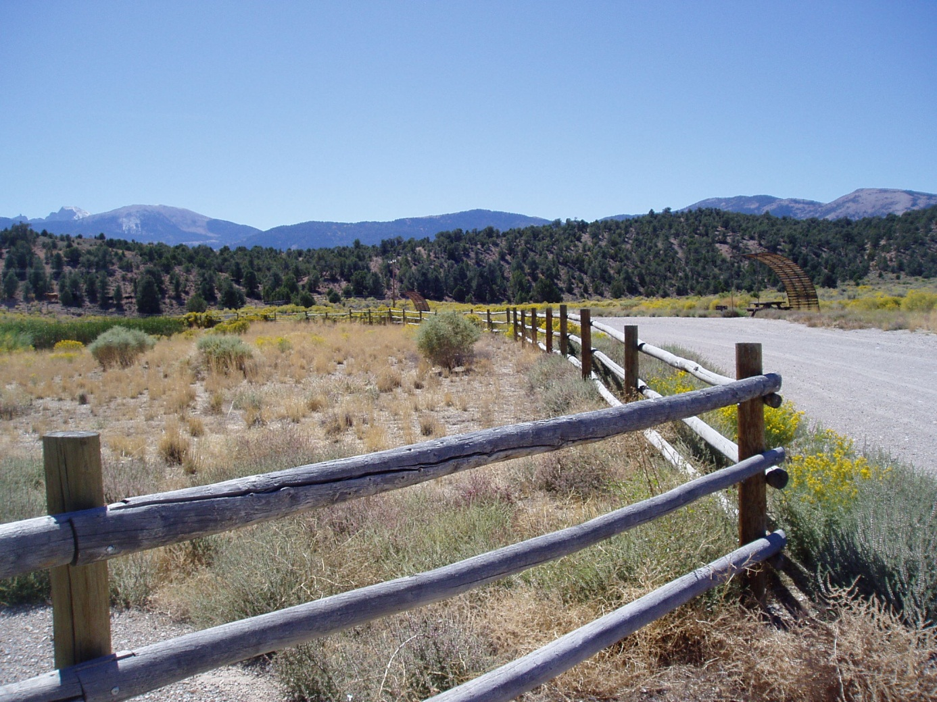
View of “Wheeler Peak” from lower camp ground loop, old shade structures will be replaced.

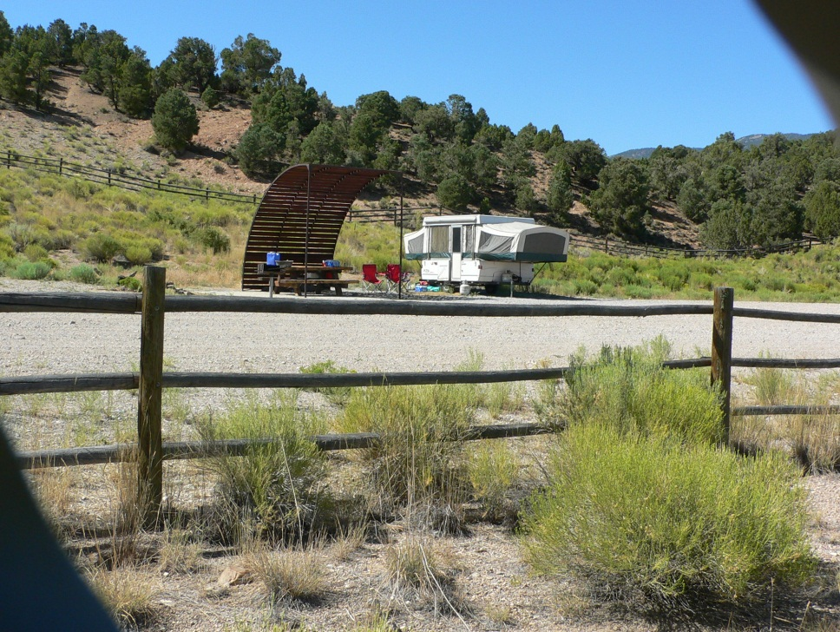
Typical use.
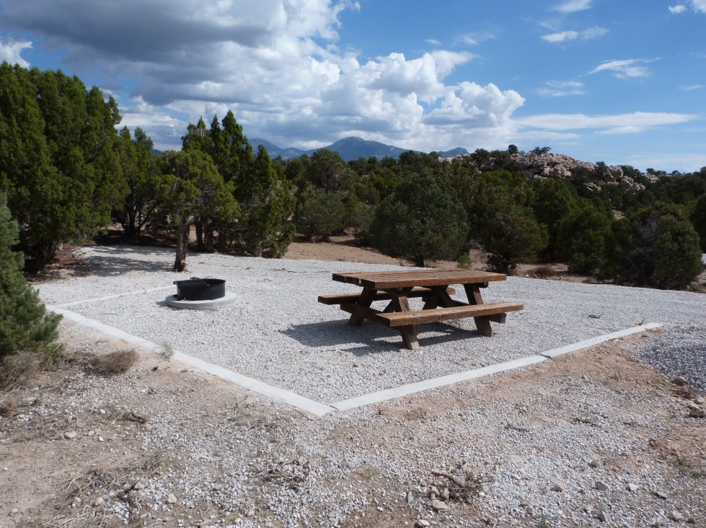
One of four new camp spots at “Upper Campground”.
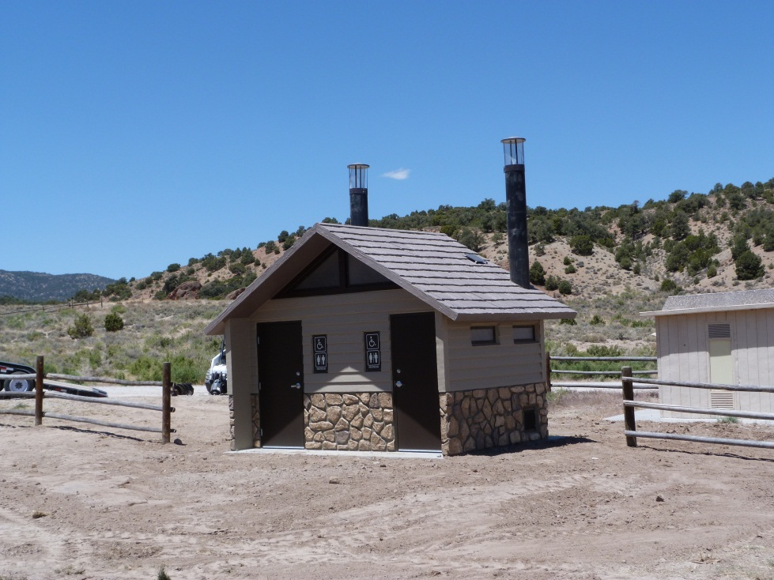
New double vault pit toilet at “lower campground”.
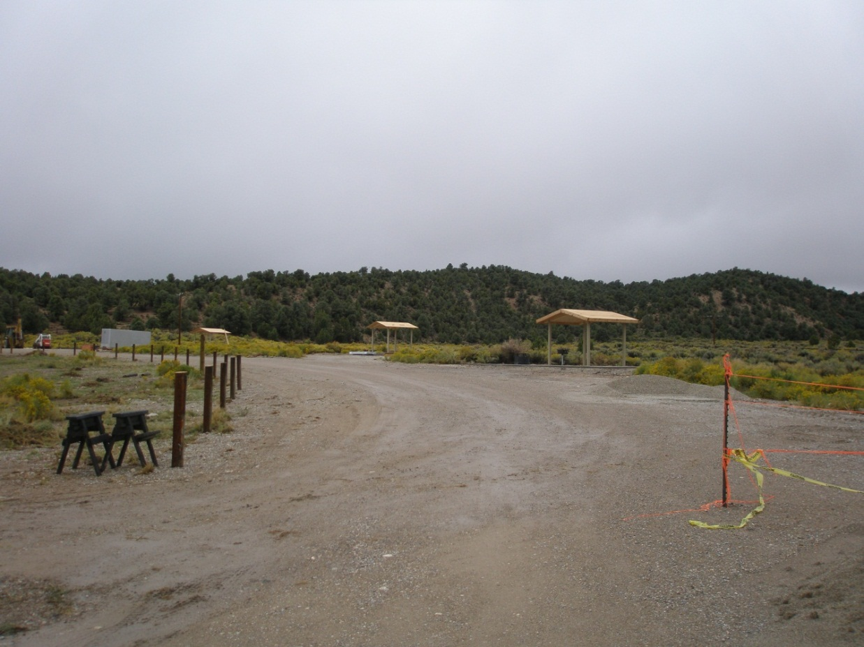 New Shade structures being installed on lower campground loop.
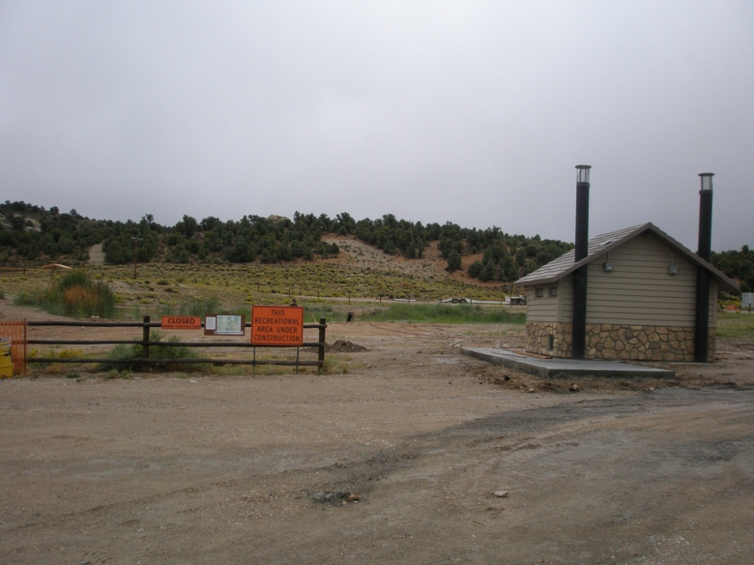 New concrete sidewalk poured around new double vault toilet at lower campground.
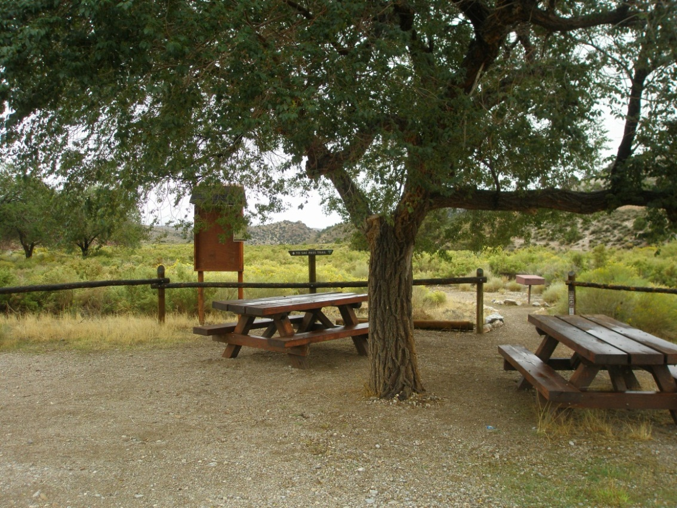
Picnic area at lower trailhead.
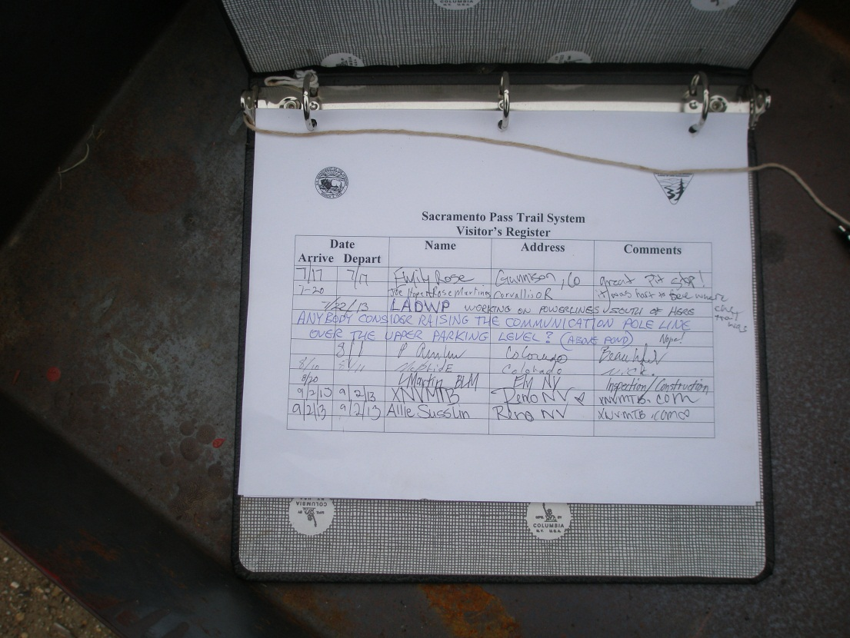 Register at lower trailhead.
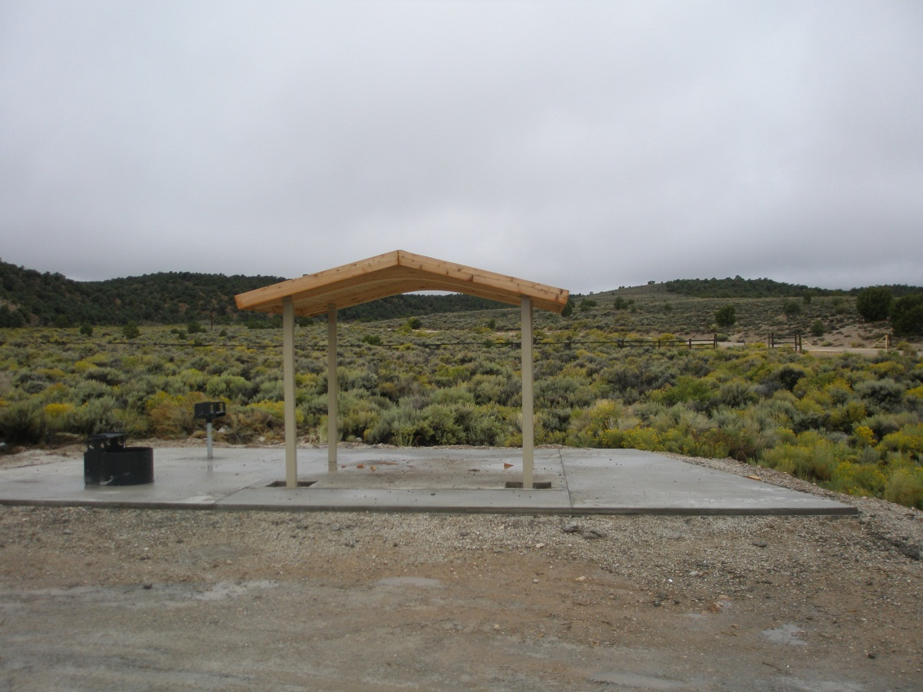
New shade structure and concrete at fully accessible site on lower campground loop.
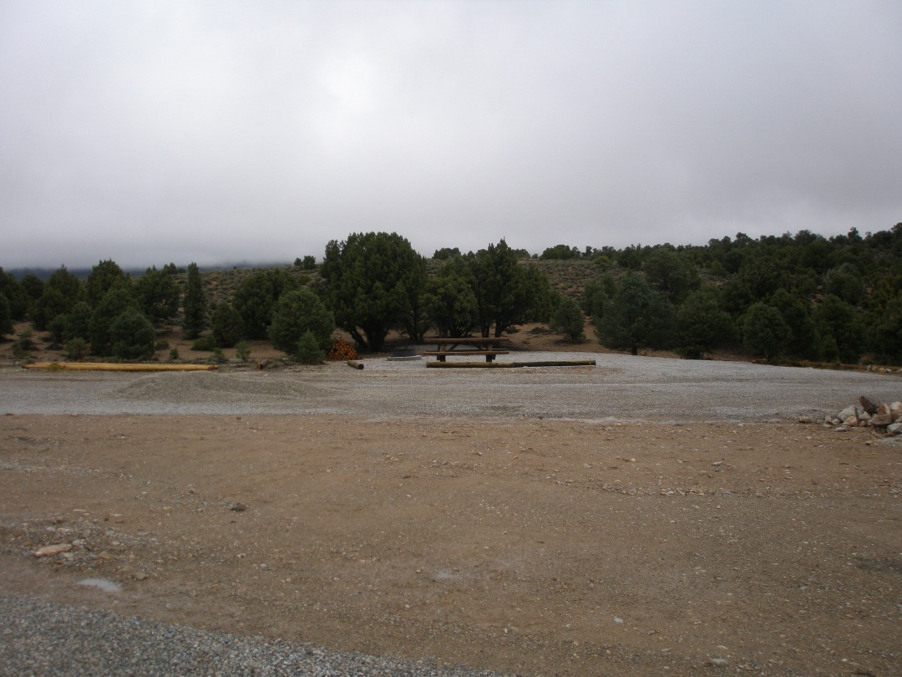 New site at upper campground loop.
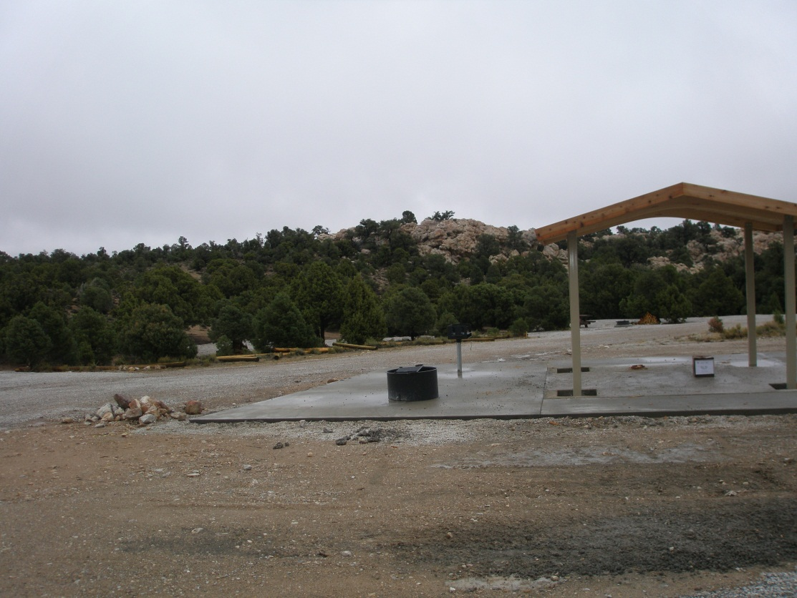
New shade structure and concrete at fully accessible site at upper campround.
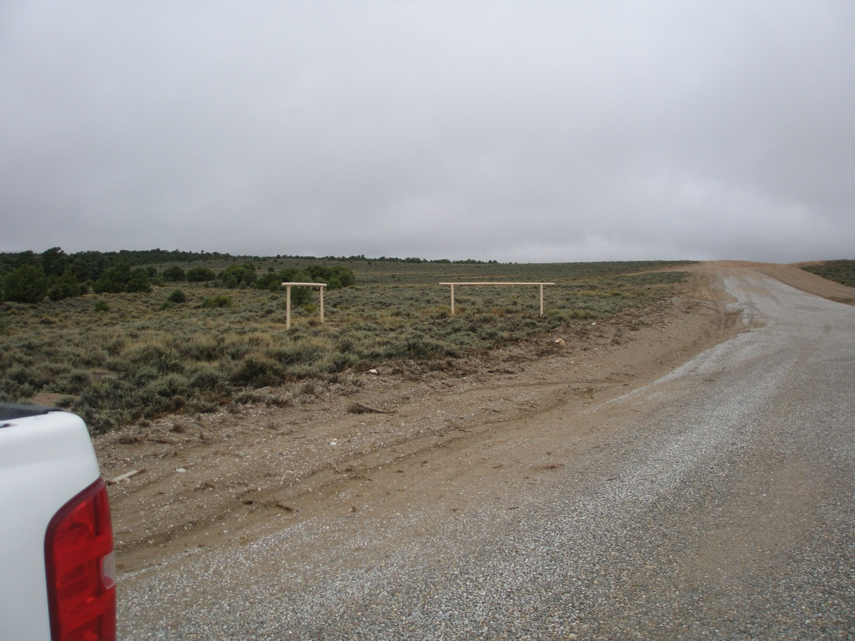 Rails for equestrian use.
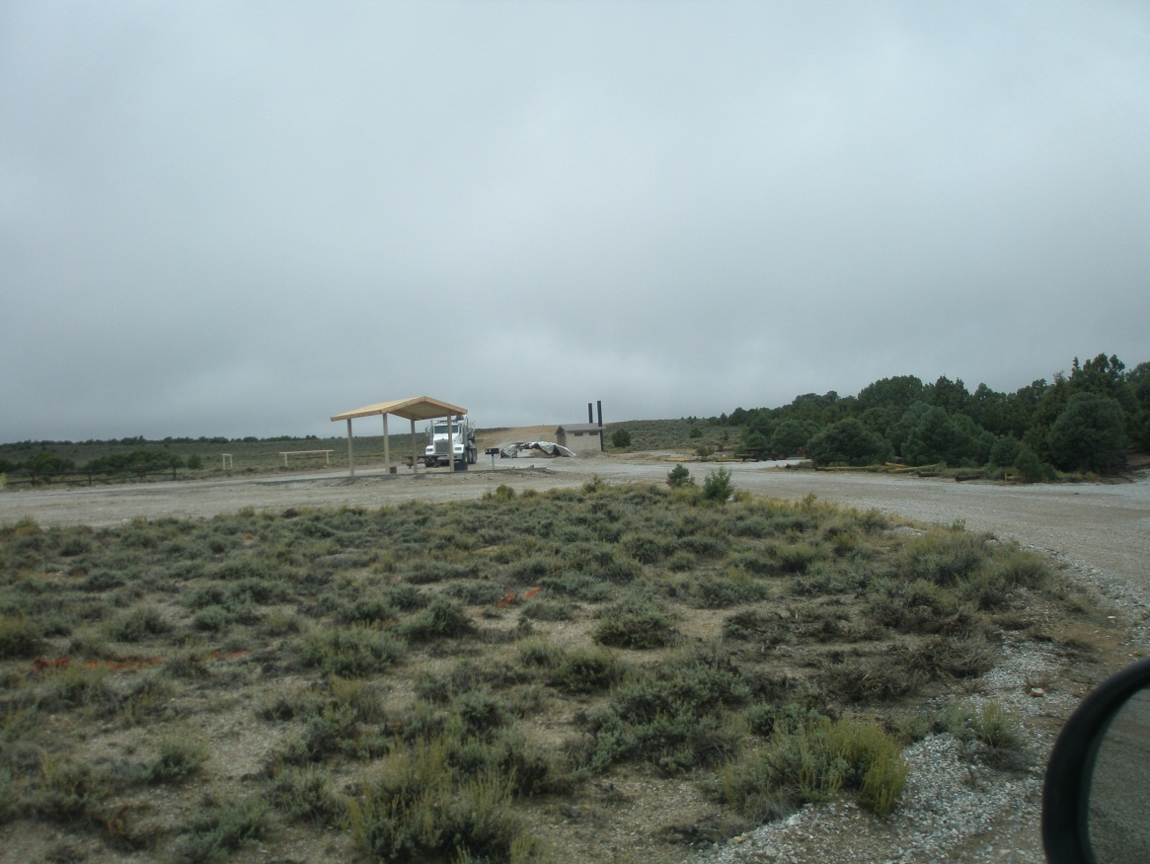 Upper campground.

