GAO

#### United States General Accounting Office

Report to the Ranking Minority Member, Committee on Resources, House of Representatives

**June 2000** BLM AND THE FOREST SERVICE

Land Exchanges Need to Reflect Appropriate Value and Serve the Public Interest

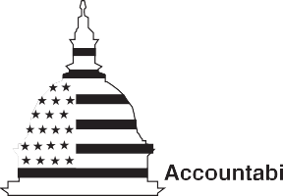

#### GAO/RCED-00-73

# Contents

|  |  |  |  |
| --- | --- | --- | --- |
|  |  |  |  |
| Letter |  |  | 3 |
| Appendixes | Appendix I: | Comments From the Forest Service | 40 |
|  | Appendix II: | Comments From the Bureau of Land Management | 55 |
|  | Appendix III: | Scope and Methodology | 83 |
|  | Appendix IV: | GAO Contacts and Staff Acknowledgements | 86 |

Tables Table 1: Number and Location of Selected Exchanges 84

|  |  |  |
| --- | --- | --- |
| Figures Figure 1: | Number of Land Exchanges by the Service, Fiscal Years |  |
|  | 1989 Through 1999 | 12 |
| Figure 2: | Acreage Exchanged by the Service, FiscalYears 1989 |  |
|  | Through 1999 | 13 |
| Figure 3: | Value of Land in the Service’s Exchanges, Fiscal Years |  |
|  | 1989 Through 1999 | 14 |
| Figure 4: | Number of Land Exchange Transactions by the Bureau, |  |
|  | Fiscal Years 1989 Through 1999 | 15 |
| Figure 5: | Acreage Exchanged by the Bureau, FiscalYears1989 |  |
|  | Through 1999 | 16 |

###### Abbreviations

FLEFA Federal Land Exchange Facilitation Act FLPMA Federal Land Policy and Management Act GAO General Accounting Office



**United States General Accounting Office Washington, D.C. 20548**

**Resources, Community, and Economic Development Division**

B-284579 June 22, 2000

The Honorable George Miller Ranking Minority Member Committee on Resources House of Representatives

Dear Mr. Miller:

Land exchanges—trading federal lands for lands that are owned by

corporations, individuals, or state or local governments who are willing to trade—have long been used by the Department of the Interior’s Bureau of Land Management (the Bureau) and the Department of Agriculture’s Forest Service (the Service) as a tool for acquiring nonfederal land and disposing of federal land. Federal and nonfederal land can be exchanged to protect wildlife habitat or aesthetic values, enhance recreational opportunities,

consolidate parcels of land owned by different parties, and promote development or community expansion. By law, for an exchange to occur, the estimated value of the nonfederal land must be within 25 percent of the estimated value of the federal land (the difference in value is paid in cash by the party with the lowest valued land), the public interest must be well served, and certain other exchange requirements must be me1t.

Recognizing the importance of land exchanges in supplementing the federal funds that were available for purchasing land, in 1988 the Congress passed legislation to facilitate and expedite land exchanges. In recent years, however, reports by the departments’ Inspectors General identified several exchanges completed by the Bureau and the Service in which lands were inappropriately valued and the public interest was not well

documented. In response, in 1998 each agency announced several initiatives designed to improve its land exchange program. Concerned about how well these initiatives are being implemented, you asked us to examine the agencies’ land exchange programs. As agreed, we determined

(1) the agencies’ use of land exchanges since 1989; (2) the extent to which the agencies ensure that their land exchanges meet exchange requirements; and (3) the effect of the agencies’ recent efforts to improve the management of their exchange programs. We also discuss the extent to

1 P.L. 94-579, Oct. 21, 1976.

which the problems we saw in specific exchanges are reflective of inherent difficulties in the land exchange program as a whole. In completing our work, we reviewed (1) data maintained by each agency on its land exchange program; (2) statutory and other requirements for land exchanges; and (3) 51 exchanges (25 for the Service and 26 for the Bureau)—selected to represent a variety of acreage amounts, land values, and locations—to assess how the requirements were being implemented.

Results in Brief The Service and the Bureau used land exchanges to acquire about 1,500

total square miles of land during fiscal years1989 through 1999. The

Service completed about 1,265 exchanges during this period, which were valued at over $1 billion. Through these exchanges, the Service acquired a net total of about 950 square miles and generally acquired land that had lower per-acre values than the land it conveyed. The Bureau does not centrally track the number of exchanges it completes or their total dollar value; instead, the agency tracks transactions—two or more of which can occur in each exchange. The Bureau completed about 2,600 transactions in fiscal years 1989 through 1999, which resulted in the Bureau’s acquiring a net total of about 550 square miles.

The agencies did not ensure that the land being exchanged was appropriately valued or that exchanges served the public interest or met certain other exchange requirements. We found numerous problems with the exchanges we examined. In particular:

* The agencies have given more than fair market value for nonfederal land they acquired and accepted less than fair market value for federal land they conveyed because the appraisals used to estimate the lands’ values did not always meet federal standards.
* The agencies did not follow their requirements that help show that the public benefits of acquiring the nonfederal land in an exchange matched or exceeded the public benefits of retaining the federal land, raising doubts about whether these exchanges served the public interest. Furthermore, the Bureau did not always follow its regulations in preparing exchange initiation agreements.
* The Bureau—under the umbrella of its land exchange authority—sold federal land, deposited the sales proceeds into interest-bearing escrow accounts, and used these funds to acquire nonfederal land (or arranged with others to do so). Current law does not authorize the Bureau to retain or use proceeds from selling federal land; it instead requires the Bureau to deposit sale proceeds into the Treasury and to use

appropriations to acquire nonfederal land. In using these funds and the interest earned on them to purchase land, the Bureau uagmented its appropriations. The Bureau also did not comply with its sale authority when it sold the land, and none of the funds retained in escrow accounts or used in this manner were tracked in the Bureau’s financial management system.

Both agencies recently increased their management oversight of exchanges by (1) creating review teams composed of headquarters and field staff to examine proposed exchanges that are valued at $500,000 or more and are considered to be controversial; (2) revising their policies and procedures that address exchanges; and (3) creating additional training for agency personnel involved in land exchanges. These efforts, if properly implemented, should improve how these programs are conducted.

However, they do not address all land exchanges—including those valued at less than $500,000, those not identified as being controversial, and those considered to be too close to completion to be stopped or altered. In addition, the Bureau’s review team has not addressed the unauthorized selling and buying of land under its exchange program or the financial management of these funds. Furthermore, handbook revisions and enhanced training can clarify the agencies’ land exchange policies and

procedures, but they do not ensure that those policies or procedures are appropriate or followed.

At least some of the agencies’ continuing problems may reflect inherent underlying difficulties associated with exchanging land compared with the more common buying and selling of land for cash. In land exchanges, a landowner must first find another landowner who is willing to trade, who owns a desirable parcel of land that can be valued at about the same amount as his/her parcel, and who wants to acquire the parcel being offered. More commonly, both landowners would simply sell the parcels they no longer want and use the cash to buy other parcels that they prefer. In this way, the value of both parcels is more easily established when they are sold in a competitive market, both parties have more flexibility in meeting their needs, and there is no requirement to equalize the values of the parcels. Difficulties in land exchanges are exacerbated when the properties are difficult to value—for example, because they have characteristics that make them unique or because the real-estate market is rapidly developing—as was the case in several exchanges we reviewed.

Both agencies want to retain land exchanges as a means to acquire land, but in most circumstances, cash-based transactions would be simpler and less costly.

In view of the many problems in both agencies’ land exchange programs and given the fundamental difficulties that underlie land exchanges when compared with cash-based transactions, we believe that the Congress may wish to consider directing the Service and the Bureau to discontinue their land exchange programs. Until such a fundamental action is taken and while the agencies continue to operate land exchange programs, we

recommend that both agencies review and approve all proposed exchanges to ensure that they meet key statutory and regulatory requirements for land exchanges; that is, that they are appropriately valued, serve the public interest well, and meet other exchange requirements. We also recommend that the Bureau immediately discontinue selling and buying land under its land exchange program—a practice that is not authorized under current law—and conduct an audit of financial records associated with these sales and purchases.

In their comments on a draft of this report, both agencies concurred with the recommendations that were addressed to them and have taken steps to respond to them. However, both agencies disagreed with our suggestion for congressional consideration, believing that land exchanges are an essential and irreplaceable tool for adjusting federal land ownership. We believe that the agencies’ program improvements cannot address the inherent difficulties associated with land-for-land exchanges and that the agencies’ desire to continue exchanges is more than offset by their programs’

continuing problems and exchanges’ fundamental inefficiencies. We continue to believe that the Congress should consider directing the

agencies to discontinue their land exchange programs because of the many problems identified and their inherent difficulties.

Background The Federal Land Policy and Management Act of 1976 (FLPMA) and its

amendments authorize both the Service and the Bureau to exchange

federal land for nonfederal land, when certain conditions are met2. Historically, both agencies preferred to buy land outright; however, in the 1980s, owing to limits on the amount of funds available to buy land, they increasingly relied on exchanges as an alternative means of acquiring land. Since 1981, the agencies have used exchanges to dispose of fragmented parcels of land and to consolidate land ownership patterns to promote more efficient management of land and resources3. Currently, the Bureau’s policy is that land exchanges should be used whenever feasible in land acquisitions.

Statutory Requirements for Land Exchanges

FLPMA is a comprehensive land-management law that has become the statutory basis for most exchanges for the Bureau and the Service; among other things, it established uniform procedures for these two agencies to exchange land with nonfederal parties4. The Federal Land Exchange Facilitation Act of 1988 (FLEFA) amended FLPMA to, among other things, facilitate and expedite land exchanges by providing more uniform rules pertaining to land appraisals and by establishing procedures for resolving appraisal disputes.5 In proceeding with a land exchange, the agencies must determine that the estimated values of the federal and nonfederal lands are equal or approximately equal, that the public interest is well served, and that certain other requirements are met.

2 P.L. 94-579, Oct. 21, 1976.

3 *Federal Land Acquisition: Land Exchange Process Working But Can Be Impro*d*ve*

(GAO/RCED-87-9, Feb. 5, 1987).

4 Other agencies, for example, the Army and its Corps of Engineers, have different statutory authority for exchanging land.

5 P.L. 100-409, Aug. 20, 1988.

##### Estimated Value of Lands Must Be Equal or Approximately Equal

The estimated values of the federal and nonfederal lands to be exchanged must be equal or, if the estimated values are not equal, then their estimated values are equalized by a monetary payment—referred to as a cash equalization payment—which cannot exceed 25 percent of the federal land’s estimated value and should be kept as small as possible6.When the federal land has a higher estimated value than the nonfederal land, the nonfederal party makes an equalization payment to the federal agency, which is to be deposited into the Treasury. When the nonfederal land has a higher estimated value than the federal land, the agency uses appropriated funds to make an equalization payment to the nonfederal party. Generally, the estimated values of lands proposed for exchange are established through appraisals, which must be done in accordance with federal appraisal standards and other requirements. If the parties to an exchange cannot agree to accept the results of the appraisal(s), they can instead determine the value of the properties by submitting the appraisal(s) to arbitration or by using a bargaining process. Under certain limited circumstances, the value of land to be exchanged can be estimated using an appraiser’s statement of value (a professional assessment that is based on more limited information than is included in a full appraisal), if the federal land value is not estimated to be more than $1500,00.7

If land to be exchanged is appraised, agency personnel may appraise the properties, or either party—the agency or the nonfederal landowner—may contract for the appraisal(s). In the latter instance, the Bureau or Service must review and approve the contract appraisal to ensure that it meets federal appraisal standards8. These standards require that land be appraised at its fair market value, which is defined as the amount for which a property would be sold—for cash or its equivalent—by a willing and knowledgeable seller who is not obligated to sell, to a willing and knowledgeable buyer who is not obligated to buy.

6 If all parties to the exchange agree, the cash equalization payment byiether the federal or nonfederal party may be waived if it is no more than 3 percent of the federal land’s value or

$15,000, whichever is less.

7 Several conditions must be met for this to occur. For example, the agency must determine that the lands to be exchanged are substanitally similar in value, location, acerage, use, and physical attributes.

8 *Uniform Appraisal Standards for Federal Land Acquisition*, *s*Interagency Land Acquisition Conference (1992).

##### Public Interest Must Be Well Served

In proceeding with an exchange, the cognizant agency must also determine that the public interest will be well served by the exchange. In making this determination, the law directs the agency to “. . . give full consideration to better Federal land management and the needs of the State and local people, including needs for lands for the economy, community expansion, recreation areas, food, fiber, minerals, and fish and wildlife . . . .9” Furthermore, in accordance with FLPMA, the agencies must determine that the public values and objectives to be served by acquiring the nonfederal lands are at least as great as the public values and objectives served by retaining the federal lands1.0 In other words, the agency has to show that

1. it gave full consideration to better federal land management practices and the needs of state and local people and (2) the benefits to the public from acquiring the nonfederal land will match or exceed the benefits from retaining the federal land. In addition to meeting FLPMA requirements, the Bureau and the Service must complete an environmental analysis under the National Environmental Policy Act for each exchange, in which the public interest is identified and analyzed1.1

Other Requirements Must Be Met In addition to the requirements regarding land values and public interest,

FLPMA has other specific requirements for land exchanges. For example, the lands to be exchanged must be in the same state; titles for exchanged lands are to be transferred simultaneously (unless all parties to the exchange agree otherwise); and land acquired within the boundaries of the national forest system, national park system, or any other land system or area established by the Congress is immediately reserved for and becomes a part of that system. For example, the Bureau recently exchanged 4,322 acres of land it managed for 632 acres of nonfederal land located in the Saguaro National Park in Arizona. Because the nonfederal acres acquired in the exchange are within the park’s boundaries, they are a part of the park and managed by the National Park Service.

9 43 U.S.C. 1716(a).

10 43 U.S.C. 1716(a).

11 P.L. 91-190, Jan. 1, 1970.

### Statutory Requirements for Sales of Federal Land

FLPMA also has a separate provision authorizing the Bureau to sell land if the Bureau determines that (1) the land is difficult and uneconomic to manage and it is not suitable for management by another federal agency,

1. it is no longer required for a specific purpose or for any other federal purpose, or (3) its transfer to nonfederal ownership will serve important public objectives that cannot be achieved prudently on land other than public land and that outweigh other public objectives that would be served by maintaining the land in federal ownership12. These requirements are more rigorous than the requirements for land exchanges. If the Bureau decides to sell such land, it must obtain at least fair market value, and the land must be offered for sale under competitive bidding procedures unless specific equity or public policy considerations would support other

procedures (e.g., the Bureau could decide to give preference to current users or adjoining landowners). Proceeds from the sale and disposal of public lands in the western states must be deposited into the reclamation fund of the Treasury, except for a 5-percent set-aside for educational and other purposes.13 In Nevada, the Bureau has the authority to sell certain land and use up to 85 percent of the proceeds to acquire environmentally sensitive lands in southern Nevada1.4

FLPMA does not authorize the Service to sell national forest lands.

### Overview of Agencies’ Processes for Land Exchanges

Land exchanges can be initiated either by the agency, by one or more nonfederal parties who are interested in trading their land for federal land (often referred to as the exchange proponent), or by a third-party facilitator (a nonfederal party such as a for-profit corporation or a not-for-profit entity) who works with the agency and the proponent(s) to put together an exchange. Third-party facilitators can play important roles in both agencies’ land exchanges—for example, they can purchase desirable nonfederal properties when they come on the market and hold them until the agency can complete all the requirements to convey federal land and

consummate a land exchange. In an exchange, agencies can acquire full title to nonfederal land or can acquire a partial interest, such as a

12 43 U.S.C. 1713.

13 43 U.S.C. 391. The western states are Arizona, California, Colorado, Idaho, Kansas, Montana, Nebraska, Nevada, New Mexico, North Dakota, Oklahoma, Oregon, South Dakota, Utah, Washington, and Wyoming.

14 Southern Nevada Public Land Management Act of 1998, P.L. 105-263, Oct. 19, 1998.

conservation easement that allows the nonfederal land to remain in nonfederal ownership but prevents it from being developed. Similarly, the nonfederal party in an exchange may acquire full title or only a partial interest in the federal land that is conveyed.

Agencies can only consider federal land for an exchange if the exchange

conforms to the agency’s land use plan. In processing a proposed exchange, the agencies must comply with various land-management requirements— for example, the agency and the proponent must execute an agreement to initiate an exchange, which must include, for example, a description of the lands to be exchanged. After the parties to an exchange sign an initiation agreement, the agency must conduct an environmental analysis, which in turn analyzes the combined effects of actions in sufficient detail to be useful to the decisionmaker (the agency official who decides whether the exchange should go forward). The agency must publish the results of its environmental analysis and solicit public comment; it must also publish public notices about the proposed exchange and meet various requirements related to transferring land titles.

The agencies’ land-exchange regulations also provide for “assembled” land exchanges, in which multiple parcels of federal or nonfederal lands are

consolidated into a package for the purpose of completing one or more exchange transactions over a period of time. The agencies may or may not use third-party facilitators in assembled exchanges to help identify and hold nonfederal parcels.

Agencies Used Land Exchanges to Acquire Land

Both the Service and the Bureau conducted many land exchanges during fiscal years 1989 through 1999. The Service completed about 1,265 exchanges (valued at about $1.066 billion) during this period, acquired a net total of about 611,000 acres (over 950 square miles of land), and generally acquired land that was of lower value than the land it conveyed. The Bureau completed about 2,600 transactions—there are two or more transactions in each exchange—during this period to acquire a net total of about 352,000 acres (about 550 square miles of land). Currently, the Bureau does not centrally track the number of exchanges it completes or their dollar value.

### Land Exchanges Completed by the Service

The Service completed about 1,265 exchanges during this period, an average of about 115 each year. The number of exchanges completed each year has fluctuated—ranging from a high of 162 exchanges in 1990 to a low

of 83 exchanges in 1999—and dropped somewhat in the last 4 years, as shown in figure 1.

**Figure 1: Number of Land Exchanges by the Service, Fiscal Years 1989 Through 1999**

**Exchanges**

200

150

100

50

0

1989

**Year**

1991 1993 1995 1997 1999

The Service acquired a net total of 611,000 acres in exchanges during this period, obtaining a total of 1,359,000 acres and conveying a total of about 748,000 acres. On average in an exchange, the Service acquired about 1,075 acres of nonfederal land and conveyed about 590 acres of federal land. The acreage acquired each year has fluctuated (ranging from a high of 316,000 acres in 1999 to a low of 64,000 acres in 1992), and theacreage conveyed each year has also fluctuated (ranging from a high of 134,000 acres i1n997 to a low of 28,000 acres in 1998)—as shown in figure 2.

**Figure 2: Acreage Exchanged by the Service, Fiscal Years 1989 Through 1999**

**Acres in thousands**

350

300

250

200

150

100

50

0

1989 1991 1993 1995 1997 1999

**Year**

Conveyed Acquired

In total, the Service exchanged land that was valued at about $1.066 billion during this period. On average in an exchange, the Service acquired nonfederal land that was valued at about $780 per acre and conveyed federal land that was valued at about $1,415 per acre. The total value of lands exchanged each year has fluctuated—ranging from a high of $224 million in 1997 to a low of $26 million in 1992—as shown in figure 3.

**Figure 3: Value of Land in the Service’s Exchanges, FiscalYears 1989 Through 1999**

**Dollars in millions**

$250

$200

$150

$100

$50

$0

1989 1991 1993 1995 1997 1999

**Year**

### Land Exchange Transactions Completed by the Bureau

The Bureau does not track the number of exchanges it completes annually; instead it tracks the number of exchange transactions completed annually. The Bureau considers each land exchange to have at least two transactions—for example, the acquisition of land and the conveyance of land. An exchange can have more transactions if the exchange involves more than two parties or more than two parcels of land. For example, if the Bureau exchanged three small parcels of federal land for one nonfederal parcel of equal value, there would be four transactions—three federal and one nonfederal—in the exchange. The Bureau completed about 2,600 transactions during fiscal years 1989 through 1999: about 1,700 transactions conveying federal land and about 900 transactions acquiring nonfederal land. The agency completed an average of about 238 transactions annually, ranging from a high of 372 transactions in 1997 to a low of 172 transactions in 1992, as shown in figure 4.

**Figure 4: Number of Land Exchange Transactions by the Bureau, Fiscal Years 1989 Through 1999**

**Transactions**

300

250

200

150

100

50

0

1989 1991 1993 1995 1997 1999

**Year**

Transactions conveying land Transactions acquiring land

The Bureau acquired a net total of about 352,000 acres in exchanges during this period; specifically, it acquired a total of 1,571,000 acres and conveyed a total of 1,219,000 acres. On average in a transaction, the Bureau acquired about 1,750 acres of nonfederal land and conveyed about 710 acres of federal land (during fiscal years 1989 through 1999). The acerage acquired each year has fluctuated (ranging from a high of 285,000 acres in 1991 to a low of 63,000 acres in 1998), and the acreage conveyed each year has also fluctuated (ranging from a high of 157,000 acres in 1999 to a low of 52,000 acres in 1990)—as shown in figure 5.

**Figure 5: Acreage Exchanged by the Bureau, Fiscal Years 1989 Through 1999**

**Acres in thousands**

300

250

200

150

100

50

0

1989 1991 1993 1995 1997 1999

**Year**

Acres conveyed Acres acquired

The Bureau does not centrally track the value of its exchanges. Therefore, neither the Bureau nor we could readily quantify the value of its exchanges.

## Agencies Have Not Met Key Statutory Requirements

In transacting exchanges, the agencies have not always ensured that the land being exchanged is appropriately valued or that the exchange is serving the public interest. Additionally, in some instances we found that the Bureau, under the umbrella of its land exchange authority, was selling federal land for cash and using the sales proceeds to buy nonfederal land. Under this practice, the Bureau avoided depositing sale proceeds into the Treasury, circumvented congressional approval and appropriations for buying land, augmented its appropriations, and may have exceeded its budget authority.

### Agencies Have Not Appropriately Valued Land

The agencies have not always appropriately valued land in exchanges. The agencies have sometimes given more than the estimated fair market value for nonfederal land they acquired and have (or would have) accepted less than the estimated fair market value for federal land they conveyed, as the following examples show:

* + The DeMar exchange in Utah, completed in 1999 by the Bureau, was to exchange federal land outside an area included in a habitat conservation plan—established to protect the desert tortoise, a threatened species— for private land held within this area1.5 The private landowners hired an appraiser to conduct a preliminary value assessment of the nonfederal property, which estimated its value to be $7,000 per acre. However, the Bureau contracted with another appraiser to conduct a full appraisal, which estimated the property’s value to be only $1,000 per acre. The two estimates differed primarily because the landowner’s appraiser assumed that the presence of the tortoise would not hinder development, whereas the Bureau’s appraiser assumed that development would be markedly restricted. The Bureau offered an exchange based on $1,000 per acre for the nonfederal property. The landowners refused the offer because they believed that their land was worth more, owing to its proximity to the growing community of St. George, Utah. The Bureau then entered into a bargaining process with the landowner, as allowed by FLEFA, to negotiate a final exchange value for the nonfederal land. Through this process, 239 nonfederal acres were valued at $7,440 per acre—an amount that exceeded both the landowners’ preliminary value assessment and the Bureau’s appraisal. A Bureau official explained that agency officials decided to bargain with the landowners because the officials believed that (1) the nonfederal acreage was worth more than the $1,000 per acre appraised value because it could be developed and

(2) the landowner would not otherwise reach agreement about the land’s value. The Bureau’s chief appraiser believed that the bargained amount exceeded a value that could be reasonably supported. We also question the basis for the final value.

* + Three exchanges in Nevada—Cashman, Deer Creek, and Red Rock II— were reported on in 1998 by Agriculture’s Office of the Inspector General.16 The Inspector General found that the Service acquired nonfederal lands in these exchanges that were overvalued by a total of

$8.8 million ($2.5 million, $5.9 million, and $0.4 million, respectively). The Inspector General attributed these overvaluations to the Service’s reliance on appraised values that were not supported by credible evidence and appraisals that did not meet federal appraisal standards. The Service generally concurred with the Inspector General and is

15 The habitat conservation plan recommends that the Bureau acquire nonfederal lands

within the area through exchanges or purchases.

16 *Humboldt-Toiyabe National Forest Land Adjustment Program*, U.S. Department of Agriculture, Office of the Inspector General(08003-02-SF,August 1998).

currently drafting new policies and procedures to address this valuation issue.

* + The Zephyr Cove exchange, located at Lake Tahoe, Nevada, was completed by the Bureau in 1997. In the exchange, the Bureau acquired 47 acres of nonfederal land valued at almost $38 million. Because the acquired land is located in the Service’s Lake Tahoe Basin Management Unit, the Service is managing the land that the Bureau acquired. Agriculture’s Office of the Inspector General reported that the appraisal of the nonfederal land did not consider a reservation of interest in the property’s improvements, which rendered the appraisal void, according to the Service’s chief appraiser. As a result, the appraisal apparently did not meet federal appraisal standards and overvalued the land by as much as $10 million1.7
  + The Red Rock exchange in Nevada was completed by the Bureau in 1995. Interior’s Office of the Inspector General reported that the Bureau did not use the approved nonfederal land value established by a Bureau chief appraiser from his review of the appraisal because the exchange proponent was “unhappy” with the appraised value1.8 Instead, the Bureau assigned a staff appraiser to review the same appraisal, and this

appraiser approved a land value that was about $1.2 million higher than the value approved by the chief appraiser. Because the value established by the chief appraiser was overridden by a staff appraiser, the Inspector General questioned the use of the higher value for the nonfederal land. In its response to the Inspector General, the Bureau stated that there were differences in approaches by the two reviewers. However,

according to the Inspector General, the Bureau did not reconcile the differences but instead decided to use the higher value.

17 *Title to Physical Improvements on the Zephyr Cove Land Exchang*,*e*U.S. Department of Agriculture, Office of the Inspector General(08003-4-SF,August 1998).

18 *Nevada Land Exchange Activities*, U.S. Department of the Interior, Office of the Inspector General (96-I-1025, July 1996).

* + The initial phase of the Del Webb exchange in Nevada was completed by the Bureau in 19971.9 Interior’s Office of the Inspector General reported that the Bureau allowed an exchange proponent to use its own appraiser to value the estimated 4,776 acres of federal land at $43 million (about

$9,000 per acre).20 The chief appraiser in the Bureau’s Nevada State Office reviewed the proponent’s appraisal and found it did not comply with federal appraisal standards because it used an inappropriate methodology. The Bureau’s headquarters’ staff removed this appraiser from the appraisal review process and then violated the Bureau’s policy by hiring a nonfederal appraiser—one who was recommended by the proponent—to review the appraisal. The nonfederal review appraiser approved the appraisal, and the Bureau’s chief appraiser subsequently accepted it without addressing the concerns raised in the earlier review. After the Inspector General announced that it was going to review the Del Webb exchange, the Bureau contracted for a second appraisal of the federal land. Bureau officials said that they had already contemplated preparing a second appraisal. The second appraisal used an appropriate methodology, met federal appraisal standards, and valued the actual 4,756 acres of federal land at $52.1 million (about $10,950 per acre). Had the Inspector General not intervened and the first appraisal been used in the exchange, the federal land would have been undervalued by more than $9 million.

* + As part of a review of the Bureau’s land exchanges in Nevada, Interior’s Office of the Inspector General reviewed land documents at the offices of the Assessor and the Recorder for Clark County. The Inspector General reported that the nonfederal party in one unidentified exchange acquired 70 acres of federal land at a value of $763,000 and sold the parcel the same day for $4.6 million2.1 The same proponent acquired another 40 acres from the Bureau at a value of $504,000 and also sold this land on the same day for $1 million. Suchlarge and quick profits raise questions about the adequacy of the exchange valuation.

19 The exchange began in 1995 and is to be completed in multiple phases over a period of 3 to

7 years.

20 *The Del Webb Land Exchange in Nevada*, U.S. Department of the Interior, Office of the Inspector General (98-I-363, March 1998).

21 *Nevada Land Exchange Activities*, U.S. Department of the Interior, Office of the Inspector General (96-I-1025, July 1996).

### Exchanges May Not Always Serve the Public Interest

The agencies have not always shown that the benefits of acquiring the nonfederal land matched or exceeded the benefits of retaining the federal land, as shown in the following examples:

* The Cache Creek Management Area land exchange in California was started about 10 years ago and is still ongoing. The purpose of the exchange is to acquire nonfederal lands that lie within an area of roughly 100 square miles that the Bureau has identified as having high- value resources, such as habitat for bald eagles. Through December 1999, the Bureau had completed about 40 exchange transactions in which it conveyed about 20,300 acres of federal land and acquired about 4,800 acres of private land. When the Bureau initiated the exchange, it did not specifically describe the parcels of land that would be exchanged. Furthermore, the Bureau’s environmental analysis for this exchange did not present the reasons for acquiring the specific parcels of nonfederal land or the public benefits of the exchange. Consequently, the Bureau has not demonstrated that the public benefits of acuqiring the nonfederal land matched or exceeded the public benefits of retaining the federal land.
* In the Red Rock exchange in Nevada, the Bureau exchanged 769 acres of federal land for 3,562 acres of nonfederal land. Interior’s Office of the Inspector General reported that the Bureau did not demonstrate why 2,461 acres of the nonfederal land (over two-thirds of the nonfederal parcel)—valued at $2.7 million—were needed2.2 Although the Bureau then demonstrated to the Inspector General that the nonfederal land was needed to provide habitat for endangered fish, the Inspector General estimated that this need supported the acquisition of fewer than 25 percent of the 2,461 acres in question. In addition, federal land is located near the nonfederal land that was acquired in this exchange, and the Bureau had already identified this federal land as being available for disposal.

22 *Nevada Land Exchange Activities*, U.S. Department of the Interior, Office of the Inspector General (96-I-1025, July 1996).

* + The Ricks College exchange in Idaho was completed by the Service in 1999. The Service acquired nonfederal land that it considered to be environmentally sensitive because it is surrounded by habitat for grizzly bears and contains significant wetlands. In exchange, the Service

conveyed to Ricks College federal land on which several private recreational residences had been built2.3 The Service wanted to dispose of the federal land because it was difficult to manage and the Service had no funds to administer it. However, at the residence owners’ request, the Service retained the development rights for the common area between the residences to ensure that the area would not be further developed. This restriction reduced the appraised value of the federal land by about $29,000. Furthermore, in order to avoid such a reduction in appraised value, the agency’s handbook for land acquisitions states it is usually undesirable to retain restrictions on lands for conveyance out of federal ownership because this connotes a responsibility to enforce the restrictions in perpetuity. During the

processing of this exchange, an official raised concerns about the Service’s retention of development rights but was told by other officials that the exchange was too far along to change the terms.

* + The Huckleberry exchange inWashington State was completed by the Service in 1998. The purpose of the exchange was to consolidate ownership and enhance future resource conservation and management by exchanging 4,362 acres of land in the Mt. Baker-Snoqualmie National Forest for 30,253 acres of nonfederal land owned by a large timber

corporation.24 Soon thereafter, the timber company began cutting timber from the lands the Service conveyed. However, in 1999, the Ninth Circuit Court of Appeals ruled that the Service failed to meet the requirements of two federal laws in processing the exchange and therefore the exchange of lands should not have taken place2.5 The court found that for this exchange, the Service did not adequately prepare its environmental analysis, which identifies and analyzes the public interest to be served. Specifically, the court found that the Service did not

consider the cumulative impacts of the exchange, in conjunction with

23 These residences are in accordance with a Forest Service special use permit that expires

in 2008.

24 In the exchange, the Service also conveyed federal mineral rights to 7,110 acres that were owned by the company, and the company donated to the United States about 2,000 acres of land it owned that was adjacent to a wilderness management area.

25 *Muckleshoot Indian Tribev. U.S. Forest Serv*., 177 F.3d 800 (9th Cir. 1999).

past or reasonably likely future land transactions, and did not consider an adequate range of alternatives to the exchange, such as buying the nonfederal land. The court enjoined any further activities on the land

conveyed by the Service (i.e., cutting timber) until the Service satisfied its legal obligations under the two federal laws.

* + In the city of Elko exchange in Nevada, which is still under

consideration, the Bureau plans to convey up to 140 acres of federal land that includes prime winter habitat for antelope to support

community expansion for Elko. In exchange, the Bureau will acquire 10 acres of city-owned land adjacent to its Elko Field Office that will be used for additional parking and equipment storage. While one of the purposes for land exchanges is to support local needs, the Bureau’s policy states, “... land exchanges using unimproved resource lands must not be undertaken for the acquisition of office administrative facilities.” On the basis of information provided in the Bureau’s environmental analysis of the exchange, we question whether the Bureau will be able to demonstrate that thepublic interest will be well served in acquiring this land, when such an acquisition is contrary to the Bureau’s policy and may not produce benefits matching or exceeding the benefits of retaining the land. In 1996, Interior’s Inspector General also raised questions about an exchange in which the Bureau acquired administrative facilities, stating “. . . management’s use of the exchange process to acquire administrative property rather than lands containing significant public resources, such as critical fish and wildlife habitat or recreational opportunities, may not represent the most effective use of federal land.”

* + The Service has started negotiations for a possible exchange with a nonfederal party to resolve ownership of a 10,000-square-foot residence situated on federal land on the shore of Lake Tahoe that was acquired by the Bureau for the Service in the Zephyr Cove exchange. In that exchange, a nonfederal party conveyed the land and the residence to the Service. However, the nonfederal party also sold the residence to another nonfederal party, who locked the gate on the fence that surrounds 43 acres and the residence, thereby restricting the Service’s and the public’s access to the property. The Service had to remove part of the fence to allow public access to the property. The gateremains locked, and the second nonfederal party continues to assert that it owns the residence and its access. Although the Service was immediately aware of the subsequent “sale” of the residence and the restricted property access, it did not request legal assistance from Agriculture’s Office of the General Counsel until almost a year after the exchange was completed. In April 1998, the General Counsel’s Office stated that the

federal government owns the residence and all of the property. However, in its comments on a draft of this report, the Service said that the Office of the General Counsel and the Department of Justice have advised the Service that they will not support the position that the government acquired or owns the residence.To resolve the ownership

conflict, the Service is considering various options, including

conducting a land exchange with the second nonfederal party under which the Service would convey a small parcel of federal land

associated with the residence and would acquire other shoreline property. According to the Service, the final decision on this matter will be evaluated in an environmental analysis process that will involve the public. According to Agriculture’s Office of the Inspector General, the exchange option would convey environmentally sensitive property to a private interest, who may develop it, and would create an inholding (that is, a privately owned land parcel that lies within the boundaries of land managed by the federal government) that may cause management difficulties for the Service. We do not believe that such an exchange would well serve the public interest.

### Some Bureau Exchanges Are Not Authorized Under Federal Law

Under the umbrella of its statutory land exchange authority and its regulations providing for assembled land exchanges, the Bureau sold federal land, retained the cash and interest in escrow accounts, and subsequently used the sales proceeds to buy nonfederal lands. In some cases, the Bureau used a third-party faciiltator to, in effect, handle the transactions. The Bureau believes these actions are authorized by FLPMA, but we disagree. FLPMA authorizes exchanges of land. Nothing in FLPMA’s language or legislative history indicates that the Congress contemplated sales of federal land to be a part of exchanges—regardless of whether the Bureau itself sells federal land or has a facilitator sell federal land. Because the Bureau believes these actions are allowed under its exchange authority, rather than its sales authority, it has not followed the law and regulations governing sales of federal land. None of the escrow funds are tracked by the Bureau’s financial management system. Under the law, the Bureau must use its appropriations to purchase land and must deposit any proceeds from sales into the Treasury. Examples of these sale transactions and subsequent purchases follow:

* The Montrose Assembled Land Exchange in Colorado began in 1994, occurred in seven phases, and was completed in February 2000. The exchange began when the Bureau decided to purchase a conservation easement and two ranches, which in total would have cost about $5

million. However, the Bureau only received about $2 million in appropriations and $315,000 from Interior’s Bureau of Reclamation for the purchase. The Bureau decided to raise the difference of almost $2.7 million through an assembled land exchange, in which it used a third- party facilitator to acquire the ranches and the easement. Under the umbrella of this exchange, in 1996 and 1997 the Bureau sold about 6,800 acres of federal land for about $6 million. The Bureau deposited the sales proceeds into an interest-bearing escrow account and used them, over the next 4 years, to buy the original properties as well as another four properties. When the Bureau initiated the exchange, it did not prepare an initiation agreement, and it did not specifically describe the land that would be exchanged because the Bureau did not initially

contemplate the full range of the exchange. The Bureau also deposited into the escrow account $211,000 it received as a cash equalization payment in 1998 and retained earned interest of about $216,000. In total, the Bureau bought about 16,000nonfederal acres and the conservation easement for about $8.7 million ($2 million appropriated, $315,000 transferred from the Bureau of Reclamation, $6 million from sales

proceeds, $211,000 from a cash equalization payment, and $216,000 in earned interest). Bureau officials in Colorado told us that they had not initially planned to buy all of the nonfederal acres they purchased; however, the sales proceeds were much higher than anticipated and they decided to keep the “excess” and use it to buy additional land, instead of depositing the proceeds into the Treasury.

* + In California, the Bureau has an agreement with a third-party facilitator (a for-profit corporation) to facilitate the assembled exchange of federal lands for nonfederal lands located within the state. One exchange previously mentioned—Cache Creek—is part of this statewide agreement. The present agreement was signed in 1996 and has no termination date. Under the agreement, the Bureau appraises the value of federal land and conveys it, with no financial consideration, to the facilitator, who then sells it at a price equal to or greater than the appraised value. Under the agreement, if the facilitator obtains a price greater than the appraised value, the facilitator can use the difference (between the price and the appraised value) to cover its costs and must deposit any remaining proceeds into an interest-bearing escrow account that is jointly controlled by the facilitator and the Bureau. The proceeds and interest remain in the escrow account and are used by the facilitator to buy additional parcels of nonfederal land that are within an area designated by the Bureau as desirable. When the facilitator acquires nonfederal land, it or the landowner transfers title to the Bureau.

According to the Bureau’s records, on behalf of the Bureau, through

December 1999 the facilitator had sold 71,858 federal acres for about

$10.9 million and acquired 31,425 nonfederal acres for about $9.9 million. According to a Bureau official, the difference of about $1 million represents “land value” that the facilitator will use to acquire a portion of a ranch on behalf of the Bureau.

* + The Bureau’s Two Crow assembled exchange in Montana was started in 1996 to purchase a specific ranch property and is stillongoing. The Bureau is raising the funds to purchase the ranch by using a third-party facilitator (a for-profit corporation) to sell parcels of federal land at prices that are equal to or greater than their appraised values. A

cognizant Bureau official in the Montana State Office said that the Bureau does not know how much the facilitator sells the federal land for, although she said that the facilitator generally makes some kind of profit by receiving more than the appraised value. For each sale, the facilitator then deposits an amount that is equal to the appraised value in an interest-bearing escrow account and retains any sales proceeds that exceed the appraised value. The Bureau then periodically uses funds from the escrow account to purchase portions of the ranch from the current owner. In this exchange, unlike the California assembled exchange, the Bureau has identified a specific property withfinite acreage to acquire and uses a facilitator only to sell federal land (not to buy nonfederal land). According to an official in the Bureau’s Montana State Office, acquiring this property is a good deal for the public whether the Bureau acquires it through exchange or purchase.

The Bureau disagrees that these transactions involve selling or buying land and is supported in this position by Interior’s Solicitor’s Office. The agency asserts that these transactions are exchanges because, ultimately, the agency has conveyed federal land in order to obtain desired nonfederal land; that is, the interim transactions involving cash serve only to support the ultimate goal of exchanging land. Bureau officials who are or have been involved in these transactions state that the practices described above provide the agency important flexibility to acquire needed nonfederal lands. Specifically, the agency has funds that are readily available to buy nonfederal land when it comes on the market, rather than having to undergo the lengthy and uncertain process of requesting and receiving appropriations.

However, current law does not authorize the Bureau’s practice of selling federal land and buying land with the proceeds. The Bureau did not comply with the sales provisions of FLPMA. The law requires sale proceeds to be deposited into the Treasury, and under appropriations acts, the Bureau is

generally required to purchase lands with appropriated funds. Our specific concerns are noted below:

* + First, while the Bureau has specific authority to sell land, this authority is separate and distinct from its authority to exchange land. The transactions described above fall under the Bureau’s sale authority, not its land exchange authority, as the Bureau maintains. Thus, the Bureau was required to comply with the statutory requirements for selling land, but it did not. For example, instead of offering the land under

competitive procedures as is required for selling land, the Bureau or its facilitator sold several of the parcels directly to parties who had been previously identified as potentially interested in buying the properties. By not using a competitive process in these sales, the Bureau may have lost opportunities to receive more proceeds for the land than was received through the direct sales. Moreover, the Bureau has no authority to acquire land with the proceeds of its sales but is generally required to use its appropriations to acquire land.

* + Second, as a consequence of not treating these transactions as sales, the Bureau failed to deposit the proceeds from thesales into the Treasury, which is required when the Bureau receives nonappropriated funds (for example, from the sale of land).26 Generally, funds must be deposited into the Treasury as soon as practicable. In the examples above, the Bureau has retained sales proceeds in interest-bearing escrow

accounts—and also retained the earned interest in those accounts—for years. Another consequence of not depositing the proceeds of the sales as required by law is that the states involved did not receive their 5- percent set-aside for educational and other purposes.

* + Third, the Bureau was not authorized to use sale funds to purchase the lands. By using these proceeds, it augmented its land acquisition appropriations. When the Congress makes an appropriation, it establishes an authorized program level and limits the agency from operating beyond that level. The Bureau, by using proceeds from land it sold to purchase land, augmented its appropriations for land exchanges. Federal agencies cannot expend funds in excess of or in advance of appropriated funds2.7 If they do so, they must report to the President and to the Congress all relevant facts and actions taken2.8 The Bureau

26 43 U.S.C. 391 and 31 U.S.C. 3302, the miscellaneousreceipts statute.

27 31 U.S.C. 1341(a)(1), the Antideficiency Act.

28 31 U.S.C. 1351 and 1517(b).

supplemented its appropriations by $6.4 million in the Montrose exchange alone.

We also found that none of the funds in the escrow accounts are tracked in the Bureau’s financial management system or reflected in the Bureau’s general financial ledger—that is, these funds are completely “off the

books.” In fact, the Bureau’s deputy chief financial officer said he and the agency’s chief financial officer were unaware of theseaccounts or their importance until Interior’s Office of the Inspector General determined that these funds needed to be identified and included on the 1999 financial statements for the Bureau and for Interior. As a result, in February 2000, the Bureau requested that field offices provide information on the year-end cash balances in escrow accounts used in connection with land exchanges and certify that the reported balances are correct. In response to this request, Bureau offices in six states—the three we identified, as well as Idaho, Nevada, and Oregon—reported having about $6.3 million at the end of fiscal year 1998 and about $4.3 million the end of fiscaylear 1999 in a total of 20 escrow accounts. However, we found inconsistencies in the reported information that raise questions about whether additional escrow accounts exist. For example, Nevada reported that it had an escrow

account with a zero balance, whereas other respondents reported that they had no cash balances but did not indicate whether they had escrow

accounts (i.e., that had year-end zero balances). Furthermore, cash balances that may have existed in any escrow accounts that were closed before the end of either year would not have been reported.

Also in February 2000—after we briefed the Bureau and Interior on our concerns regarding the cash transactions in assembled exchanges—the Bureau’s headquarters office drafted guidance to clarify the Bureau’s policy, which is that interest earned on funds held in escrow accounts

associated with land exchanges should be deposited into the Treasury. The Bureau distributed this draft guidance to state and field offices and initiated an effort to identify the amount of interest earned in these

accounts for 6 years, from 1994 through 1999. However, the Bureau continues to believe that it has the authority under its land exchange

program to sell federal land, deposit and retain the sale proceeds in escrow accounts, and use these funds to buy nonfederal land—or to use third-party facilitators for these transactions.

## Agencies Have Improved Oversight but Need to Make Additional Efforts

In 1997 and 1998, the Bureau identified its land exchange program as a material weakness in its annual assurance statements on management controls and initiated several corrective actions2.9 In 1998, both agencies announced they would increase management oversight of their land

exchange programs. Specifically, both of the agencies established teams to review proposed exchanges that are high-value or considered to be

controversial, are revising their policies and guidance, and have provided additional training to field offices that process exchanges. These efforts are worthwhile but do not fully address the concerns we raise in this report.

The agencies’ efforts do not ensure that lands to be exchanged are valued appropriately or that exchanges well serve the public interest; furthermore, the Bureau’s efforts do not address or prohibit the unauthorized selling and buying of land in land exchanges.

The Bureau’s Land Exchange Review Team summarized the result of its efforts in a draft report in November 1999. The team reported that it found “... those components of the exchange process which are most susceptible to risk lack adequate guidance, and are undertaken inconsistently and without the benefit of a quality assurance system.” The review team’s specific findings included (1) a lack of documentation to support certain public interest determinations, (2) misuse of escrow accounts with regard to exchange authority, and (3) inconsistent use and inadequate

documentation of mechanisms such as bargaining and assembled exchanges. The team has made over 40 recommendations, including increasing management oversight over both the land exchange and appraisal programs. The Bureau plans to continue to have its review team exercise oversight reviews on land exchanges valued at $500,000 or more.

The Service’s National Landownership Adjustment Team reported that most of its review efforts focused on uncovering inadequate

documentation of legal and policy compliance matters. This review team has made several recommendations to improve the land exchange program. For example, the team recommended that field offices should reject proposals for land exchanges that are not consistent with land and resource management objectives or do not clearly serve the public interest and that they should analyze the feasibility of proposed exchanges early in the exchange process. The team has also made specific recommendations

29 These annual reports are required by theFederal Managers’ Financial Integrity Act, specifically 31 U.S.C. 3512(d).

to improve field offices’ compliance with national policies on appraisals and environmental analyses. However, the review team has expressed concern that some regional offices are still not fully performing their

responsibility of providing initial guidance and oversight on proposals. The Service is incorporating these findings into its revision of its policies and guidance.

Both agencies are revising their internal guidance—that is, manuals and handbooks—on land exchanges and on appraisals and plan to issue the revisions this year. In the interim, both agencies have issued internal memorandums to field offices that clarify or summarize existing regulations and policy. Both agencies have also created additional training. For example, in conjunction with the National Appraisal Institute, the Bureau and the Service piloted a newly developed appraisal training course in the fall of 1999. The Service’s review team is also planning to conduct training sessions on the Service’s new draft handbook in each region during fiscal year 2000. According to the Bureau, recent changes in its appraisal manual will help reduce instances of nonfederal parties acquiring federal land through exchange and immediately reselling the land for a price that greatly exceeds its appraised value.

These efforts are likely to improve aspects of the agencies’ land exchange programs, and we support them. However, they do not fully address the

concerns we have expressed in this report. For example, the agencies’ review teams examine only those exchanges that are identified as

controversial or are valued at $500,000 or more. However, it is unclear how or when an exchange becomes recognized as being controversial; in some of the examples highlighted in this report, the exchange did not become

controversial until after it was completed and the Inspector General and public became fully aware of its terms—at which time the usefulness of a review by the review team would be limited. The rationale for the $500,000 threshold is also unclear; although separate phases of an assembled exchange, for example, may not rise above this level, the value of the full exchange is likely to be in the millions of dollars. Because most exchanges are processed by the agencies’ field offices, we also question whether the review teams would be informed enough to know about all the potentially controversial or high-valued exchanges that are being contemplated in the field offices. Furthermore, although the Bureau’s team reviewed two of the three assembled exchanges in which we found that the Bureau was selling and buying land, it did not intervene or recommend that this practice be stopped. Finally, handbook revisions and enhanced training can clarify the

agencies’ land exchange policies and procedures, but they do not ensure that those policies or procedures are appropriate or followed.

## Land Exchanges Are an Inherently Difficult Way to Convey and Acquire Land

The continuing problems faced by the Bureau and the Service in their land exchange programs may, in part, reflect the underlying diffiuclties

associated with exchanges when compared to a more common market- based system of buying and selling land for cash.To exchange land, a landowner must first find another landowner who owns a desirable piece of property, is interested in trading it, and is interested in acquiring the property currently owned by the first party (who may also use a third-party facilitator to locate other such landowners). Both properties must be valued at about the same amount, and both parties must be satisfied with the assigned values. In contrast, and more commonly, both landowners would more easily sell the property they no longer want—obtaining the best prices they could in a competitive market—and use their sales

proceeds to buy other parcels of land that they prefer to own. In this system, both parties have flexibility to buy the property they want and there is no requirement to equalize the properties’ values.

Land exchanges are further complicated by the inherent difficulties of estimating the fair market value of land. Although the values of most properties exchanged by the Bureau and the Service are established by appraisals, appraisals are only estimates of fair market value. Appraisals are generally based on data from sales of properties that are considered

comparable to the property being appraised, and it is increasingly difficult to make such comparisons when the property being exchanged is unique and when the market is rapidly developing and/or is speculative. These factors were present in some of the exchanges highlighted in this report, many of which had problems associated with their appraised values. For example, Interior’s Inspector General identified some exchanges in Nevada in which the nonfederal party who acquired federal land sold it the same day for amounts that were two to six times the amount that it had been valued in the exchange. These exchanges were very costly to the federal government, in terms of lost income, because they did not take advantage of a very competitive market for this federal land.

Both agencies said that they want to retain the option of exchanging land as a supplemental means of acquiring land in addition to purchasing land with appropriated funds. They said that exchanges are an important tool for them to acquire land because appropriated funds for land acquisition are limited. Even if appropriated funds were unlimited, however, they said that they would still need to conduct land exchanges, to acquire desirable nonfederal land, because some landowners will only consider exchanging their land and are not willing to sell their land. The agencies said that landowners may prefer exchanges for several reasons: For example, landowners may not want to give up their land base (e.g., a rancher may be willing to relocate but wants to continue to ranch); they may need specific land-based resources (e.g., a timber company may need land that contains enough timber to cut); or they may desire specific parcels of federal land (e.g., a real estate company may want to develop or market a specific parcel). Furthermore, Bureau officials said that the federal tax code provides a tax incentive for land exchanges by allowing private landowners to defer any capital gains taxes if they exchange their land (for land of similar or greater value) rather than selling i3t0.Finally, both agencies said that land exchanges are important tools in dealing with state and local governments, some of which may resist additional federal purchases of nonfederal land but will support federal-nonfederal land exchanges, and others of which want to acquire federal land but avoid lengthy appropriations processes.

Continuing the land exchange program should not hinge on these reasons because they do not generally preclude more common and less

complicated buying and selling transactions. While some landowners or government entities may currently prefer to exchange their land, that preference does not necessarily mean that they would be unwilling to sell their properties if the option of a land exchange were not available to them. Furthermore, the federal tax code allows landowners to defer capital gains taxes whether they exchange their land or sell it and reinvest the proceeds by buying other land. However, because the Service—unlike the Bureau— does not have authority under FLPMA to sell its land, private parties (such as timber companies) or governments who want to acquire national forest land would only be able to do so through exchanges.

30 Internal Revenue Service Code, section 1031.

We also note that the Bureau’s practice of using cash in assembled exchanges—that is, selling federal land, retaining the sales proceeds, and buying nonfederal land—explicitly recognizes the difficulties and inefficiencies of exchanging land. This practice is not authorized under the law. However, it does provide the Bureau more flexibility than land-for-land exchanges because the Bureau, in effect, follows more common market- based land transactions. The Congress has also recognized the difficulties associated with land exchanges. For example, the Congress gave the Bureau limited authority to sell certain land in the Las Vegas Valley, deposit the proceeds into an interest-bearing special account in the Treasury, and use the proceeds and interest to acquire certain other environmentally sensitive land in southern Nevada. In a similar vein, the Congress is

considering proposed legislation that would authorize the Bureau to sell land identified for disposal, deposit the proceeds into a special account in the Treasury, and use these proceeds to buy inholdings3.1 In both instances, the lands to be sold are identified by the Bureau, funds resulting from selling those lands are deposited into special accounts in the Treasury, and those funds can be drawn down only for specific landacquisitions.

Conclusions Both the Service and the Bureau have used land exchanges over the years

to consolidate land ownership and acquire land. However, the agencies

have sometimes acquired this land without due regard for key statutory requirements governing land exchanges and, in doing so, have disregarded congressional direction and interests. Specifically, the agencies have given more than fair market value for nonfederal land they acquired, accepted less than fair market value for federal land they conveyed, and have not demonstrated that the public benefits of acquiring the nonfederal land matched or exceeded the public benefits of retaining the federal land— thereby raising doubts about whether these exchanges served the public interest. In addition, we found that the Bureau has not prepared exchange initiation agreements in compliance with regulations. For example, it did not always specifically describe the land to be exchanged. Finally, the Bureau or its facilitators sold federal land and used the proceeds to purchase nonfederal land, a practice that is not within its land exchange authority. In doing so, the Bureau did not comply with requirements for selling federal land, failed to deposit sales proceeds into the Treasury, retained interest that was earned on those proceeds, and augmented its

31 Senate Bill 1892 and House Bill 3288, Title II: The Federal Land Transaction Facilitation

Act.

congressional appropriations for land acquisitions. None of these funds— sales proceeds, earned interest, and other cash deposited into escrow

accounts (such as cash equalization payments)—have been tracked in the Bureau’s financial management system, although they total millions of dollars. In keeping these funds “off the books,” the Bureau has not adopted appropriate financial safeguards for them and does not know whether public funds were handled improperly or used erroneously.

Measures recently taken by the agencies to strengthen their land exchange programs—most significantly, establishing review teams to examine certain exchanges—are steps in the right direction. However, we remain

concerned that these improvement efforts do not go far enough to ensure that the agencies will give and receive fair market value for exchanged land and that exchanges will clearly serve the public interest. Both agencies’ efforts would be strengthened by expanding the roles and responsibilities of their review teams and by making these teams accountable for reviewing and approving all proposed exchanges (or designating other agency representatives to do so, if they believe the teams should not be assigned this accountability). We are concerned that the Bureau believes that its practice of selling and buying land under some assembled land exchanges is authorized under FLPMA. None of the Bureau’s recent land exchange reform efforts address this unauthorized practice, and in fact the Bureau recently issued draft guidance that affirms its use (but states that interest earned on sales proceeds should be deposited into the Treasury). While we identified instances in three states in which such practices occurred, information subsequently obtained by the Bureau indicates that the practice is more widespread. The Bureau has not yet determined the extent to which its field offices have established or used escrow accounts for cash transactions under the umbrella of its land exchange program or the full amount of funds that have flowed through those accounts over the years.

Procedural improvements, while useful, do not address the inherent difficulties and inefficiency associated with land exchanges. In this

context, we believe there is reason to question whether land exchanges remain a viable tool for acquiring nonfederal land, especially in rapidly developing real estate markets.

## Matters for Congressional Consideration

Since the Congress passed legislation to facilitate land exchanges more than a decade ago, the Bureau and the Service have increasingly relied on exchanges to acquire land. In recent years, many controversies and problems have been reported in both agencies’ land exchange programs. While both agencies have taken steps to improve their programs, we believe that these problems reflect, in part, the difficulties and inefficiencies that are inherent in land exchanges. And we remain

concerned that the Bureau wants to continue to sell and buy land under the umbrella of its assembled land exchanges. On the basis of these fundamental issues, the Congress may wish to consider directing both agencies to discontinue their land exchange programs.

## Recommendations to the Secretaries of Agriculture and the Interior

We recommend that the Secretary of the Interior instruct the Director of the Bureau of Land Management and that the Secretary of Agriculture instruct the Chief of the Forest Service to take the following action:

* Require that all exchanges be reviewed and approved by the agencies’ review teams (or other designated officials) before those exchanges are completed. In this review, the agencies must ensure that the federal and nonfederal lands proposed to be exchanged are appropriately valued, that the officials give full consideration to improving federal land management and/or addressing state or local needs, that the benefits from acquiring the nonfederal land will match or exceed the benefits from retaining the federal land, and that all statutory and regulatory requirements for land exchanges are met.

In addition, we recommend that Interior and the Bureau take the following actions:

* Identify and immediately discontinue assembled exchanges under which the Bureau is—either directly or through third-party facilitators— following the unauthorized practice of selling federal land, retaining the sales proceeds (and interest) in escrow accounts rather than depositing them into the Treasury, and using these proceeds to buy nonfederal land.
  + Conduct a full audit of financial records associated with assembled exchanges under which land has been sold and purchased—including escrow accounts and expenses deducted by third-party faciiltators—to

1. determine whether sale proceeds were handled properly; (2) resolve any augmentation, erroneous use of public funds, or deficiency in

accordance with appropriate laws; and (3) take appropriate actions, including reporting to the President and to the Congress, as required by law, all relevant facts and a statement of the actions taken3.2

* + Review all exchange initiation agreements for ongoing exchanges to ensure that they comply with regulations—for example, specifically and clearly describing the land that will be exchanged—and amend them if warranted.

## Agency Comments and Our Evaluation

We provided the Bureau and the Service with a draft of this report for their review and comment. Both agencies concurred with the recommendations that were addressed to them and have taken steps to respond to them. The Service now requires that its national review team or regional directors review all land exchanges twice during the exchange process—once at the feasibility phase and again prior to making a formal decision. Similarly, the Bureau now requires that its national review team or state directors review and concur with all land exchanges, first in conjunction with the feasibility report and second prior to final approval, and has clarified the elements that constitute each review. Additionally, the Bureau has begun clarifying its policy on assembled exchanges, by (1) identifying all escrow accounts and earned interest and by depositing interest balances into the Treasury and (2) issuing guidance that defines the terms and elements of these exchanges and establishes more stringent financial controls. For example, the Bureau will no longer retain or use interest earned on the sales

proceeds and instead now requires that such interest be deposited into the Treasury. The Bureau has also begun the process of hiring an independent firm to audit the financial records associated with assembled exchanges and has required that all exchange initiation agreements be reviewed and, if needed, amended.

The Bureau plans to continue to allow the practice of selling federal land and retaining and using the proceeds to buy nonfederal land, under the umbrella of assembled exchanges. Although the Bureau no longer allows

32 Further instructions on preparing this report are contained in the Office of Management and Budget’s Circular No. A-34.

cash to be held in escrow accounts to purchase nonfederal land under assembled exchanges, it instead now allows other financial instruments— i.e., cash bonds, Treasury bonds, orcorporate security bonds—to be held for this purpose. Furthermore, the Bureau has directed its staff not to refer to these transactions as “sales” or “purchases” if they are conducted as part of an assembled exchange, and has implemented stronger managreial and financial controls over the associated funds. However, we continue to believe that the Bureau lacks legal authority to sell land and retain the

proceeds—whether the Bureau accepts cash or other financial instruments—and should instead deposit the proceeds into the Treasury. The Bureau’s practice generates nonappropriated funds that, by definition, augment its appropriated funds. FLPMA authorizes exchanges of land for land—not exchanges of land for cash or other financial instruments—and we remain concerned that neither the Department nor the Bureau has adequately explained why these transactions are not sales or purchases.

As previously stated, both agencies agreed with our recommendations. It should be noted that both agencies raised concerns about other aspects of our report. The Service questioned whether our conclusions were logically supported by the relatively small number of exchanges that we reviewed and asserted that our report did not consider steps that it had already taken to strengthen its land exchange program (in response to problems identified in Nevada). The Bureau asserted that it had already corrected valuation problems reported by the Inspector General, disagreed that it failed to show the public benefits associated with the land exchanges we reported, and disagreed that the assembled exchanges we reported were

conducted outside of the agency’s land exchange authority or that the agency augmented its appropriations by selling land and retaining the sales proceeds. The Bureau agreed that funds associated with assembled exchanges should be tracked in the Bureau’s financial management system and plans to implement full accounting control by June 15, 2000.

We continue to believe that our conclusions, which serve as the basis for the recommendations that the agencies agreed with, were fullyuspported by the information presented in our report. Because it was not feasible for us to use a statistical sampling approach, the results of our analysis are not projectable; nonetheless, we believe the exchanges presented in our report demonstrate serious, substantive, and continuing problems with the agencies’ land exchange programs. Our report summarizes efforts undertaken by both agencies since 1998 to strengthen their programs; while we support those efforts, we do not believe that they fully address the problems we identify or the concerns we express in our report.

Both agencies disagreed with our matters for congressional consideration, which suggested that the land exchange programs be discontinued and, possibly, replaced with additional authority allowing the agencies to sell federal land and retain use of the proceeds to buy nonfederal land. Both agencies commented that land exchanges are an important and essential tool for adjusting federal land ownership. They noted that exchanges are the only viable tool to deal with neighboring private landowners who desire to maintain a land base and will not sell their land, and that they are a particularly effective tool to deal with state and local governments—which may resist additional federal purchases or which desire to avoid lengthy appropriations processes. Both agencies supported the concept of receiving additional authority to sell federal land and retain use of the

proceeds to buy nonfederal land, but only as a complement to their existing authority to exchange land, not as a replacement. They noted that such a program would retain many of the problems reported in land exchanges, such as concerns about appraised values, and could create additional potential difficulties, such as increasing conflicts with state and/or local governments and increasing participation by third parties.

We do not believe that the agencies’ best efforts to improve their programs can address the inherent difficulties associated with land-for-land exchanges. These difficulties have been present for as long as land exchanges have been occurring and are exacerbated in today’s rapidly developing real estate markets. In our view, the administrative flexibility cited by the agencies as a reason to continue exchanges—that is, allowing the agencies to accommodate certain exchange proponents—is more than offset by their continuing problems and fundamental inefficiencies. For this reason, we still believe that the Congress should consider

discontinuing the agencies’ land exchange programs. However, we have deleted our suggestion that the Congress also consider expanding the agencies’ authority to sell federal land and retain the use of the proceeds to buy nonfederal land, believing that such expanded authority would not resolve the problems identified in the agencies’ land exchange programs. Under existing statutes, the Bureau is authorized to sell certain federal land and deposit the proceeds into the Treasury, and both agencies are authorized to request appropriated funds from the Congress to purchase desirable nonfederal land.

Both agencies also provided technical clarifications on the text of our report, which we incorporated as appropriate. The full text of the Service’s comments and our responses are in appendix I. The full text of the Bureau’s comments and our responses are in appendix II.

We conducted our review from June 1999 through May 2000 in accordance with generally accepted auditing standards. Details of our scope and methodology are discussed in appendix III.

As requested, unless you publicly announce its contents earlier, we plan no further distribution of this report until 30 days from the date of this letter. At that time, we will send copies of this report to the Honorable Bruce Babbitt, Secretary of the Interior; the Honorable Thomas A. Fry III, Director of the Bureau of Land Management; the Honorable Dan Glickman, Secretary of Agriculture; and the Honorable Mike Dombeck, Chief of the Forest Service. We will also send copies to other appropriate congressional members and make copies available to others upon request.

If you or your staff have any questions, please call me at 202-512-3841. Key contributors to this report are listed in appendix IV.

Sincerely yours,



Jim Wells

Director, Energy, Resources, and Science Issues

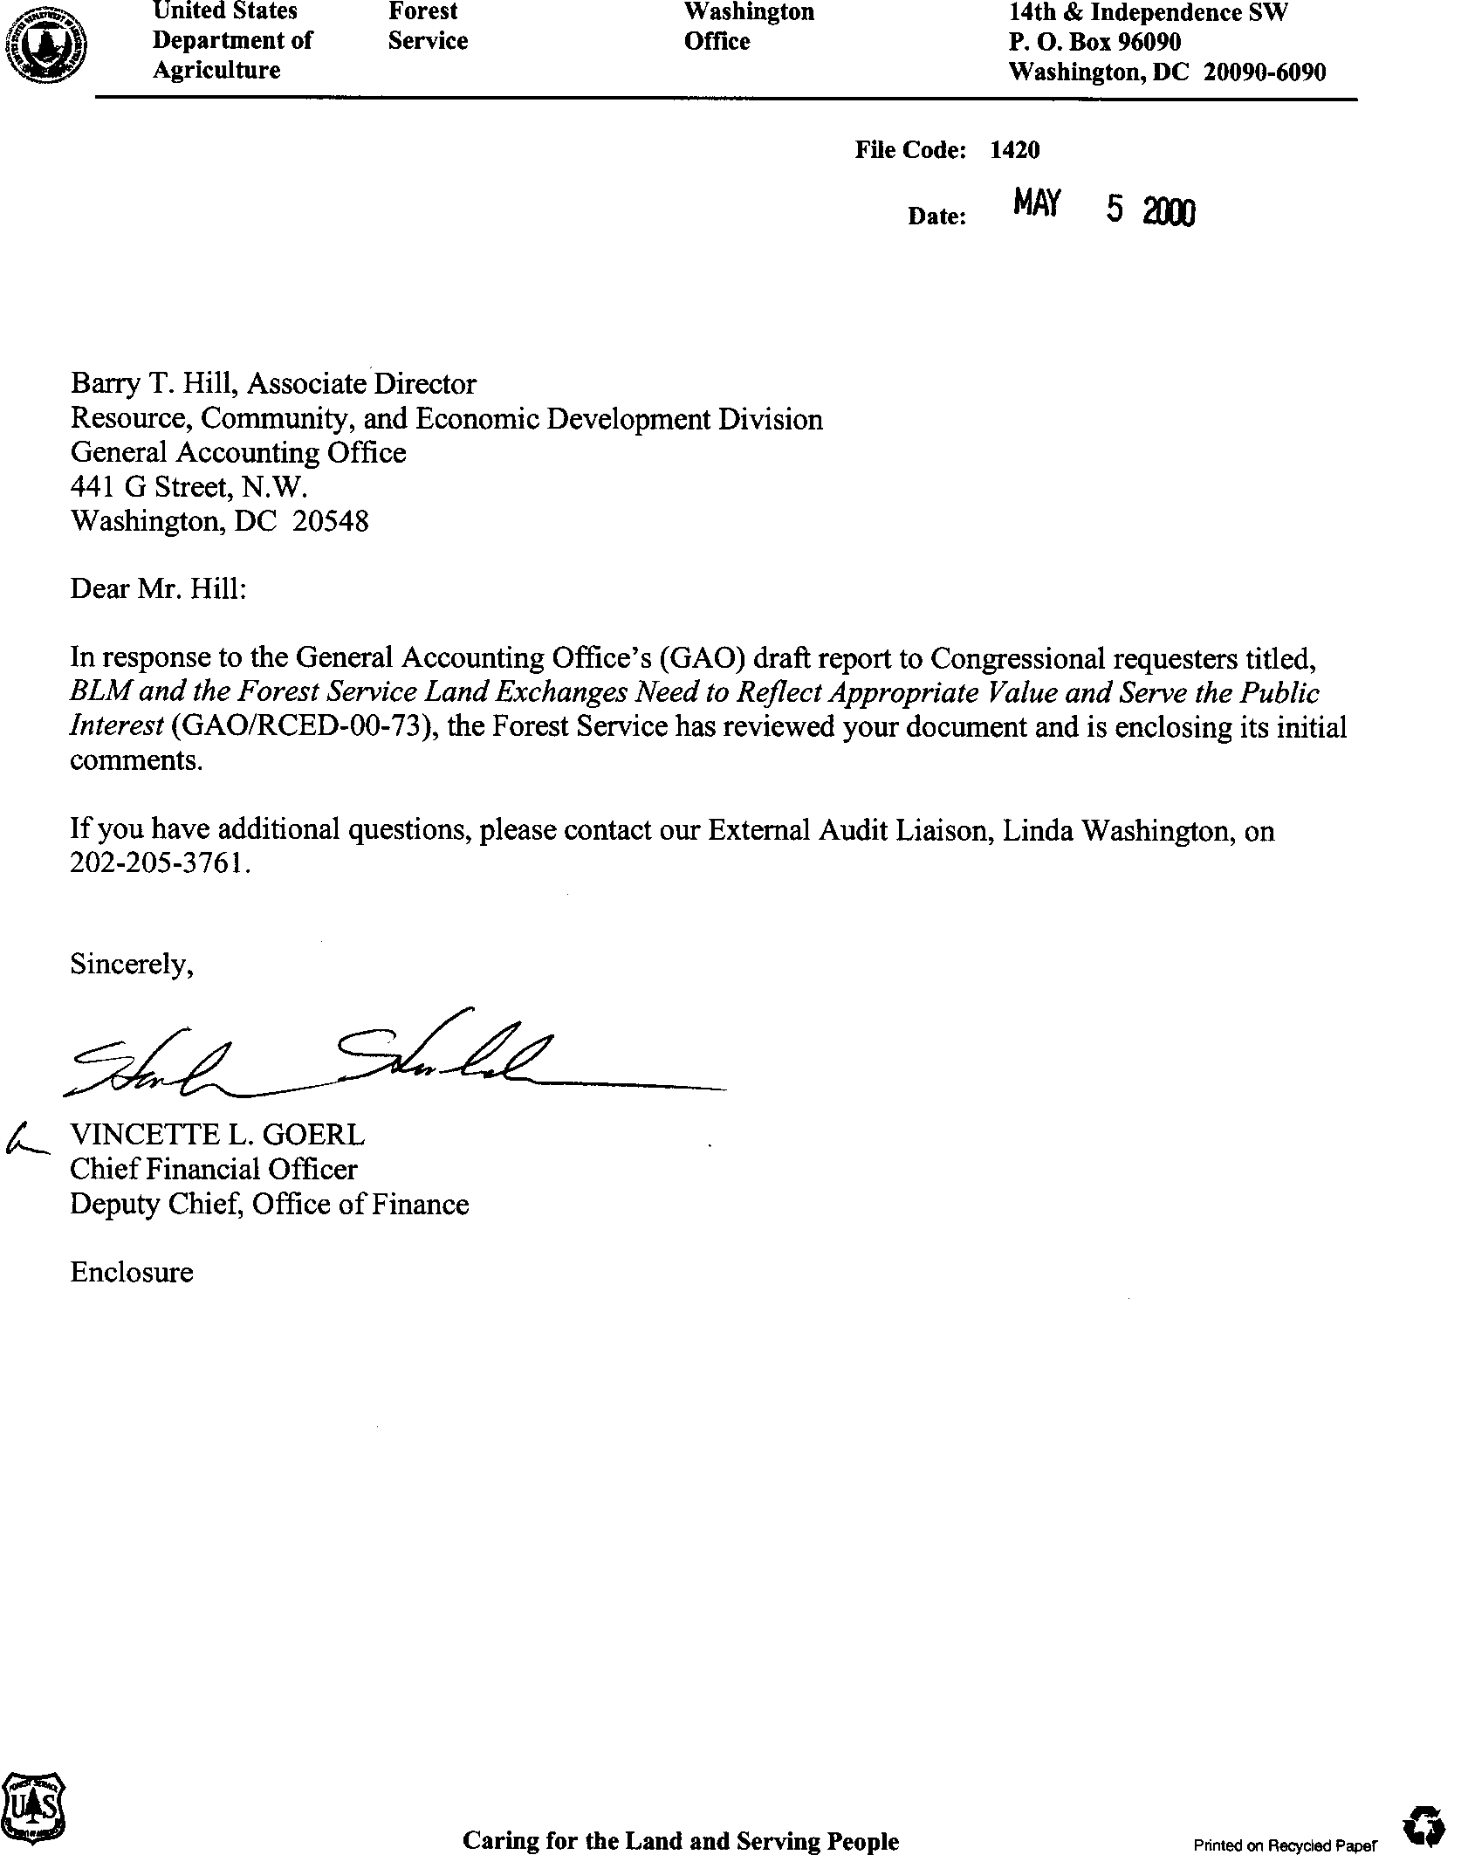Appendix I

# Comments From the Forest Service

Note: GAO’s comments supplementing those in the report text appear at the end of this appendix.

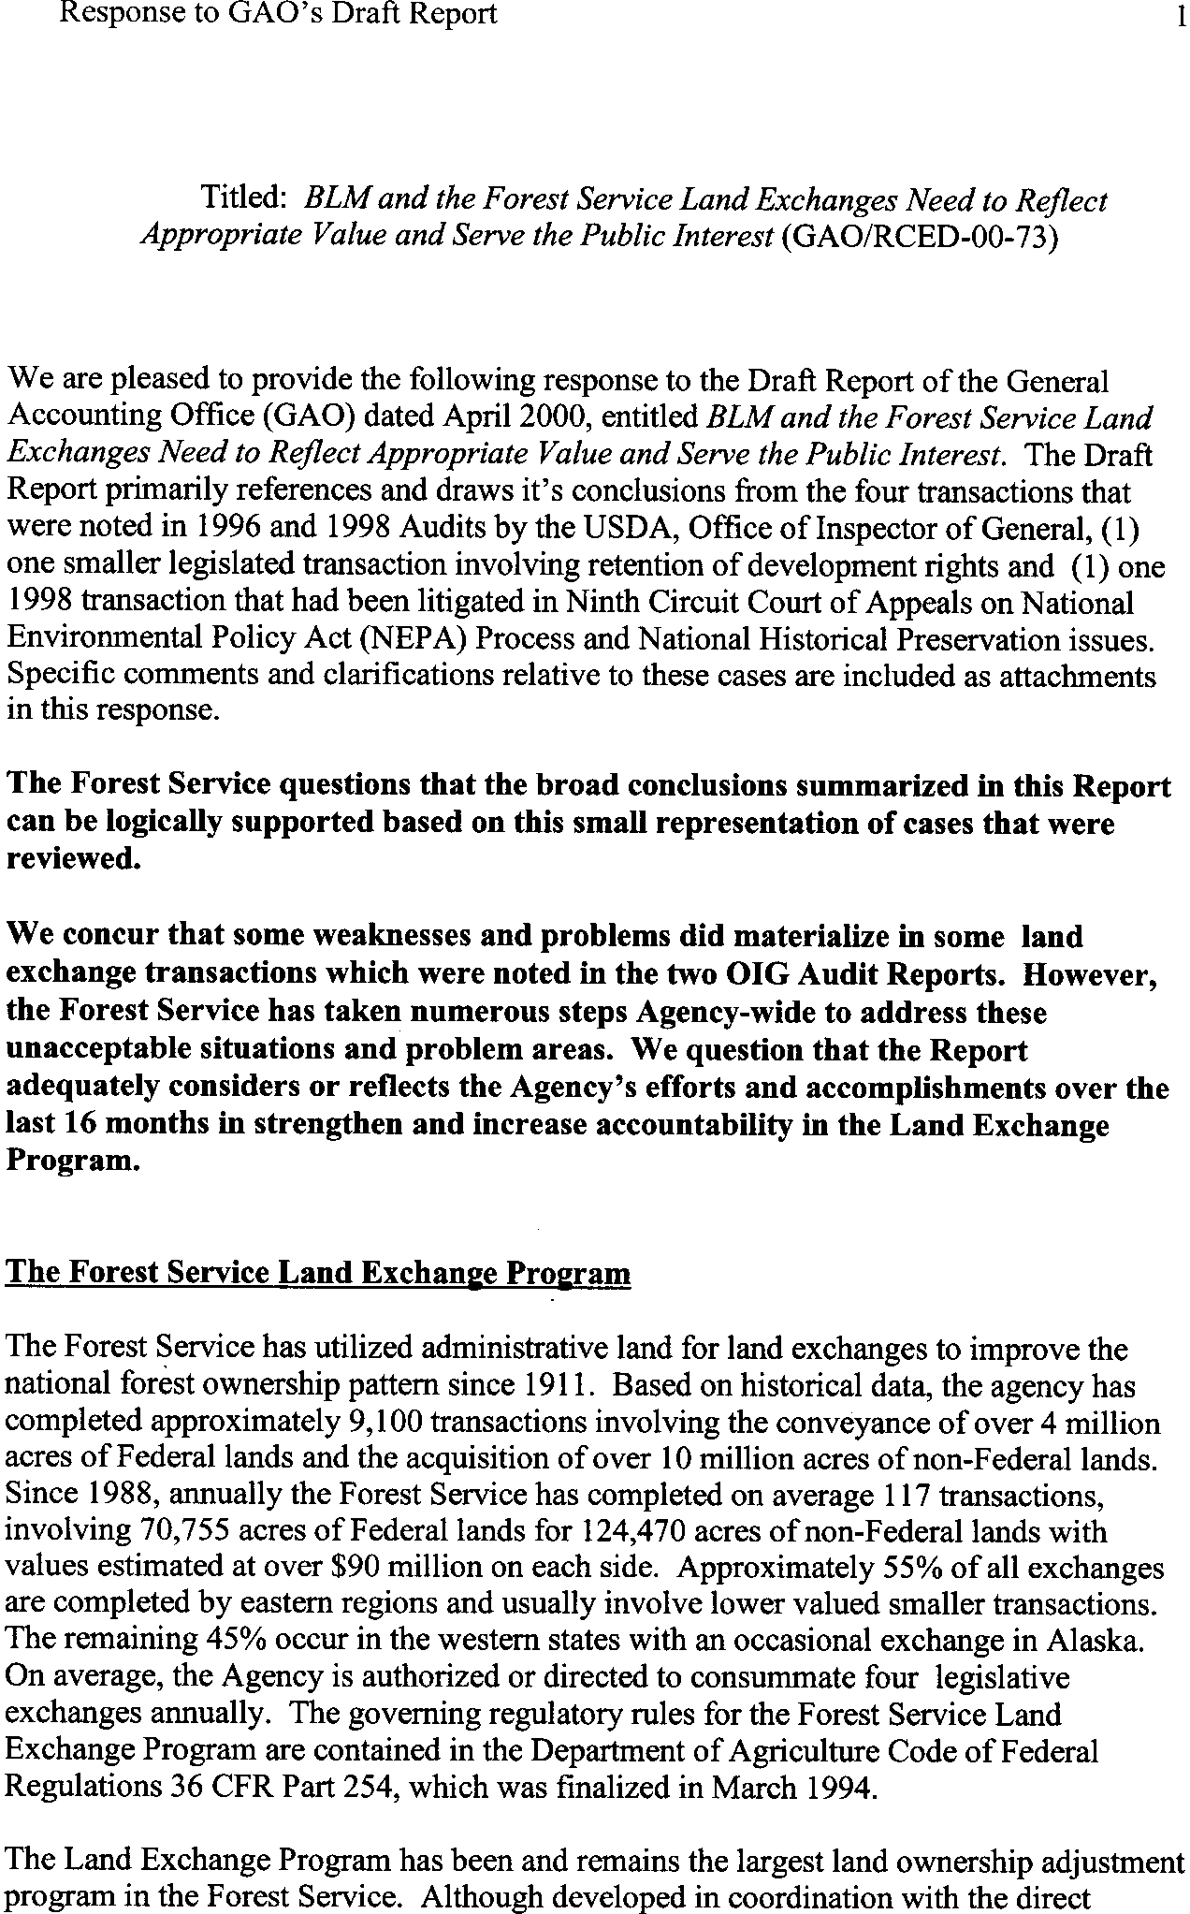See comment 1.

See comment 2.

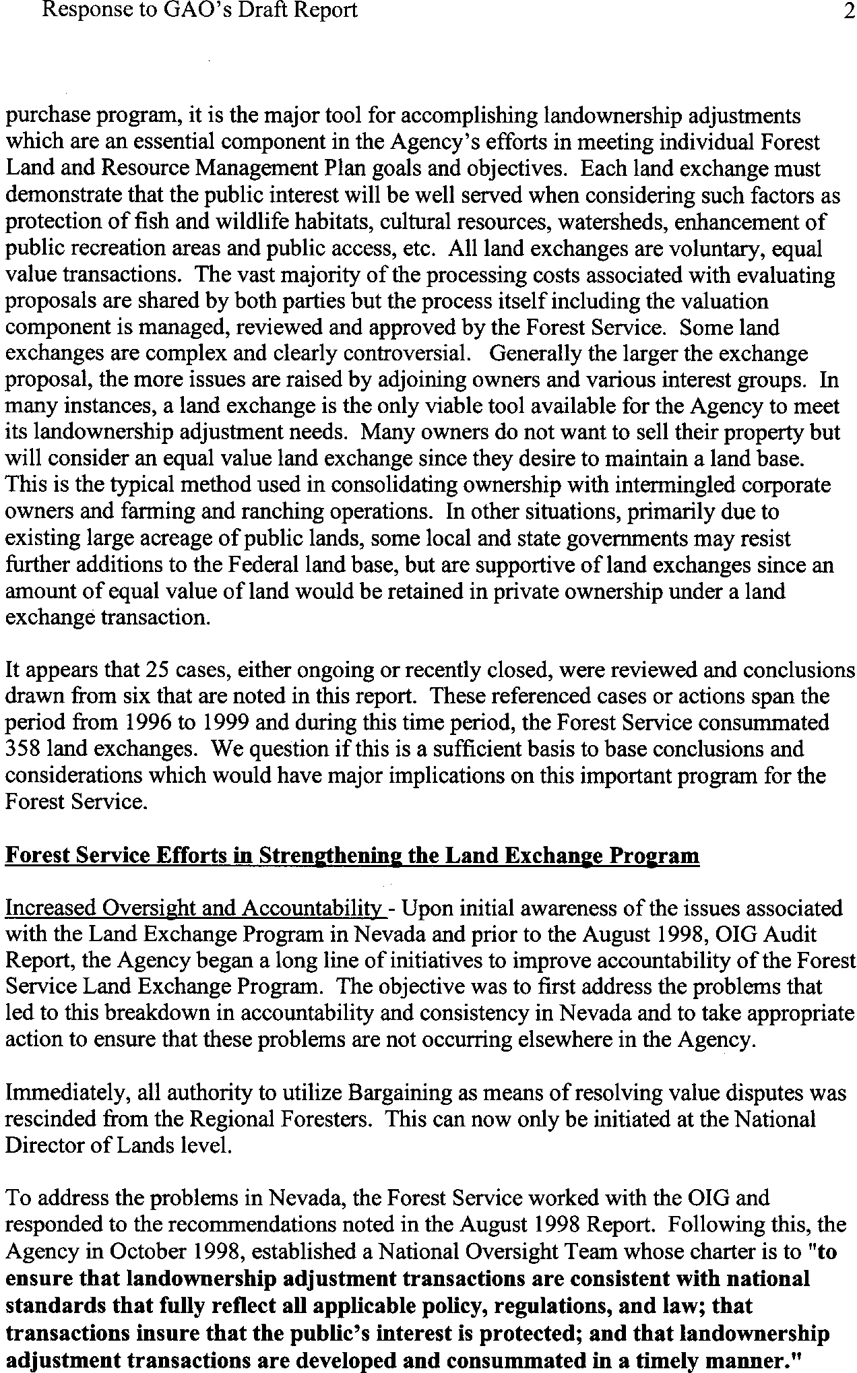See comment 1.

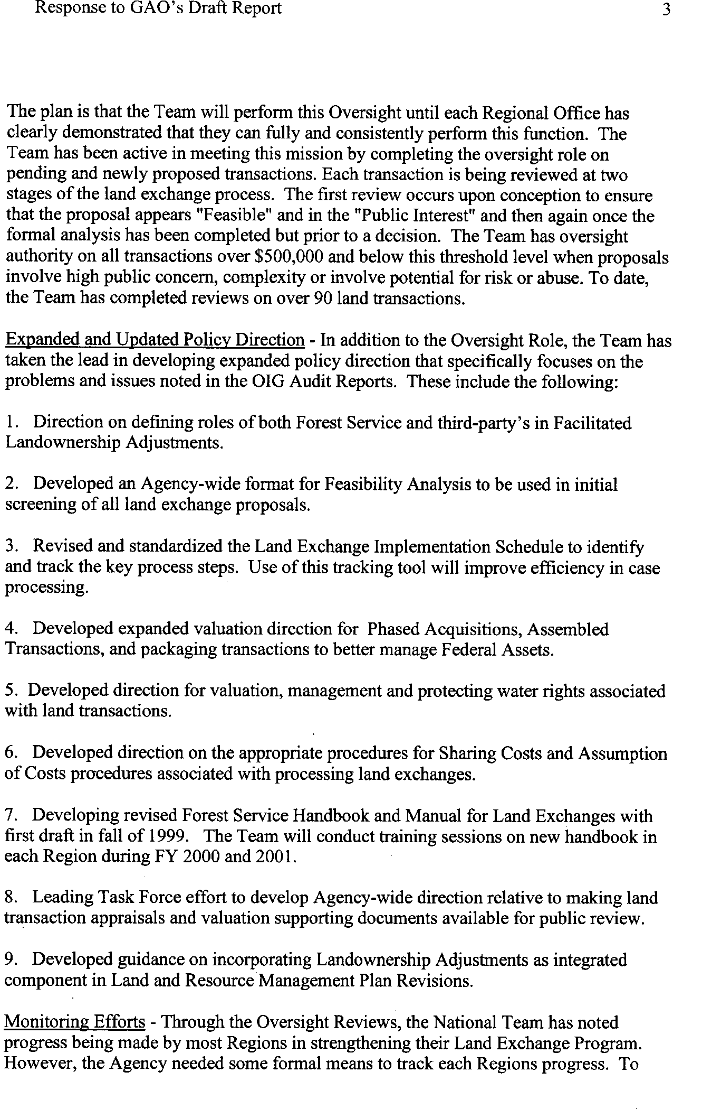

See comment 2.

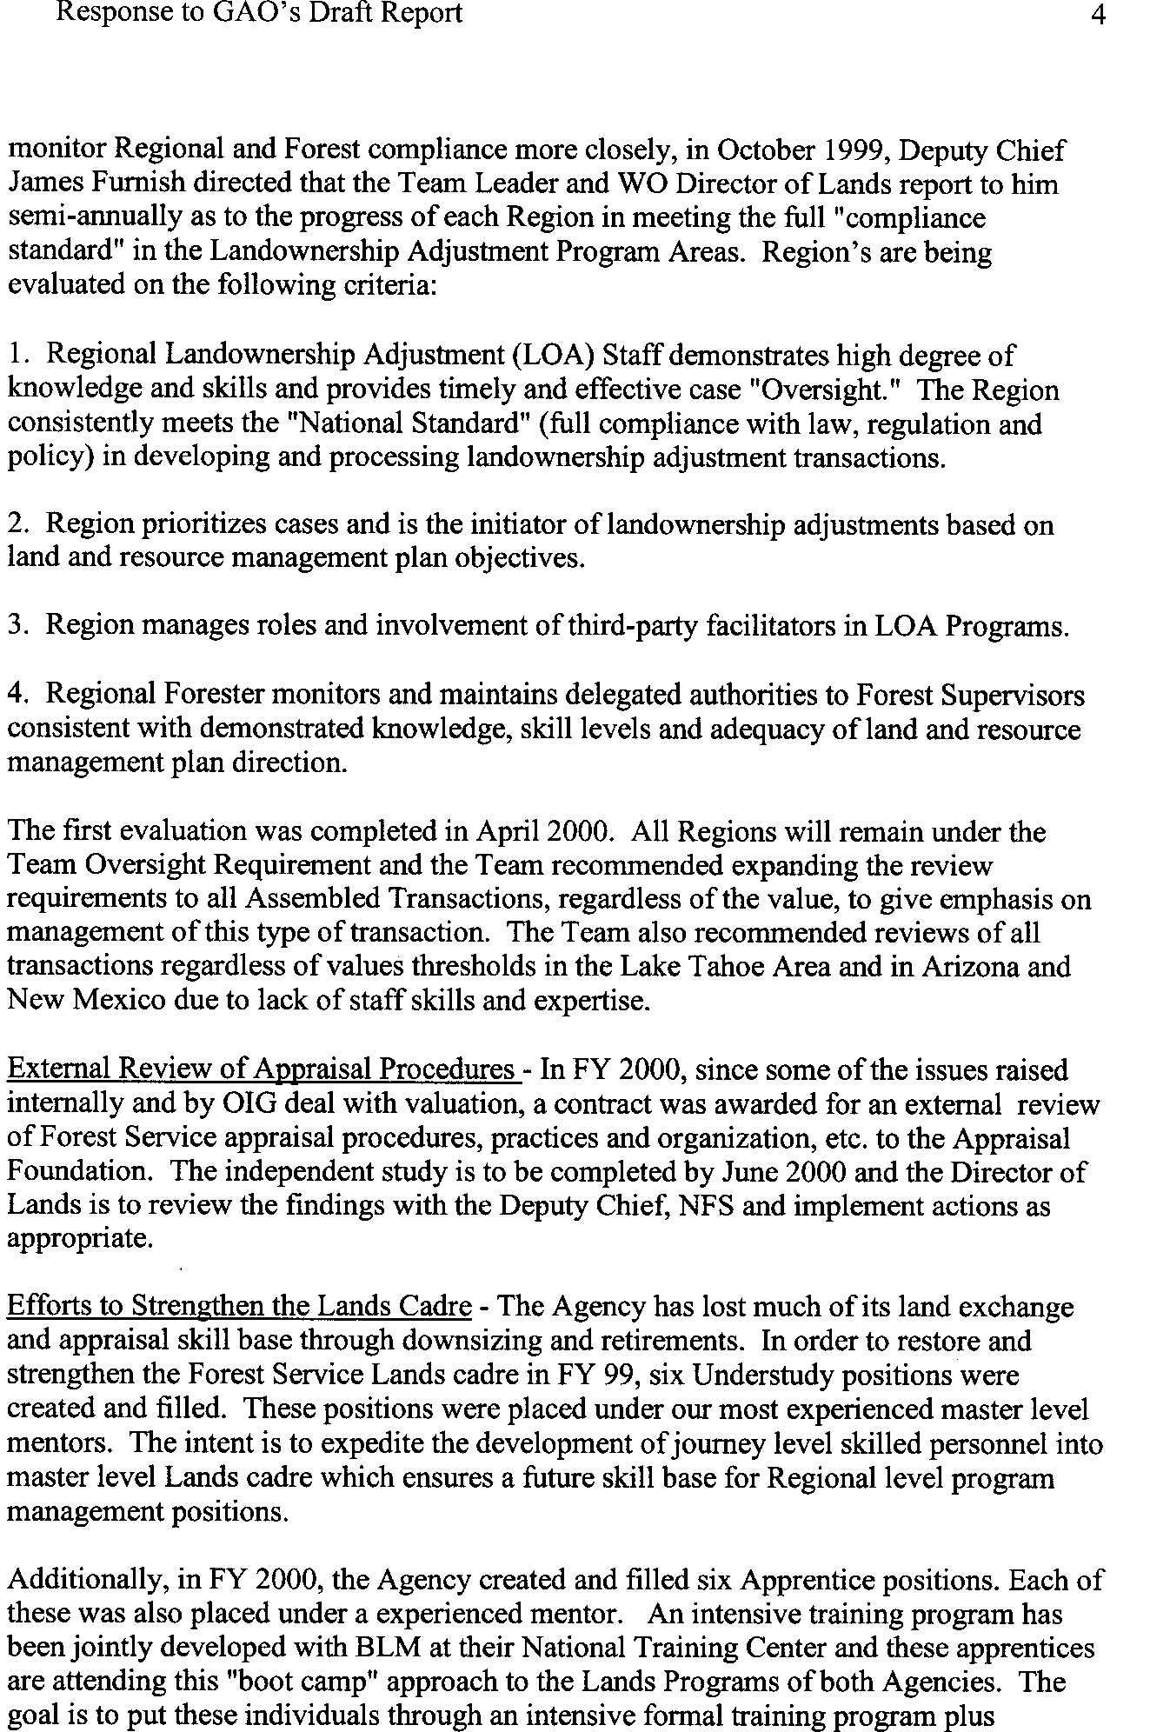See comment 3.

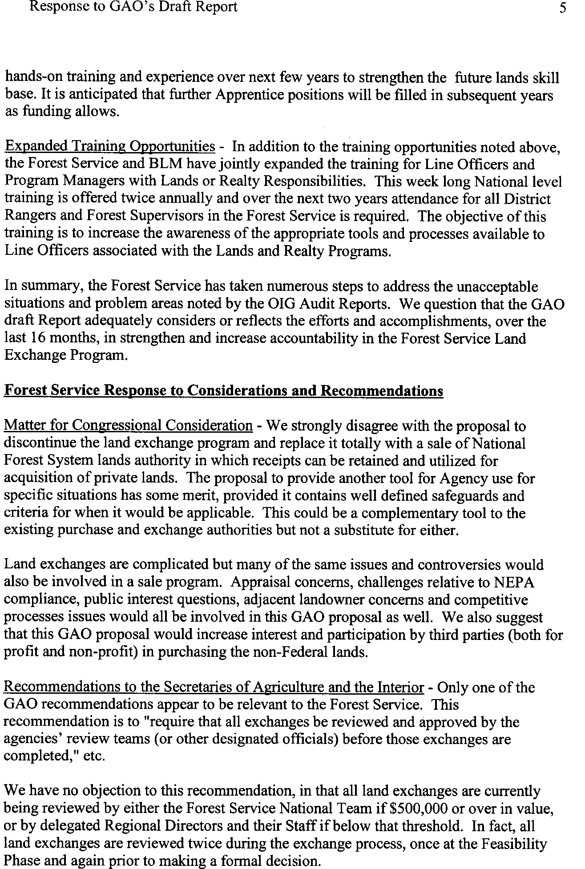See comment 4.

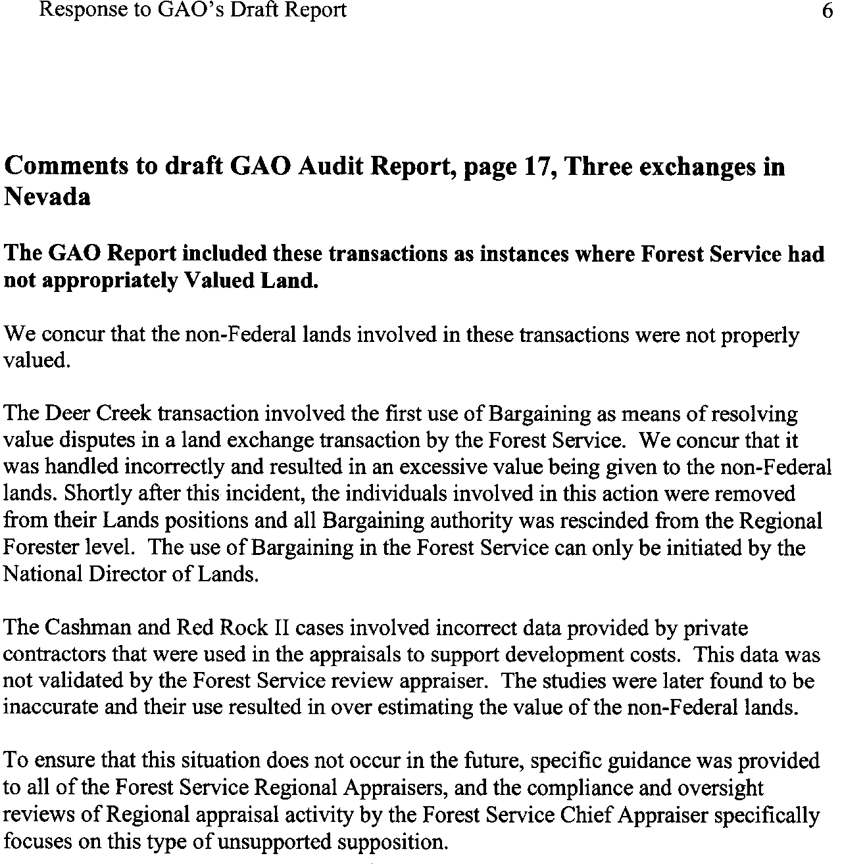

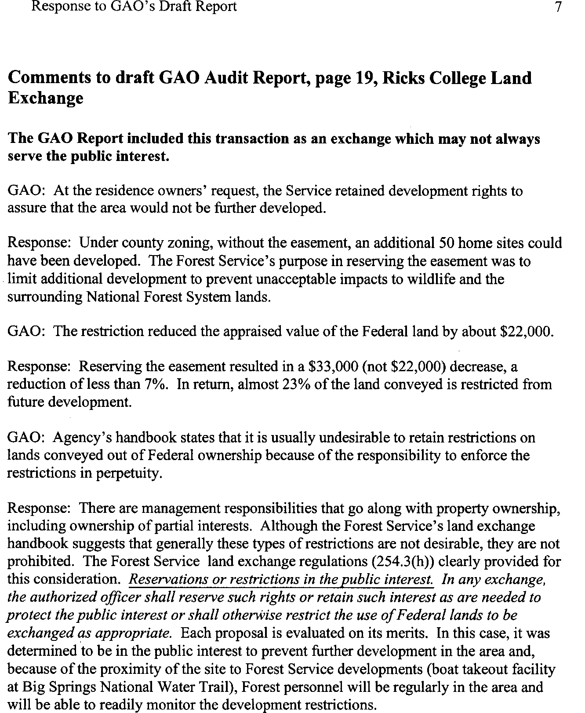See comment 5.

See comment 6.

See comment 5.

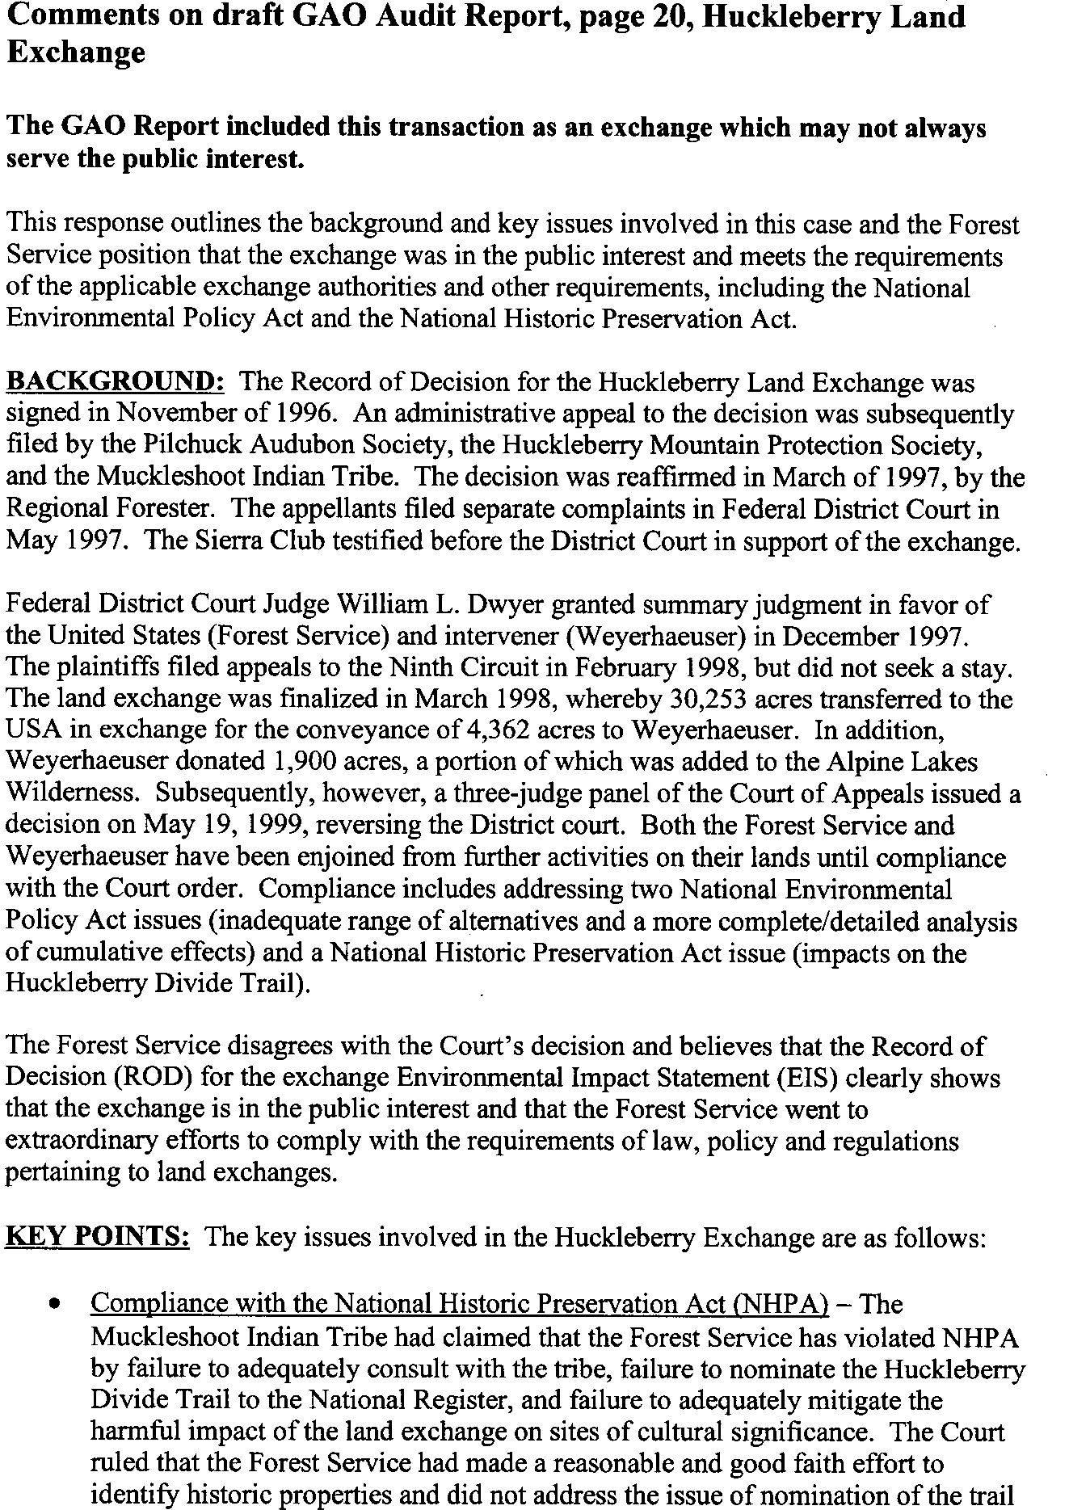See comment 7.

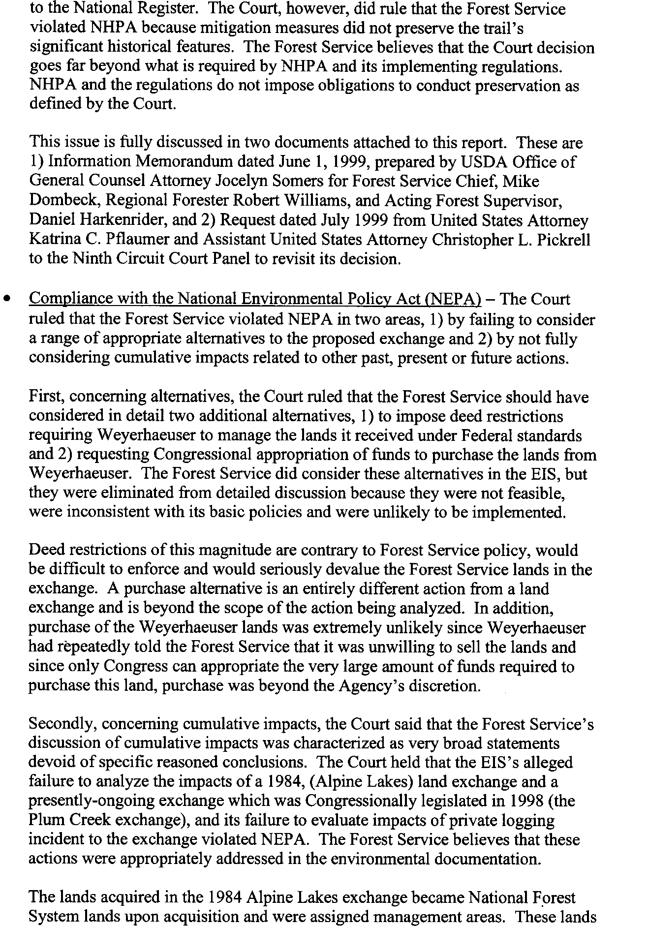

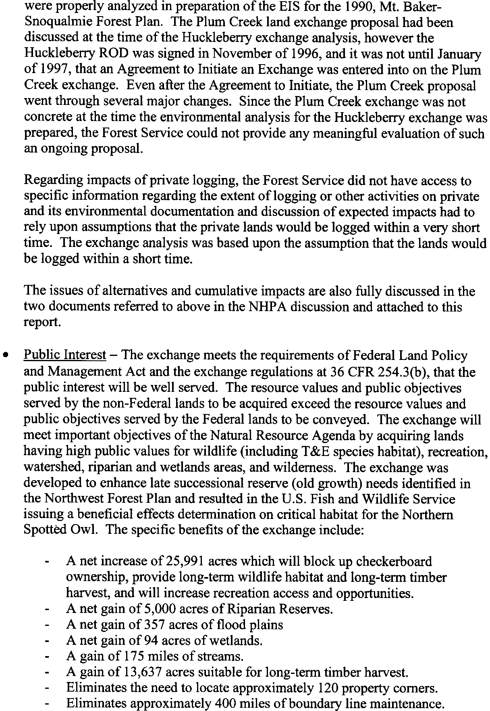

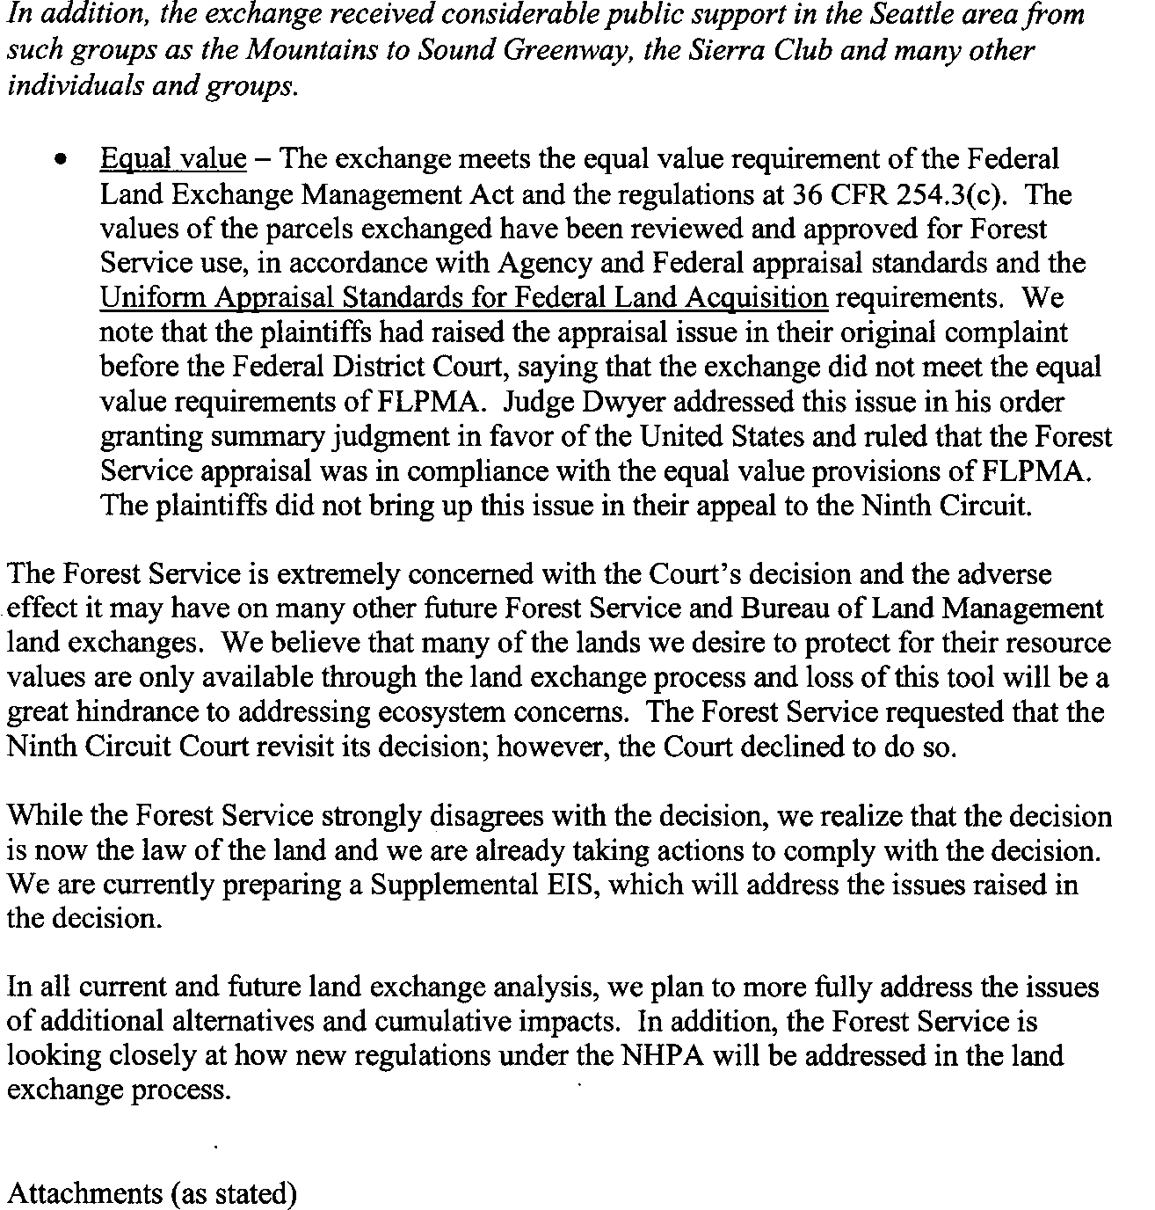

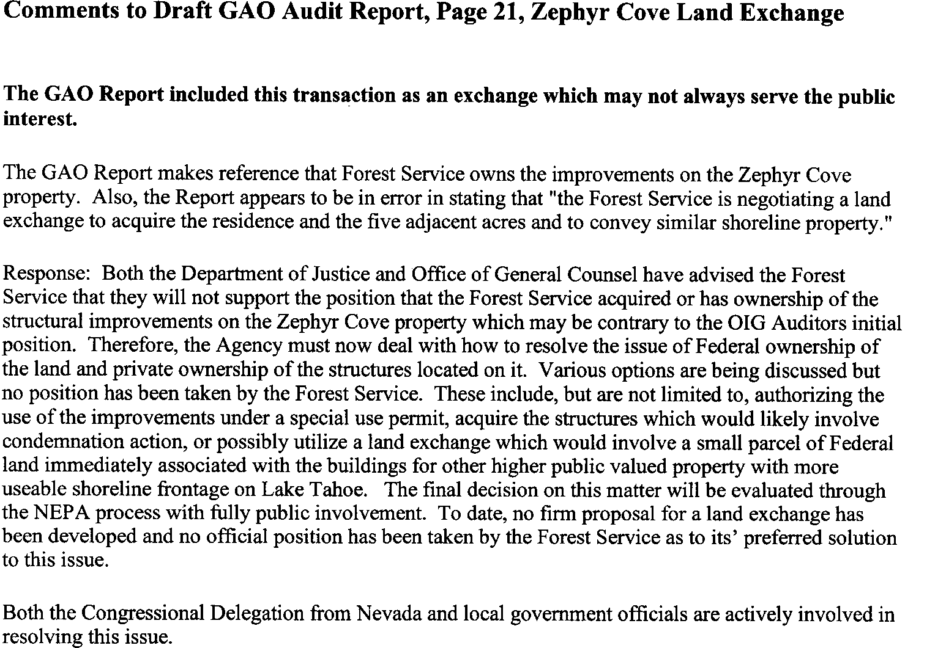See comment 8.

GAO’s Comments The following are GAO’s comments on the Forest Service’s (the Service)

letter dated May 5, 2000.

1. We believe the exchanges highlighted in our report demonstrate serious and substantive problems with the Service’s land exchange program— problems that were also documented in reports issued by Agriculture’s Office of the Inspector General. The exchanges we highlighted further demonstrate the inherently difficult nature of land exchanges.
2. We acknowledge the efforts the Service has made to address problem areas and believe that they are steps in the right direction. However, these efforts have not eliminated all of the problems or our concerns. For example, the Service commented that its own national review team found that while “most” regions have made progress in strengthening their land exchange programs, none have clearly demonstrated that they fully and

consistently comply with national standards reflecting applicable laws, regulations, and policies in developing and processing land exchanges. The team also recommended that it review all land exchange transactions in Arizona, New Mexico, and the Lake Tahoe area, owing to the lack of field offices’ staff skills and expertise. Furthermore, we believe that establishing new policies and procedures cannot overcome the fundamental and inherent difficulties associated with the use of exchanges to acquire nonfederal land.

1. We acknowledge the Service’s efforts to hire, train, and mentor staff to work in the landownership adjustment program, which will strengthen the future lands skill base over the next few years. However, according to the Service, the agency has already lost much of its land exchange and appraisal skill base through downsizing and retirements, and it anticipates that some headquarters staff who are responsible for reviewing land exchanges may be retiring soon.
2. We share the Service’s concern that having expanded authority to sell certain federal land and to retain use of some or all of the sale proceeds to purchase nonfederal land would not resolve many of the problems we reported with land exchanges—most notably, concerns about appraised values—and could create additional potential difficulties, such as increasing participation by third parties or conflicts with state and local governments. For this reason, we have deleted the suggestion that the Congress consider replacing the Service’s land exchange program with such expanded authority. Under existing authority, the Service is not

authorized to sell national forest land but is authorized to seek appropriated funds from the Congress to acquire desirable nonfederal land. However, we do not believe that the administrative flexibility offered by exchanges warrants continuing the program. Because of the inherent difficulties and the recurring problems that the agencies have experienced in managing their land exchange programs, we still believe that the Congress should consider directing the agencies to discontinue their land exchange programs.

1. The environmental assessment and associated documents for the Ricks College exchange did not state that an additional 50 home sites could have been developed in the area or that the Service needed to limit this potential development to prevent unacceptable impacts to wildlife and the surrounding national forest lands. In addition, cognizant Service officials told us the restriction was included at the request of the residence owners.
2. We recalculated the value of the restriction and found it to be $29,000 and clarified our report accordingly.
3. The Service commented that it strongly disagrees with the Court’s decision on the Huckleberry exchange—believing that the exchange was in the public interest and complied with applicable laws—but realizes the decision is the law of the land and is already taking actions to comply with it. Our report summarizes the Court’s decision, which found that the agency did not adequately prepare its environmental analysis, which identifies and analyzes the public interest to be served.
4. We have revised our report to incorporate the updated information provided by the Service, to reflect that neither the Office of General Counsel nor the Department of Justice now supports the position that the residence was acquired or is owned by the federal government, that the Service is considering an exchange as one of several options to resolve the ownership conflict, and that the Service will develop its preferred solution through the National Environmental Policy Act process with full public involvement. Nonetheless, we are concerned that an exchange would

convey recently acquired and environmentally sensitive land to a nonfederal landowner and create an inholding.

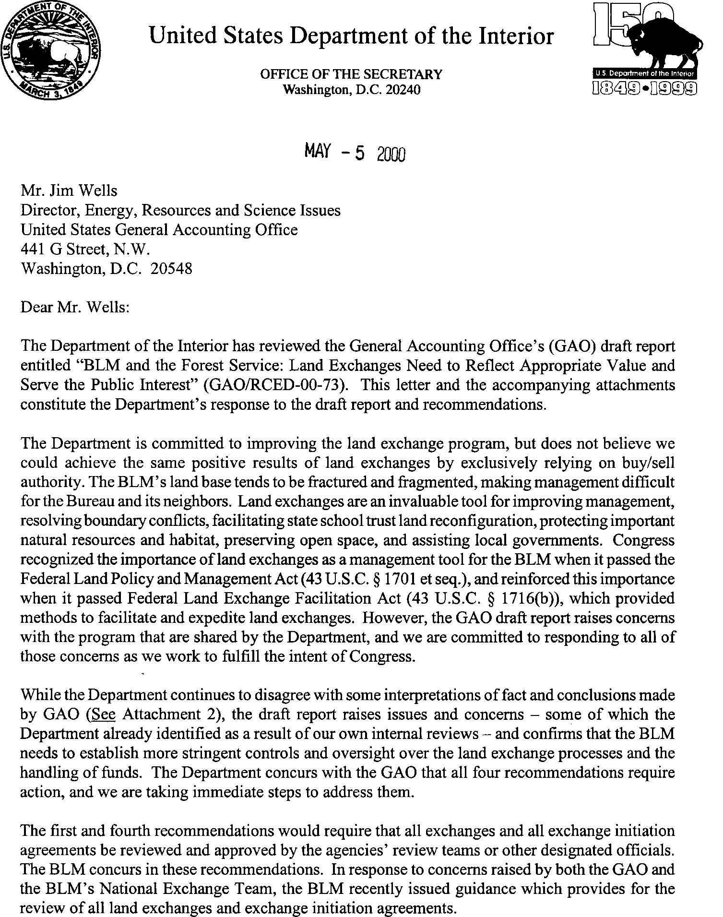Appendix II

# Comments From the Bureau of Land Management

Note: GAO’s comments supplementing those in the report text appear at the end of this appendix.

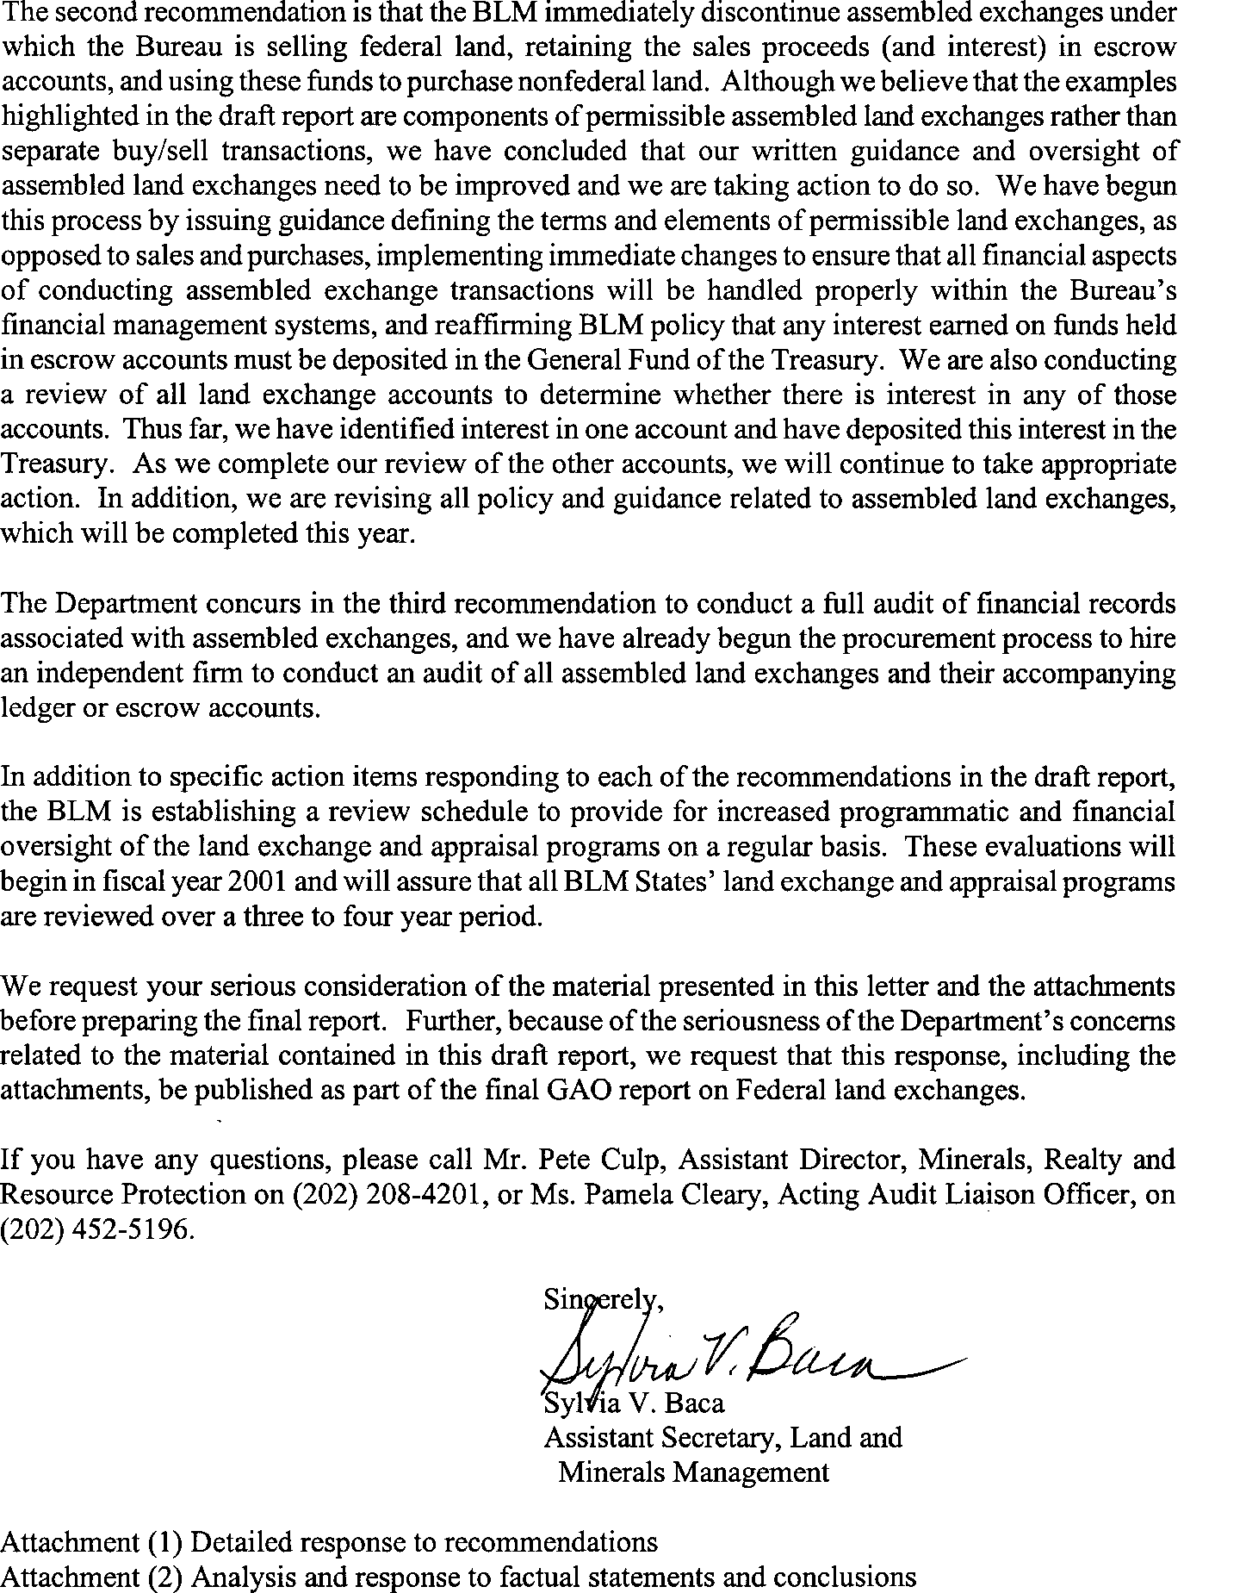

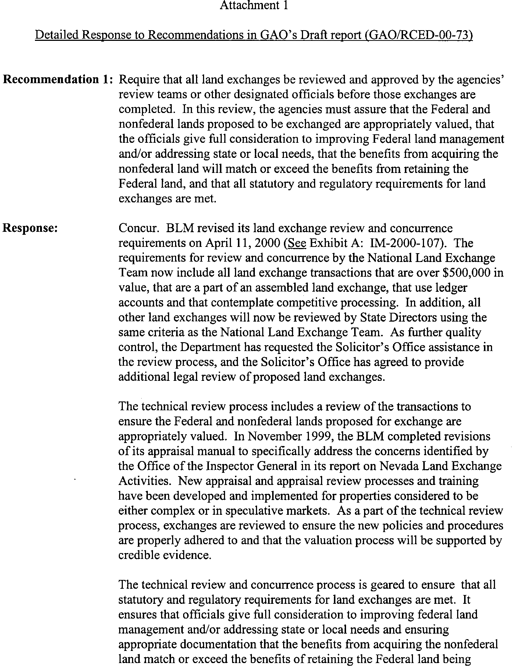

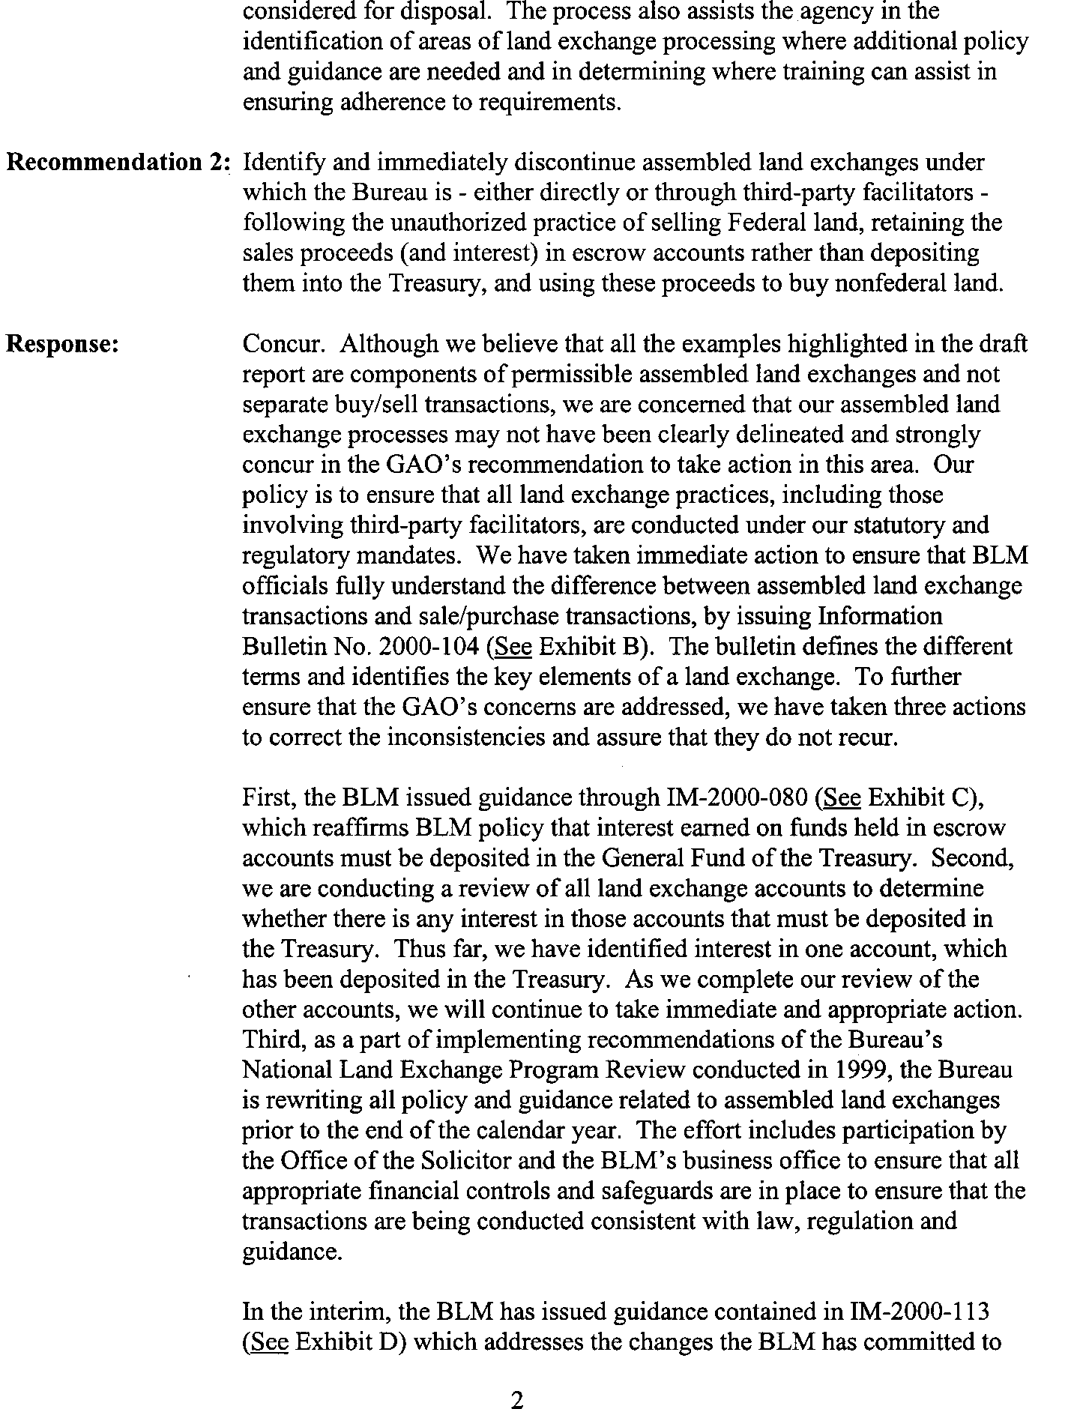See comment 1.

See comment 2.

See comment 3.

See comment 4.

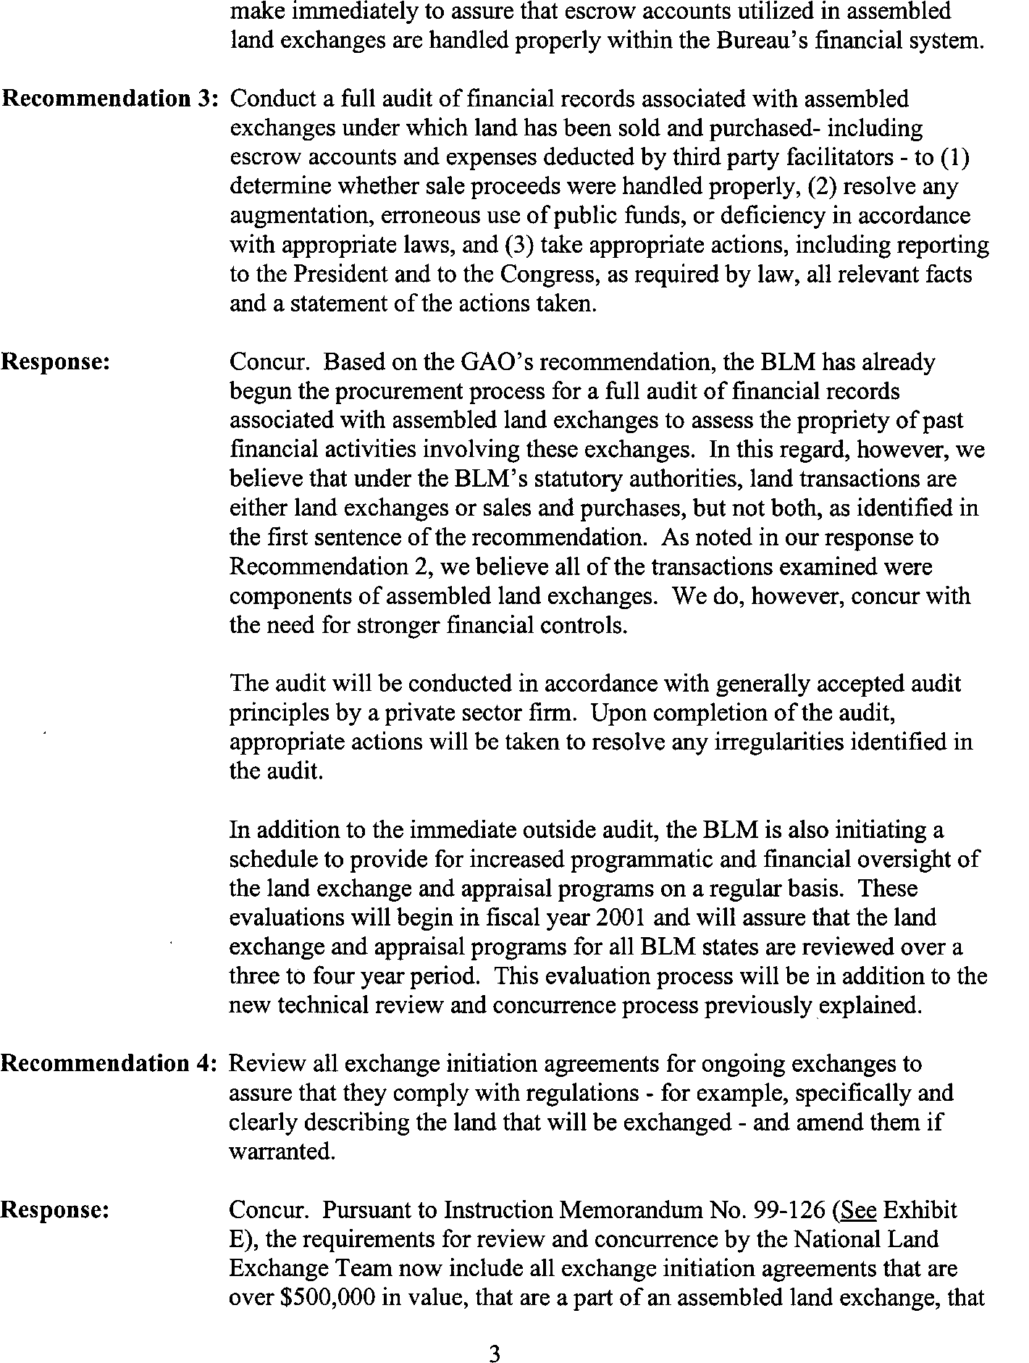See comment 1.

See comment 5.

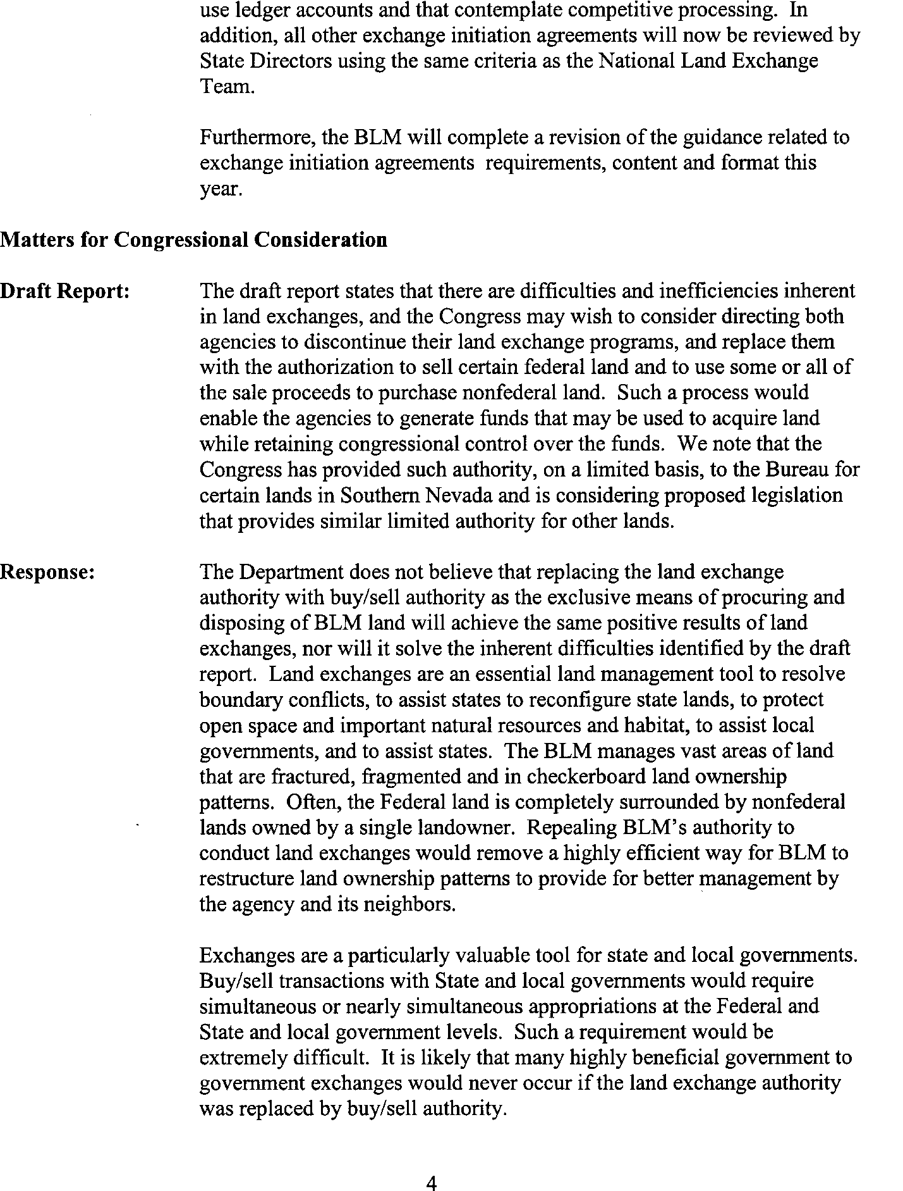See comment 6.

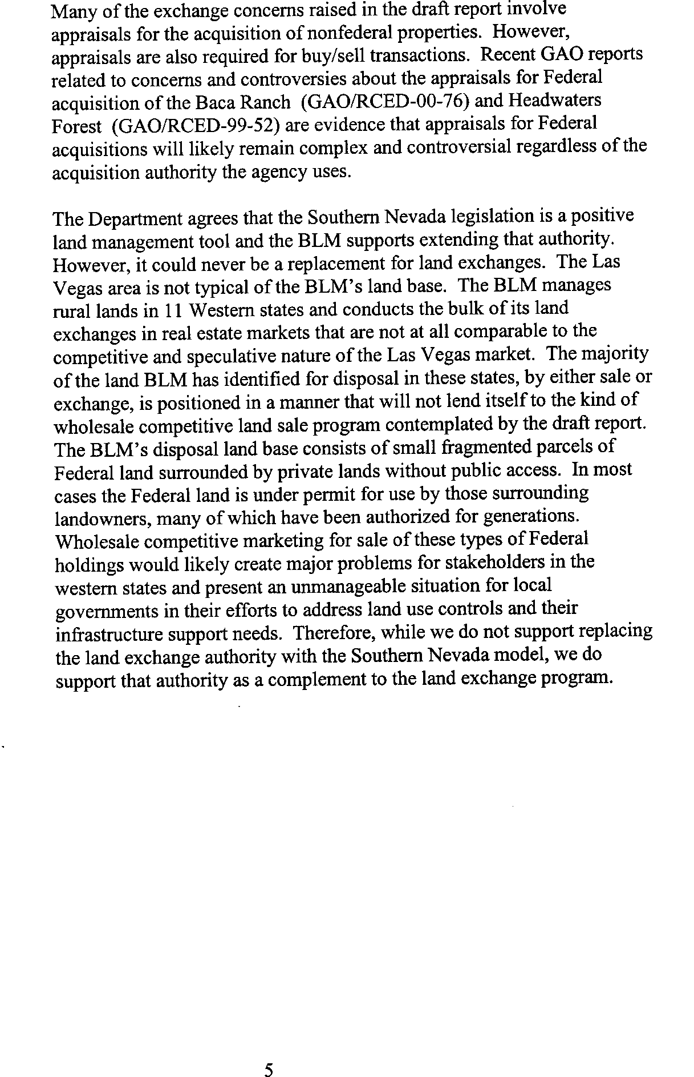See comment 7.

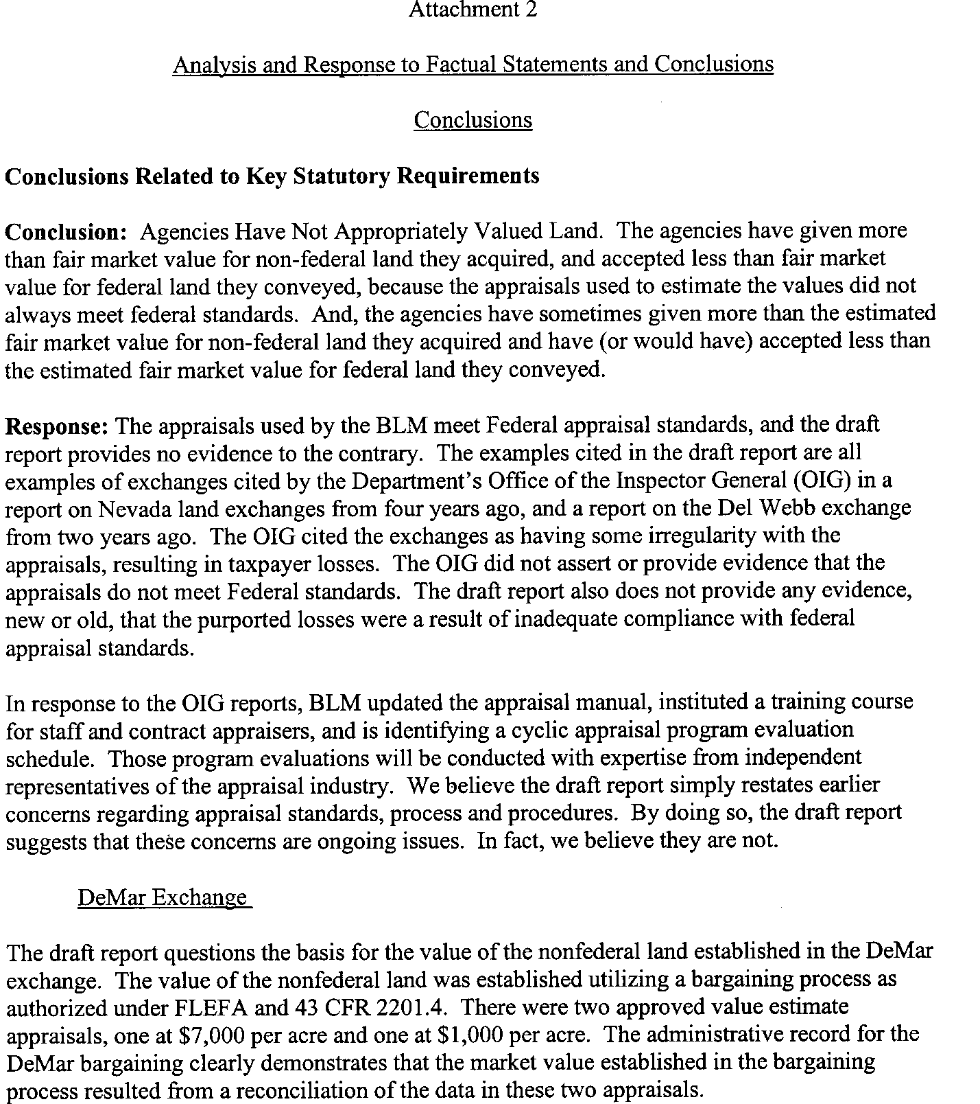See comment 8.

See comment 9.

See comment 10.

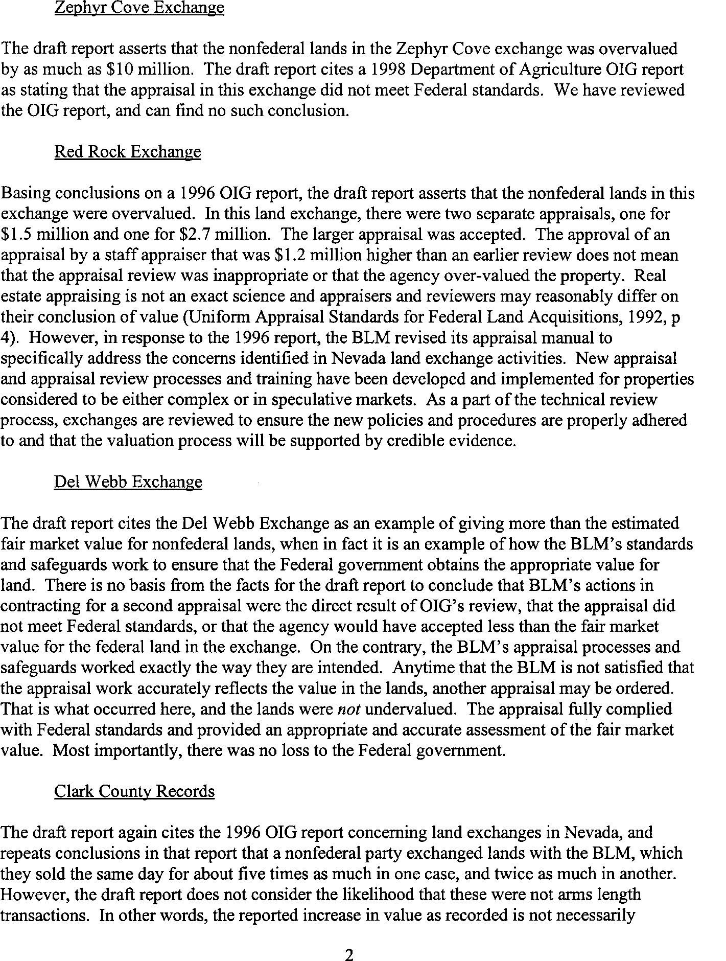See comment 11.

See comment 12.

See comment 13.

See comment 14.

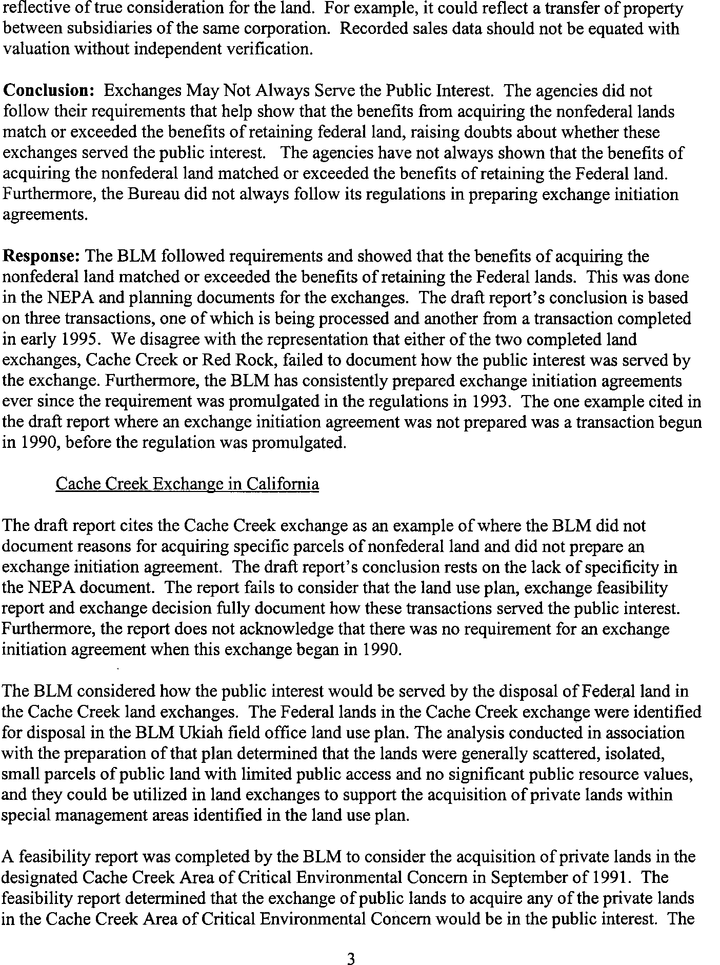See comment 15.

See comment 16.

See comment 16.

See comment 15.

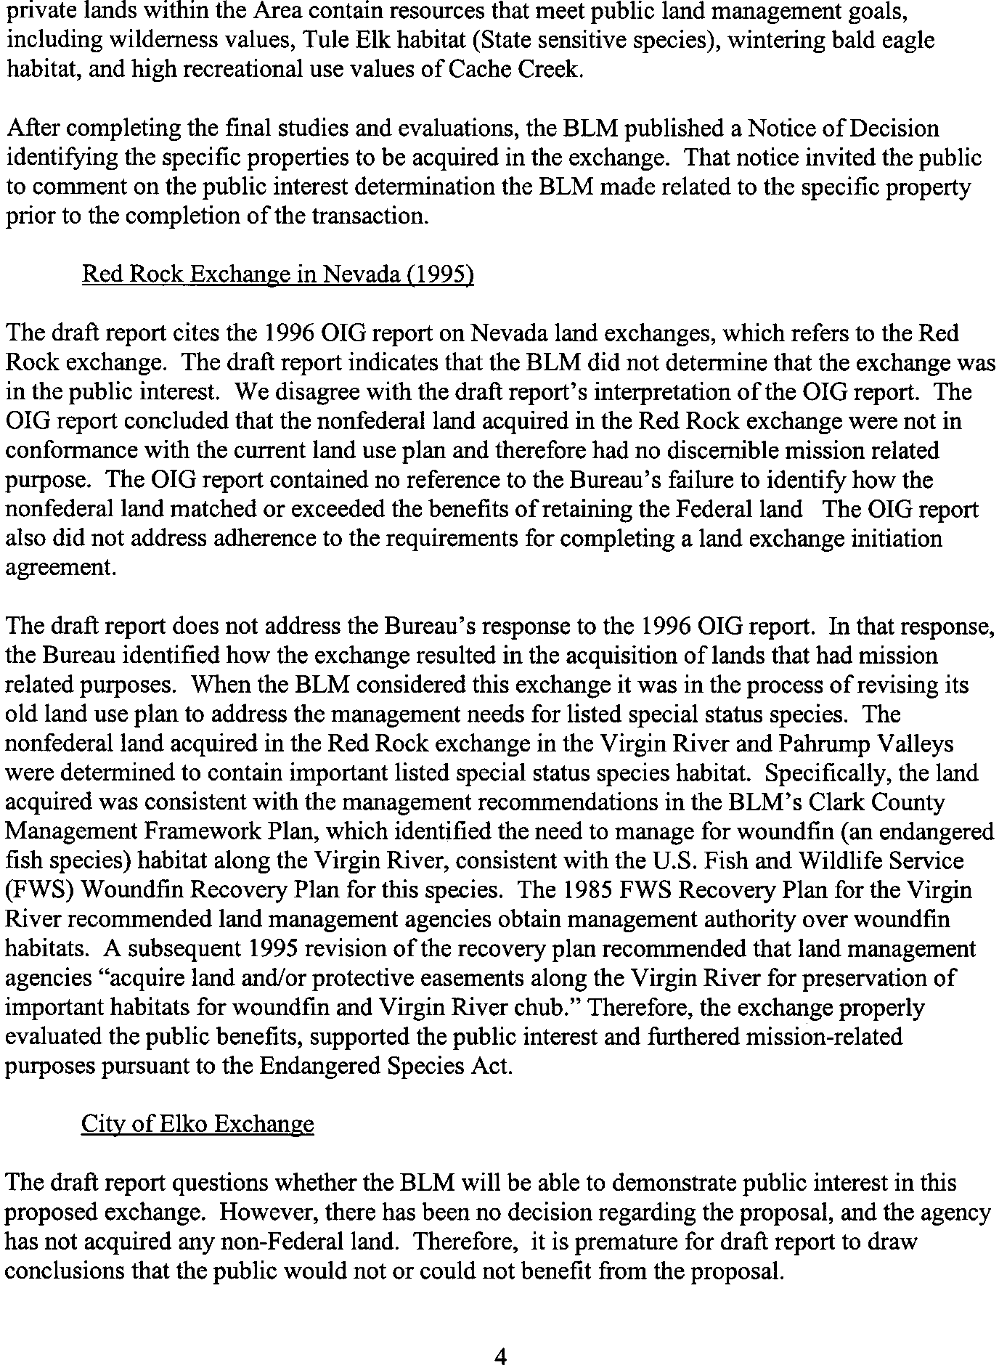See comment 15.

See comment 17.

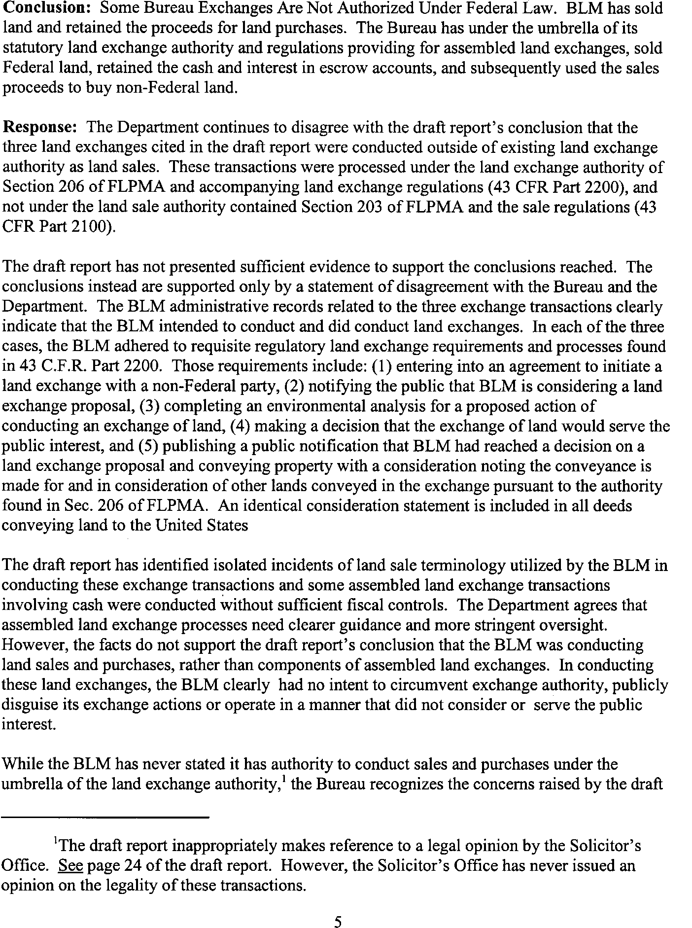See comment 1.

See comment 18.

See comment 19.

See comment 20.

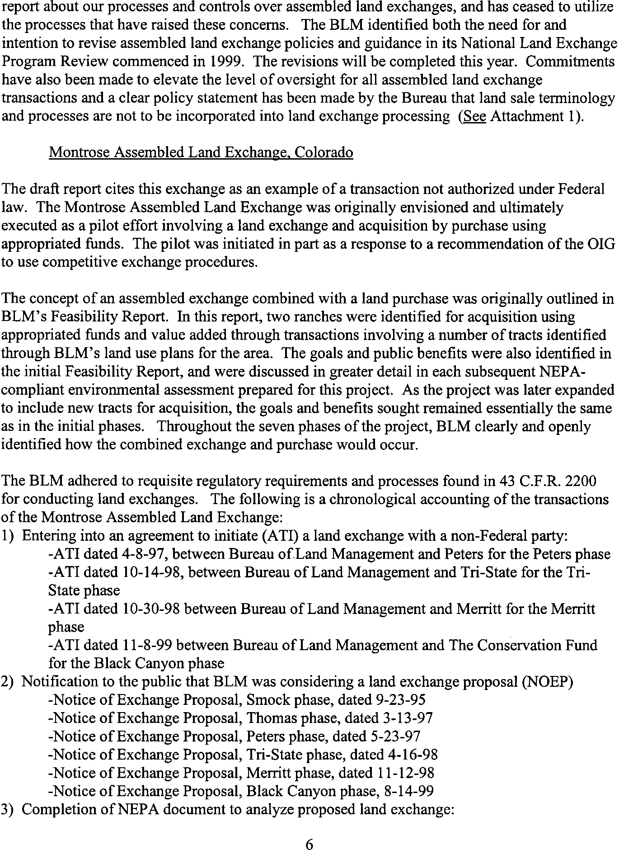See comments 1 through 4.

See comments 21.

See comments 1, 16, and 18.

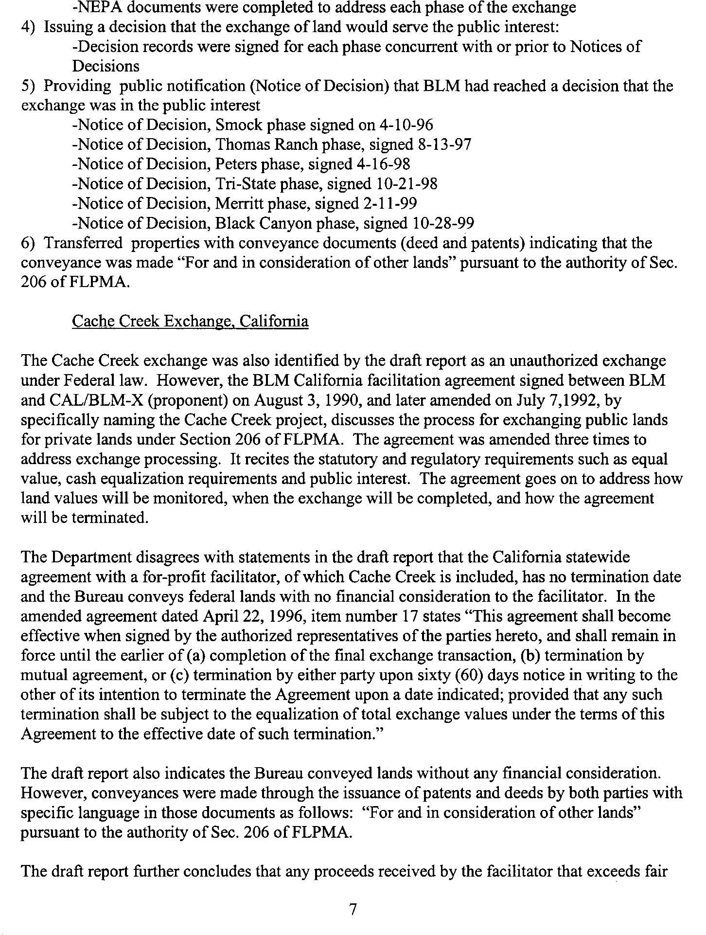See comment 22.

See comment 23.

See comment 24.

See comment 25.

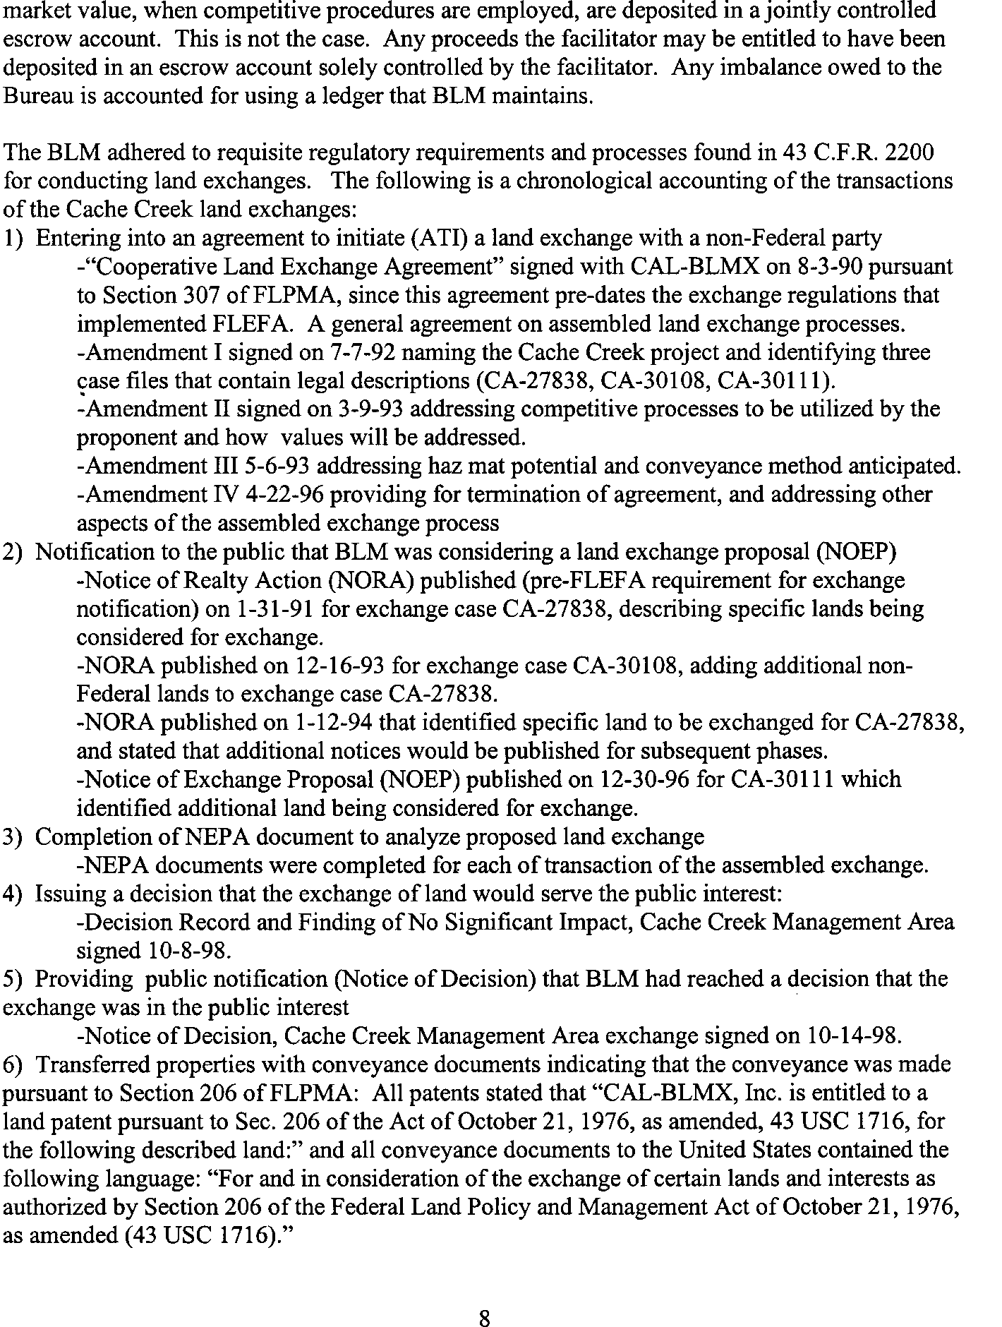See comments 1 and 18.

See comment 24.

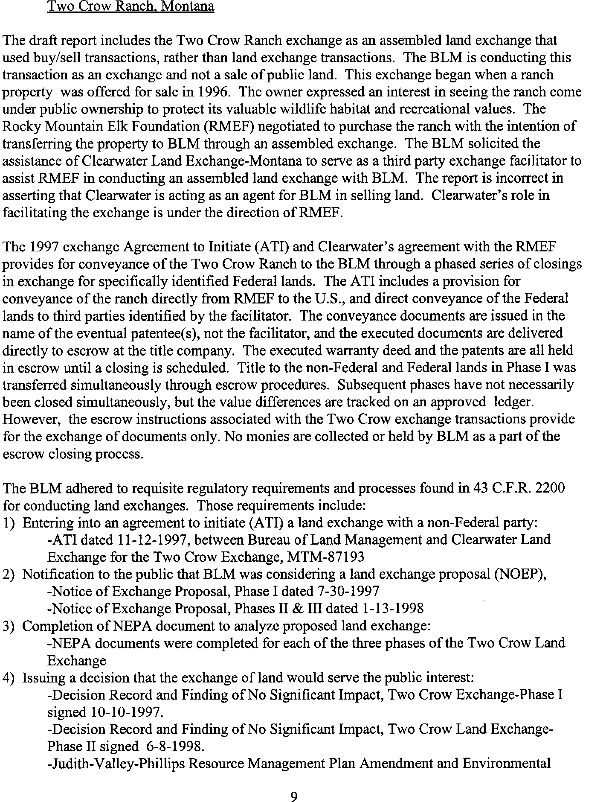See comment 26.

See comment 27.

See comments 1 and 18.

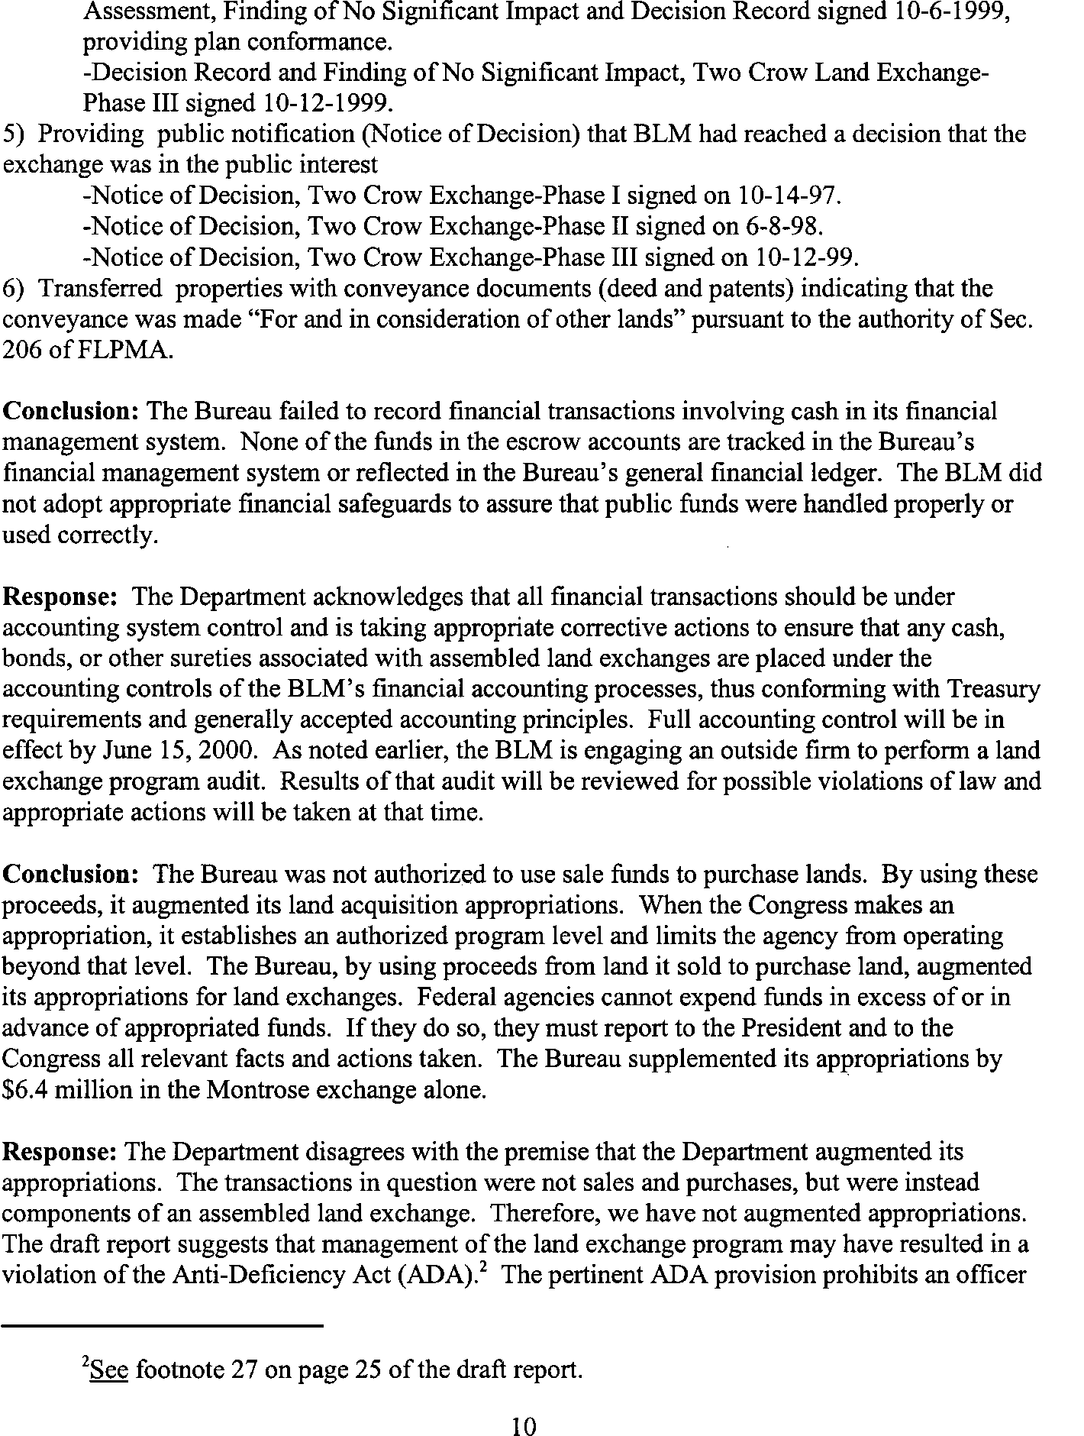See comments 1 through 4.

See comment 28.

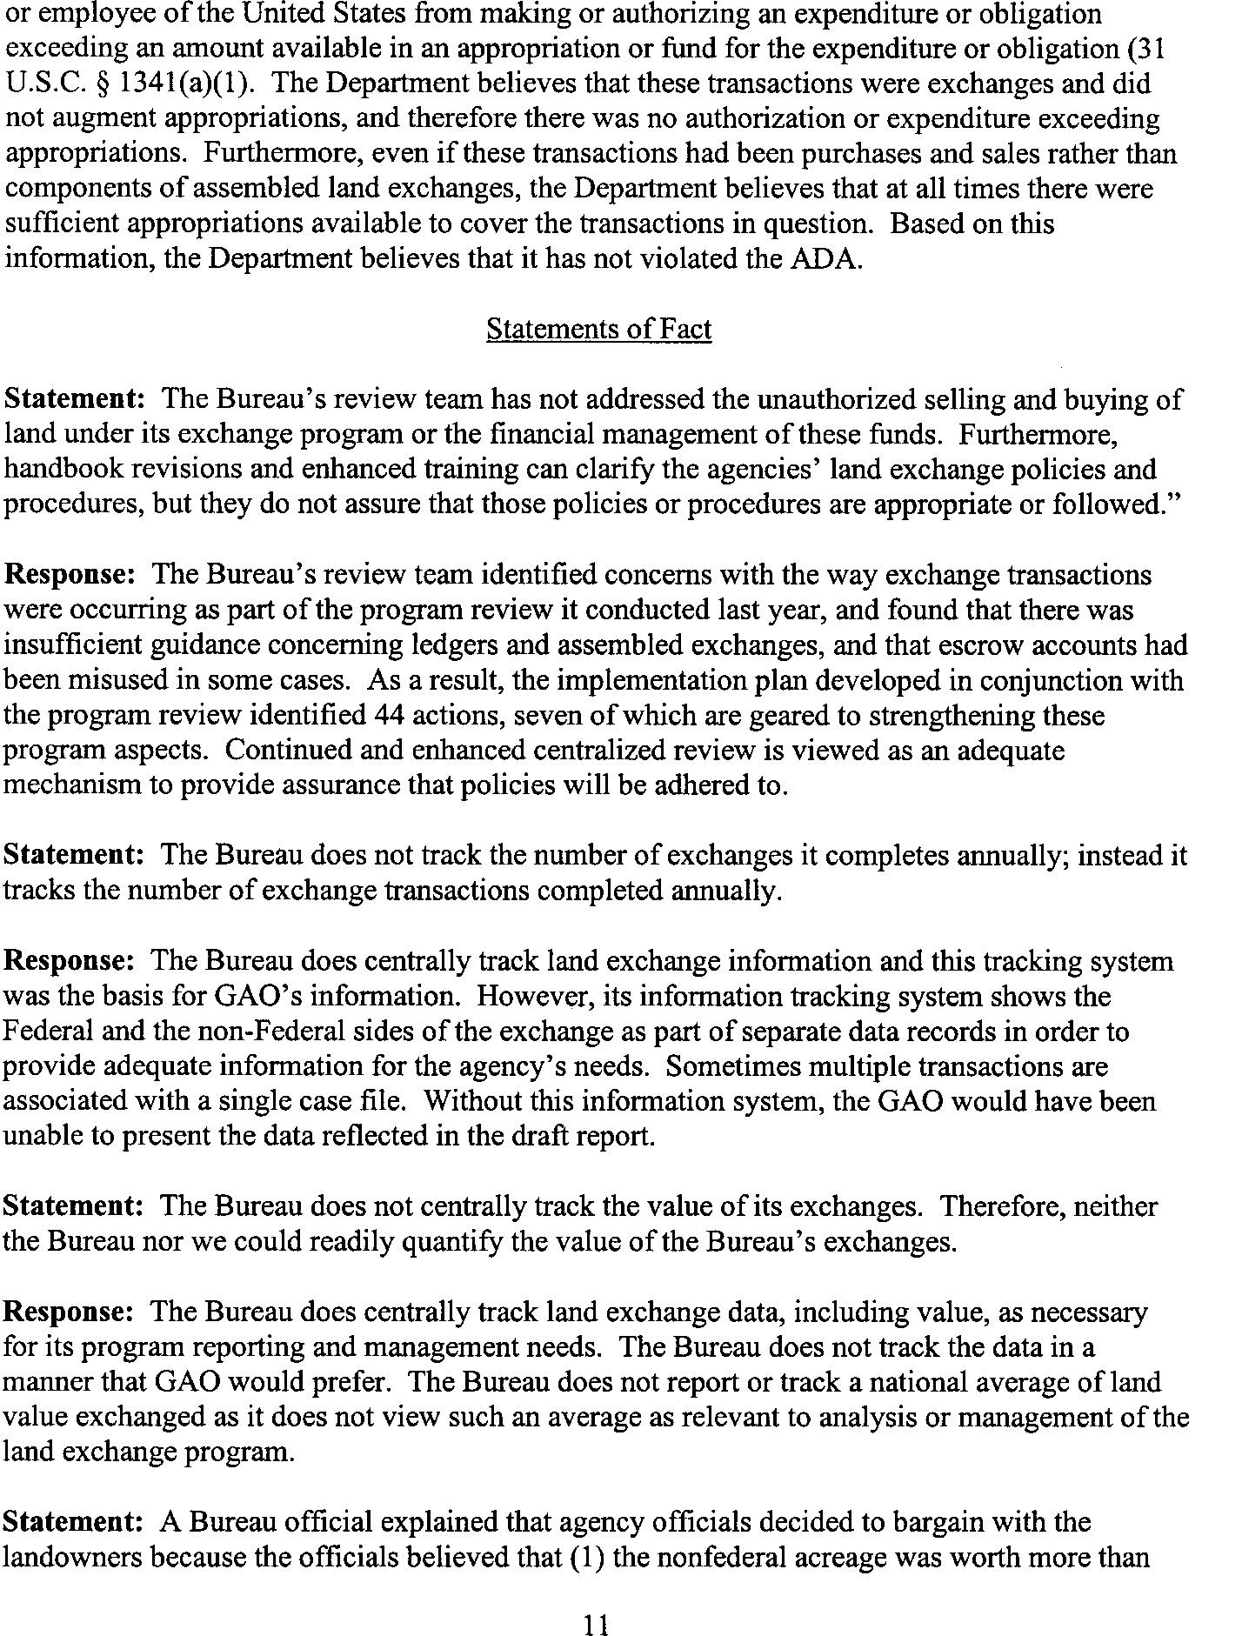See comment 29.

See comment 30.

See comment 30.

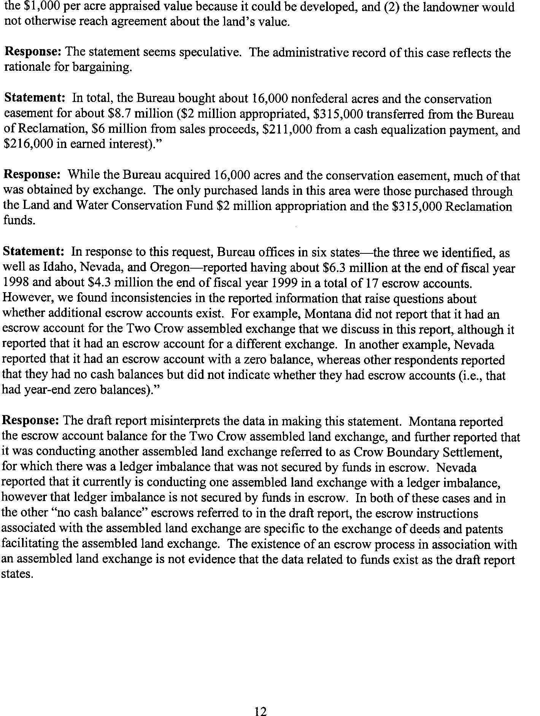See comment 10.

See comment 21.

See comment 31.

See comment 32.

GAO’s Comments The following are GAO’s comments on the Department of the Interior’s

Bureau of Land Management’s (the Bureau) letter dated May 5, 2000.

1. Although concurring with our recommendations regarding its unauthorized practice—under the umbrella of assembled exchanges—of selling federal land, retaining the proceeds and usinghtese funds to buy nonfederal land, the Bureau believes that the examples highlighted in our report are components of permissibleassembled land exchanges rather than buy/sell transactions. While the Bureau undertook these transactions under the umbrella of its regulations governing assembled land exchanges, we disagree that these transactions are allowed under theagency’s statutory authority governing land exchanges. FLPMA authorizes exchanges of land for land—not exchanges of land for cash—and these transactions were the latter: The Bureau or a third-party facilitator sold federal land for cash, retained the cash in escrow accounts rather than depositing it into the Treasury, and used the cash to purchase nonfederal land. Our assessment is clearly supported with evidence from ledger and escrow balances, documents prepared by the Bureau in support of these transactions (such as environmental analyses), dates when federal land was disposed and nonfederal land was acquired, and testimonial evidence from Bureau employees responsible for the transactions.
2. Information Bulletin No. 2000-104 (dated April 24, 2000) notes that Bureau employees have made occasional references to assembled land exchange transactions as sales and purchases. To avoid further misunderstandings, the bulletin (1) clarifies that these transactions should be referred to as “disposals,” rather than “sales,” and “acquisitions,” rather than “purchases,” in any documents related to exchange transactions and
3. requires that these transactions adhere to certain basic principles and mandatory process steps in order to be considered by the Bureau to be a land exchange. Some of these principles/steps address issues we raise in this report; for example, the lands proposed for an exchange must be specifically described, and initiation agreements must involve all parties. However, we believe that the Bureau’s transactions involving cash (or other financial securities) are accurately described as selling and buying land— that is, giving or receiving land for money (or other financial securities)— rather than exchanging land—that is, conveying land and receiving other land.
4. Instruction Memorandum No. 2000-080 (dated Feb. 17, 2000) noted that the Bureau’s land exchange handbook encourages depositing funds

received from nonfederal land exchange partners into interest-bearing accounts, reaffirmed the Bureau’s policy that interest earned on escrow accounts should be deposited into the Treasury, and stated that the handbook was being revised to provide more specific guidance on handling earned interest. The Bureau also notes that it is rewriting all policy and guidance related to assembled exchanges. While clear and consistent policies are important in managing any program, it is uncertain whether Bureau employees were confused when they conducted cash transactions in the past under the umbrella of land exchanges. Furthermore, while we support the Bureau’s efforts to implement financial controls over these funds, we disagree with its apparent decision to continue sell/buy

transactions under the umbrella of assembled exchanges despite having no legal authority to do so.

1. Instruction Memorandum No. 2000-113 (dated May 2, 2000) supplements and replaces guidance on managing funds associated with assembled exchanges and requires state directors to bring all accounts into

compliance with the revised guidance by June 15, 2000. In summary, the Bureau no longer allows cash to be held in escrow accounts to purchase nonfederal land; instead, it now requires other financial instruments—for example, cash bonds, Treasury bonds, or corporate security bonds—to be held for this purpose. The Bureau acknowledges the nonfederal exchange partner or facilitator may have cash in the escrow account—for example, if she or he has sold federal land at a price exceeding the appraised value— but now requires that escrow instructions clearly indicate that the Bureau has no control of or interest in these funds. We do not believe that the Bureau is operating within its statutory authority in exchanging land for cash or near-cash financial instruments and retaining those instruments for subsequent land purchases. Instead, the Bureau should deposit all sales proceeds into the Treasury.

1. Instruction Memorandum No. 99-126 (dated May 19, 1999) was superceded by Instruction Memorandum No. 2000-107 (dated Apr. 11, 2000), a copy of which the Bureau also provided in its comments on our draft report. The more recent memorandum revised and expanded requirements that all land exchanges will be reivewed twice—first, in

conjunction with the feasibility report and second, prior to approval of the land exchange decision—and must receive concurrence at each review.

1. We share the Bureau’s concern that having expanded authority to sell certain federal land and to retain use of some or all of the sale proceeds to purchase nonfederal land would not resolve many of the problems we

reported with land exchanges—most notably, concerns about appraised values—and could create additional potential difficulties, such as increasing conflicts with local governments in their land-use controls and their infrastructure support needs. For this reason, we have deleted the suggestion that the Congress consider replacing the Bureau’s land exchange program with such expanded authority. Under existing authority, the Bureau is authorized to sell certain federal land, deposit the prcoeeds into the Treasury, and seek appropriated funds from the Congress to acquire desirable nonfederal land. We disagree with the Bureau’s comment that land exchanges are a highly efficient way to restructure land ownership patterns. In fact, our work has shown that they have inherent difficulties that make them noticeably inefficient, and we do not believe the administrative flexibility cited by the agencies as a reason to continue exchanges outweigh their many problems. Because of these inherent difficulties and the recurring problems that the agencies have experienced in managing their land exchange programs, we still believe that the Congress should consider directing the agencies to discontinue their land exchange programs.

1. We did not intend to endorse the Southern Nevada legislation—which we have not reviewed or evaluated—but to suggest it as a possibility if the Congress wanted to consider alternatives to the Bureau’s land exchange program. As noted above, we have deleted this suggestion from our report.
2. Interior’s Office of the Inspector General reported in 1998 that two Bureau exchanges highlighted in our report—Zephyr Cove and Del Webb— involved appraisals that did not apparently meet federal appraisal standards (see comment 11 below). According to the Inspector General reports, the Bureau used the Zephyr Cove appraisal, which resulted in nonfederal land being overvalued by as much as $10 million, but contracted for a second Del Webb appraisal, which avoided federal land being undervalued by more than $9 million.
3. We disagree with the Bureau’s assertion that the efforts it has made in response to the reports of the Office of the Inspector General have fully addressed all concerns raised about land valuation and appraisals.

Although these efforts are worthwhile, they have not eliminated all

concerns; for example, the Bureau commented that its own national review team made over 40 recommendations in November 1999 to improve the land exchange and appraisal programs. And as the Bureau noted elsewhere in its comments, we have raised questions about appraisals used in the

agencies’ recent involvement in two other properties (the Headwaters Forest1 and the Baca Ranch2).

1. While the Bureau is authorized to use a bargaining process to determine land values in exchanges, in the DeMar exchange this process resulted in a value for the nonfederal land that was higher than either the landowners’ preliminary value estimate or the Bureau’s appraised value. The Bureau’s administrative record for the exchange did not provide the basis for this value, and the Bureau’s chief appraiser believed that it could not be reasonably supported.
2. The Department of Agriculture’s Office of the Inspector General reported that the Zephyr Cove appraisal did not consider a reservation of interest in the property’s improvements (a 10,000-square-foot residence that encumbered about 6 acres), which would have reduced the land’s value by as much as $10 million. The Inspector General reported that the Service’s chief appraiser said the appraisal was void because the estate had been appraised as if it included the improvements, which was not the same estate that had been conveyed to the Service, and that leaving the appraisal unchanged would result in the public’s paying more than fair market value for the property. According to this analysis, the appraisal did not apparently meet federal standards, which require (among other things) that the appraiser (1) consider restrictions and encumbrances and (2) not commit a substantial error of omission or commission that significantly affects an appraisal. We have clarified the report to reflect this situation.
3. We do not assert that the nonfederal land in the Red Rock exchange was overvalued. We do share the Office of the Inspector General’s concern that the Bureau (1) assigned a second appraisal reviewer—in response to the exchange proponent’s unhappiness with the initial estimate—who estimated a value for the nonfederal property that was 80 percent higher than the initial appraisal reviewer’s estimate, and (2) used the higher estimate without reconciling it with the lower estimate.
4. We cite the Del Webb exchange as an example of potential undervaluation of federal land. Interior’s Office of the Inspector General

1 *Federal Land Management: Appraisals of Headwaters Forest Propertie*(*s*GAO/RCED-99-

52, Dec. 24, 1998).

2 *Federal Land Management: Land Acquisition Issues Related to the Baca Ranch Apprai*l*sa*

(GAO/RCED-00-76, Mar. 2, 2000).

reported that the chief appraiser in the Bureau’s Nevada State Office reviewed the proponent’s appraisal of the federal land and found that it did not comply with federal standards, that the Bureau removed Nevada’s chief appraiser from the appraisal review process and replaced him with a nonfederal appraiser—recommended by the proponent—who approved the appraisal, and that the Bureau’s chief appraiser then accepted the

second reviewer’s results. In its comments, the Bureau states that it then ordered a second appraisal, not as a direct result of the Office of the Inspector General’s announced review, but because it was not satisfied with the first appraisal. Importantly, the second appraisal met federal standards, estimated the federal land’s value to be $9 million higher than the first appraisal, and was used by the Bureau in completing the exchange.

1. Although the Bureau suggests that the subsequent sales reported in Clark County were not arm’s-length transactions and the resale prices did not indicate the properties’ market values, it provided no information to support this position. In the absence of information to the contrary, we believe that resale prices from county land records are reasonable indicators of the properties’ market values.
2. The Bureau disagreed with our assessment that in two exchanges— Cache Creek and Red Rock—it did not show that the benefits of acquiring the nonfederal land matched or exceeded the benefits of retaining the federal land, stating that this analysis was done in the environmental and planning documents for the exchanges. We continue to believe that our assessment is correct. When the Bureau initiated the Cache Creek assembled exchange, it did not specifically know which nonfederal lands it would acquire—only that they would lie within an area of roughly 100 square miles that has high-value resources, such as habitat for bald eagles—and environmental and planning documents prepared by the Bureau for the exchange did not identify the benefits of acquiring specific nonfederal parcels. For the Red Rock exchange, the Bureau commented that it had responded to the 1996 report of Interior’s Office of the Inspector General that the nonfederal land was acquired to provide habitat for endangered fish, a management recommendation contained in several

land-use plans. We found that, in turn, the Inspector General estimated that these plans supported the acquisition of fewer than 25 percent of the 2,461 nonfederal acres that were questioned. We have clarified our report.

1. The Bureau commented that exchange initiation agreements were not required before 1993 and that they have been consistently prepared ever since. We have clarified our report and do not indicate that such an

agreement was needed for the Cache Creek assembled exchange, which began in 1990. However, initiation agreements were needed for each of the seven phases of the Montrose assembled exchange, which began in 1994, but were not prepared for the first three phases.

1. While the Bureau has not yet acquired any nonfederal land in the city of Elko exchange, in April 1999 the Bureau’s Elko Field Office Manager signed a Decision Record approving the exchange. In addition, documents we obtained from the Bureau indicate the agency’s support for this exchange.
2. We disagree that the cash transactions conducted under the umbrella of assembled land exchanges are authorized under the Bureau’s statutory authority to conduct land exchanges. We believe that the Bureau’s analysis—for example, that these transactions are land exchanges because they followed the Bureau’s requisite regulatory requirements for land exchanges—is circular and unconvincing. FLPMA authorizes exchanges of land for land, not land for cash or other financial instruments.
3. Bureau officials who are or have been involved in conducting cash transactions under the umbrella of assembled exchanges told us that these transactions provide the agency important flexibility to acquire nonfederal lands; specifically, they have readily available funds to buy nonfederal land when it comes on the market and avoid the lengthy and uncertain process of requesting and receiving appropriations from the Congress.
4. Our report does not refer to a legal opinion by Interior’s Office of the Solicitor. Representatives of the Solicitor’s Office have verbally expressed support for the position taken by the Bureau and Interior on this issue during several discussions with us.
5. We disagree with the Bureau’s characterization of the Montrose assembled exchange as a “. . . pilot effort involving a land exchange and acquisition by purchase using appropriated funds” because it primarily involved sales and purchases using nonappropriated funds. In total, the Bureau sold about 6,800 acres of federal land and bought about 16,000 acres of nonfederal land—and exchanged 240 acres of federal land for 113 acres of nonfederal land. The Bureau generated and used about $6.4 million in nonappropriated funds, compared to about $2.3 million in appropriated funds.
6. The Bureau commented that the statewide facilitation agreement between the Bureau and the third-party facilitator, which includes the

Cache Creek assembled exchange, discusses the process for exchanging federal and nonfederal land. We do not agree that this agreement gives the Bureau any legal authority to conduct cash transactions under the umbrella of the assembled exchange. We also found that the current agreement was not reviewed by Interior’s Office of the Solicitor and are troubled by certain provisions—such as allowing the facilitator to sell federal land at greater than appraised value and retain any amounts exceeding the appraised value to cover miscellaneous costs.

1. Although the statewide facilitation agreement (which includes the Cache Creek exchange) lists three provisions under which it can be terminated, our concern is that the assembled exchanges conducted under the agreement have no definite end—that is, a specific date or event. An official in the Bureau’s California State Office told us that the Bureau can keep this assembled land exchange going for as long as the Bureau has federal land it wants to dispose of and nonfederal land it wants to acquire in California.
2. The Bureau commented that it conveyed federal land to the facilitator through documents (deeds and patents) stating “for and in consideration of other lands.” Although the facilitator may have an agreement to subsequently give the Bureau land, at the time of the transfer of federal land, the facilitator did not give financial consideration to the Bureau.
3. The cognizant official in the Bureau’s California State Office told us in December 1999 that the Bureau and the facilitator issue joint instructions for the escrow account and that neither party has sole authority or total control. It is unclear from the Bureau’s comments whether this situation has been changed since that time. If the facilitator now solely controls the escrow account, we question the propriety of the Bureau’s allowing the facilitator to (1) retain sales proceeds that exceed the appraised value of the federal land and (2) deduct any portion of the sale proceeds to cover its costs. The Bureau should receive all proceeds from selling federal land, should pay the facilitator’s fee from available appropriations if warranted and supported by an invoice, and should promptly deposit the proceeds into the Treasury.
4. We disagree with the Bureau’s comment that the Two Crow assembled exchange is not a sale of public land—see comments 1 and 18 above. We also found an April 1997 letter in which the Bureau describes its plan to sell federal land to raise funds to buy the ranch under the umbrella of an assembled land exchange: “It is our intention to make the Rocky Mountain

Elk Foundation [the landowner] whole by selling as many disposal acres as are required to meet the $3,000,000 purchase price. The BLM proposes to reimburse the Elk Foundation through a process called a ‘pooled’ or ‘assembled’ land exchange. This entails disposing of isolated parcels of public land to willing buyers. The proceeds from these sales would transfer directly to the Elk Foundation as reimbursement for the purchase price of the Two Crow property.”

1. The Bureau commented that it solicited the third-party facilitator to assist the landowner in the Two Crow assembled exchange, that the landowner—not the Bureau—directs the facilitator in this regard, and that the facilitator is not acting as the Bureau’s agent in selling federal land. However, a representative of the facilitator told us that its role in this exchange is to market the federal land to potential buyers and that it does not have a contract with the landowner to market the nonfederal land. Based on this, we question the Bureau’s assertion that the landowner directs the facilitator.
2. The Bureau presents no support for its position that retaining and using proceeds from selling federal land in assembled land exchanges does not augment the agency’s appropriations, and we continue to believe that this practice does just that. This practice generates nonappropriated funds that, by definition, exceed appropriated funds. It is now the agency’s responsibility to report to the President and the Congress all relevant facts and actions taken and to determine whether the Bureau violated the Antideficiency Act.
3. The Bureau’s national review team’s recommendations addressed clarifying guidance for and improving management controls over land exchanges—including assembled land exchanges. However, they do not address the lack of statutory authority for selling and buying land under the umbrella of assembled land exchanges, which is our concern.
4. Our report did not state that the Bureau does not centrally track land exchange information; we state that the Bureau does not centrally track the number or value of exchanges it completes annually. We think it is important to explain this for the reader, but we do not draw any conclusions or make any recommendations regarding the Bureau’s program data.
5. We have revised our report to reflect updated information recently provided by the Bureau.
6. While we agree that the presence of an escrow account does not necessarily mean that the account includes cash, neither does a year-end zero balance in an escrow account necessarily mean that the escrow

account never included cash. The Bureau’s revised policy on and ongoing review of escrow accounts, as well as its planned audit of all financial

records associated with assembled exchanges, should clarify any reporting inconsistencies and, more importantly, determine whether sales proceeds were handled properly and public funds were used appropriately.

Appendix III

# Scope and Methodology

To determine the trends in the land exchanges completed by the Department of the Interior’s Bureau of Land Management (Bureau) and the Department of Agriculture’s Forest Service (Service) during fiscal years 1989 through 1999, we reviewed data maintained by each agency regarding

(1) the number of exchanges or exchange transactions, (2) the acreage acquired and conveyed, and (3) the dollar value of the Service’s exchanges, for each of those fiscal years. The Bureau does not centrally track the value of its exchanges. We completed several analyses to ascertain whether there were any clear trends and to identify any other meaningful relationships in the data. Although we did not verify the accuracy of all of these data, due to time constraints, we did validate the information to the extent that we

could by cross-checking with other data sources.

To determine whether the agencies can assure that their land exchanges appropriately value the land, serve the public interest, and meet other requirements, we first reviewed statutory and other requirements for land exchanges. To categorize the concerns that had been raised by others regarding the agencies’ land exchanges, we (1) reviewed prior audit reports addressing land exchanges that had been issued by the Departments’ Offices of Inspectors General and by GAO and interviewed cognizant staff from the Offices of Inspectors General, (2) reviewed several articles that were published in the media in 1998, (3) reviewed other information obtained by the Western Land Exchange Project (a nonprofit organization that gathers and disseminates information on land exchanges) and interviewed the Project’s Director, and (4) interviewed representatives of both agencies. To assess whether agencies were meeting statutory requirements in completing exchanges, we selected 51 exchanges (both recently completed and still in process) and reviewed them in light of these requirements. In selecting the exchanges, we considered the following factors: the acreage, the complexity (such as the presence of legal or environmental concerns), the value of land, the purpose, the geographic location, the extent of controversy, and the involvement of third parties (such as real estate companies who facilitate exchanges). We identified 25 Service exchanges, located in 7 of the Service’s 8 administrative regions in the lower 48 states, and 26 Bureau exchanges, located in the 11 contiguous western states covered by the Bureau. Table III.1 shows the number and location of these exchanges and compares the Service’s regions with the Bureau’s states.

**Table 1: Number and Location of Selected Exchanges**

**Service Bureau**

|  |  |  |  |  |
| --- | --- | --- | --- | --- |
| **Region** | **Exchanges** |  | **State** | **Exchanges** |
| 1 Northern | 4 |  | Montana | 2 |
| 2 Rocky Mountain | 1 |  | Colorado | 1 |
|  |  |  | Wyoming | 1 |
| 3 Southwestern | 5 |  | Arizona | 5 |
|  |  |  | New Mexico | 1 |
| 4 Intermountain | 7 |  | Idaho | 2 |
|  |  |  | Nevada | 4 |
|  |  |  | Utah | 2 |
| 5 Pacific Southwest | 0 |  | California | 6 |
| 6 Pacific Northwest | 4 |  | Oregon | 1 |
|  |  |  | Washington | 1 |
| 8 Southern | 3 |  |  |  |
| 9 Eastern | 1 |  |  |  |
| **Total** | **25** |  |  | **26** |

Note: The Service does not have a Region 7. Region 10 is Alaska, and we did not review any exchanges in Alaska.

To determine the effect of the agencies’ recent efforts to improve management of their land exchange programs, we interviewed the leaders and some members of the agencies’ national review teams and reviewed reports issued by both teams. We also accompanied the Bureau’s team during its review of one state office. We also reviewed revisions to the agencies’ policies and procedures that have been drafted or issued.

We conducted our work by visiting the following locations: Interior’s Solicitor’s Office and Office of the Inspector General (Washington, D.C.); the Bureau’s Washington Office (Washington, D.C.), Colorado State Office (Lakewood, Colorado), Utah State Office (Salt Lake City, Utah), St. George Field Office (St. George, Utah), and Uncompahgre Field Office (Montrose, Colorado); Agriculture’s Office of the Inspector General (Washington, D.C.); and the Service’s Washington Office (Washington, D.C.), Region 2 Office (Lakewood, Colorado), Region 4 Office (Ogden, Utah), Region 8 Office (Atlanta, Georgia), and National Forests in North Carolina Supervisor’s Office (Asheville, North Carolina). We also spoke with realty officials in the following agency offices: the Bureau’s Arizona State Office (Phoenix, Arizona), California State Office (Sacramento, California),

Montana State Office (Billings, Montana), Nevada State Office (Reno, Nevada), Wyoming State Office (Cheyenne, Wyoming), Casper Field Office (Casper, Wyoming), Elko Field Office (Elko, Nevada), Safford Field Office (Safford, Arizona), and Worland Field Office (Worland, Wyoming); and the Service’s Region 5 Office (San Francisco, California), Region 6 Office (Portland, Oregon), Boise National Forest Supervisor’s Office (Boise, Idaho), Bridger-Teton National Forest Supervisor’s Office (Jackson, Wyoming), Fishlake National Forest Supervisor’s Office (Richland, Utah), Targhee National Forest Supervisor’s Office (St. Anthony, Idaho), and the Wasatch-Cache National Forest Supervisor’s Office (Salt Lake City, Utah). In addition, we attended a Service Land Adjustment Workshop (Lake Tahoe, California); met with the Director of the Western Land Exchange Project (Seattle, Washington); and had discussions with an appraiser from the Farm America Appraisal Services (Omaha, Nebraska), officials of assessors offices and clerk and recorder offices for three Colorado

counties (Delta County, Gunnison County, and Montrose County), an official of Gunnison Savings and Loan (Gunnison, Colorado), and a former Deputy State Director of Natural Resources for the Bureau’s Nevada State Office (Reno, Nevada).

We performed our work from June 1999 through May 2000 in accordance with generally accepted government auditing standards.

Appendix IV

# GAO Contacts and Staff Acknowledgements

GAO Contacts Barry T. Hill, (202) 512-3841

Sue Ellen Naiberk, (303) 572-7357

Acknowledgements In addition, Tom Armstrong, Christine Colburn, Mark Connelly, Jennifer

Duncan, Joseph Kile, Diane Lund, Cheryl Pilatzke, Susan Poling, Pam

Tumler, and Amy Webbink made key contributions to this report.

**(141336)**

**Page 86 GAO/RCED-00-73 Land Exchanges**

###### The first copy of each GAO report is free. Additional copies of reports are $2 each. A check or money order should be made out to the Superintendent of Documents. VISA and MasterCard credit cards are accepted, also.

Ordering Information

**Orders for 100 or more copies to be mailed to a single address are discounted 25 percent.**

***Orders by mail:***

**U.S. General Accounting Office**

**P.O. Box 37050 Washington, DC 20013**

***Orders by visiting* : Room 1100**

###### 700 4th St. NW (corner of 4th and G Sts. NW)

**U.S. General Accounting Office Washington, DC**

***Orders by phone:***

**( 202) 512-6000**

**fax: ( 202) 512-6061**

**TDD (202) 512-2537**

**Each day, GAO issues a list of newly available reports and testimony. To receive facsimile copies of the daily list or any list from the past 30 days, please call (202 ) 512-6000 using a touchtone phone. A recorded menu will provide information on how to obtain these lists.**

***Orders by Internet:***

**For information on how to access GAO reports on the Internet, send an e-mail message with “info” in the body to:**

[**info@www.gao.gov**](mailto:info@www.gao.gov)

**or visit GAO’s World Wide Web home page at:** [**http://www.gao.gov**](http://www.gao.gov/)

To Report Fraud, Waste, or Abuse in Federal Programs

***Contact one:***

* [**Web site: http://www.gao.gov/fraudnet/fraudnet.htm**](http://www.gao.gov/fraudnet/fraudnet.htm)
* **e-mail:** [**fraudnet@gao.gov**](mailto:fraudnet@gao.gov)
* **1-800-424-5454 (automated answering system)**



**United States**

**Bulk Rate Postage & Fees Paid**

**GAO**

**Permit No. GI00**

**General Accounting Office Washington, D.C. 20548-0001**

**Official Business**

**Penalty for Private Use $300**

**Address Correction Requested**