**TITLE CLEARANCE**

**OBJECTIVES:**

* Understand the steps involved in reviewing title for Federal land acquisition projects
* Know how to recognize title deficiencies and clear unacceptable title encumbrances
* Recognize title issues that could delay the acquisition process

**MAIN STEPS FOR CLEARING TITLE**



1. Obtain and review the title evidence:
   1. Vesting information – verify who holds title to the property and status of ownership
   2. Estate to be acquired – know what interest the US plans to acquire and what interest grantor plans to reserve
   3. Property description – make sure legal the description and any exclusions are correct
   4. Encumbrances of record – determine which are acceptable, which will need to be eliminated, and which require more research
   5. Ask the title company if they insure mineral interest. If not, see if they can confirm that any and all deeds reserving a mineral interest are noted in Schedule B. If not, request copies of all conveyance documents affecting the property so that mineral ownership can be established and confirmed.
2. Complete a physical inspection of the property:



* 1. Certificate of Inspection and Possession
     + Verify existing encumbrances of record
     + Identify encumbrances, uses, or possible liens that are not of record
  2. Environmental Site Assessment
  3. If structures are included in the acquisition, BLM prepares an Acquisition Asset Business Plan (WO-IM 2006-152)

1. Prepare a Certificate of Use and Consent (FS); Administrative Determination (BLM)
2. Request a preliminary title opinion
3. Resolve title issues and complete acquisition through escrow or other arrangements
4. Request a final title opinion

**VESTING INFORMATION (identified in Schedule A)**

Review the vesting deed and any corporate/trust documents to confirm status of ownership and ensure proper preparation of deed to the U.S.

* Private/Public Corporations – certificate of good standing from the Secretary of State, corporate documents confirming the power of the entity to hold and convey real estate, a resolution of the Board of Directors authorizing the contemplated transaction and designating which corporate officers have the power to execute on behalf of the corporation.
* Limited Liability Companies: Obtain operating agreement and articles of organization.
* Partnerships: Obtain certificate of partnership and partnership agreement.
* Trusts: Obtain portions from the trust documents and any amendments which designate the trustee and confer upon the trustee the power to act.
* Individuals: Confirm how property is held
* joint tenancy = equal shares; right of survivorship
* tenancy in common = separate distinct shares; no right of survivorship
* common law/community property states = confirm marital status

**PROPERTY DESCRIPTION (Schedule A)**

* Parcel description should be reviewed by a qualified surveyor, especially if a metes and bounds description is used. BLM uses a Land Survey Services Request (LSSR)/FS uses a Legal Verification Review Worksheet.
  + If parcel is described by a new survey, there may be requirements for filing and approval by the county which may take considerable time.
  + Subdivision of an assessor parcel may also require county approval before they will record the deed. Be sure to check.
* **Reserved interest**: Any interest to be reserved by the owner(s) should be noted as an exclusion from the lands/interests described in this section. Interests could include water, minerals, timber, life estate, access or other use rights. If a reserved interest is not noted in title report or commitment but would appear in the deed to the U.S., this must be addressed in the preliminary title opinion.

Note that a reserved interest can also be created through a separate document (such as an access easement) recorded by landowner just prior to conveyance of the land to the U.S. In this case, it will not appear in the commitment, but will be included as a new exception in Schedule B of the title policy. The reviewing Solicitor/OGC will need to be made aware of this.

* **Additional interest that may not be disclosed in the title commitment**:
  + Water Rights: Title companies do not insure water rights. You must identify any water rights that will be conveyed to the U.S. or reserved by grantor, and any that are held by a third party. For water rights to be acquired by the US:
    - Verify ownership, status of water right, and chain of title
    - Verify that the water right is being properly used and not subject to abandonment
    - Water rights should be included in the deed to the U.S.; separate conveyance documents (water deeds) are executed and filed with State water agency
    - Check with your state water resource agency for any specific requirements and consult with agency water specialist
  + Mineral Rights: Many title companies do not insure mineral interests, and some do not provide any information on past transactions in which mineral interests have been reserved. If mineral ownership is not disclosed in the title evidence, you will need to verify mineral ownership through a chain-of-title research.

*An example where mineral estate will be insured (except on lands noted), and there are no exclusions of any mineral interest in Schedule B:* 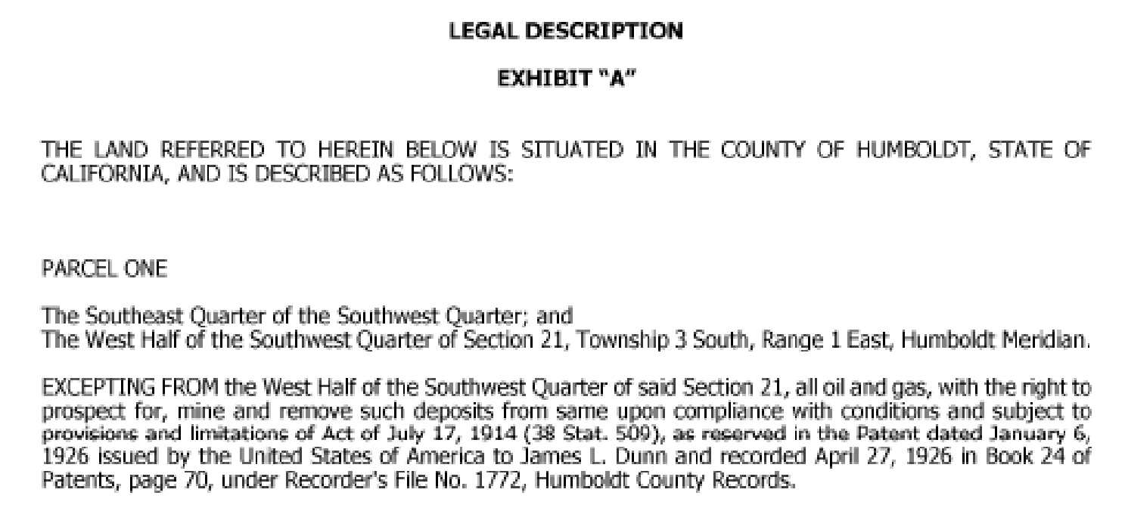

*An example of Schedule B exception noting prior mineral reservations that will not be insured:* 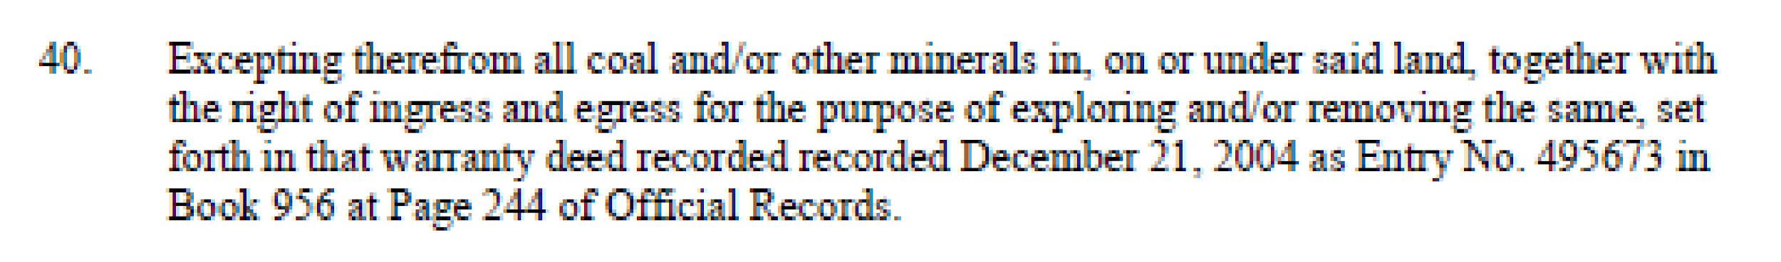

*Examples of Schedule B exceptions indicating the mineral estate is not insured and not disclosed in title commitment (will require a thorough title search to confirm mineral ownership):* 



**ENCUMBRANCES (Schedule B) – The Good, the Bad, and the Ugly**

* Review and read each item identified in Schedule B of the title report or commitment.
* Determine which are:
* acceptable and require no further action;
* acceptable but may require further investigation/action;
* unacceptable and what will need to be done to clear them from the title.
* Discuss any questionable encumbrances with the title officer, state/regional office, solicitor/OGC, or appropriate party to determine what actions may be necessary to get the encumbrances waived or removed.
* Document which encumbrances are administratively acceptable to the agency and which ones are to be remedied or removed. Any actions needing to be taken to clear an unacceptable encumbrance should be outlined in the preliminary title opinion request.
  + BLM documents this in an Administrative Determination, signed by the authorized officer, generally the Field Office Manager.
  + FS documents this in a Certificate of Use and Consent, signed by the Forest Supervisor.

**Generally Acceptable Encumbrances (the Good):**

1. Standard or regional exceptions (also referred to as “boiler plate” exceptions, also see attachment “Schedule B General Exceptions”) – included in all policies, may vary by State and County. These generally pertain to items that are undisclosed in the public records such as:

1. Taxes or assessments which are not shown; as existing liens by the records of any taxing authority that levies taxes or assessments on real property or by the public records.

2. Any facts, rights, interests or claims which are not shown by the public records but which could be ascertained by an inspection of said land or by making inquiry of persons in possession thereof.

3. Easements, claims or easement or encumbrances which are not shown by the public records.

4. Discrepancies, conflicts in boundary lines, shortage in area, encroachments or any other facts which a correct survey would disclose, and which are not shown by the public records.

5. Unpatented mining claims: reservations or exceptions in patents or in acts authorizing the issuance thereof: water rights, claims or title to water.

6. Any lien, or right to a lien, for services, labor or material theretofore or hereafter furnished, imposed by law and not shown by the public records.

7. Defects, liens, encumbrances, adverse claims or other matters, if any created, first appearing in the public records or attaching subsequent to the effective date hereof but prior to the date the proposed insured acquires of record for value the estate or interest or mortgage thereon covered by this commitment. *(This will be removed in the title policy. The title company should be instructed to notify you before a title policy is issued if any new items have developed. Any new items will need to be cleared by the Solicitor/OGC.)*

These are usually acceptable, provided you have confirmed through an on-site inspection and have documented that there is no evidence of unauthorized improvements, use, or boundary conflicts.

1. **Reservations in U.S. Patents** – usually pertains to mineral reservations, ditches and canals, easements, etc. These reserved interests will merge with title when the U.S. acquires the land.
2. **Utility or Road Easements or Rights-of-Way** - easements are usually acceptable provided they will not interfere with the intended use of the land. Review all easement documents to make sure there are no unacceptable terms or conditions that would conflict with the purpose of the acquisition.

* **Floating easements**: If the easement is a floating easement (location undefined), then the location should be identified on a map and referenced as an attachment to the title policy; the holder should record the map as an addendum to the previously recorded easement; or a new easement could be negotiated that will fix the location.
* **Appurtenant easements:** If the easement is appurtenant to the property being acquired, then it should be included in the description in Schedule A, rather than an encumbrance under Schedule B.

If a road use agreement exists, look for any clauses that may require the future expenditure of funds or other obligations for road maintenance or improvement. This would be unacceptable unless the road is a part of the agency’s transportation system or the agency has a specific need for use of the road and has funding available for continued maintenance costs.

Review all easements and R/Ws of record during site inspection to confirm they have been properly constructed and located.

* If they are not being utilized, the holder should be contacted and the easement should be released or terminated prior to acquisition.
* If the easement is not being maintained and operated properly, problems should be fixed or resolved prior to acquisition.
* If any unauthorized roads or utilities are discovered during site inspection, the seller should be responsible for addressing prior to acquisition.

1. **Water Rights (third party or reserved):** Assess the impact of third party or reserved water rights on the intended use and management of the land. These may be unacceptable if the land is being acquired for its riparian, fishery or wildlife habitat values.
2. **Land Conservation Contracts:** Contracts usually authorized under State law that dedicate the lands to a specified use (agriculture, open space, etc.) and allow for a reduced property tax rate. They generally dissolve upon conveyance of the property to the U.S., but not always. Check with the title officer, applicable County or State agency to confirm. Dissolution of the contract may require a payoff by the landowner. Such costs qualify for reimbursement under PL 91-646.
3. **Survey Discrepancies:** Reference to a specific recorded survey of record that affects the property. The survey is reviewed by a cadastral surveyor to determine if any conflict exists.
4. **Navigable Waters:** If any water bodies are located on the property, title companies will often include provisions for public trust easements and/or claims arising from the difference in the mean high water line and meander lines.
5. **Lack of Access:** This is a common exception unless a dedicated county or state road crosses through the parcel, or there is an appurtenant easement. Acceptable if the BLM or FS has adjoining property from which to access the parcel or some other form of easement authorization across private land to access the parcel.

**Conditionally Acceptable Encumbrances (require good documentation and possibly DOJ waiver – the Bad):**

1. **Mineral reservations and/or mineral leases:** Mineral reservations are only acceptable when the agency determines that possible future mineral development by a third party would not interfere with the intended use of the land. This could be based on a finding of low mineral occurrence or low development potential in a mineral report, or that mineral development activity would be compatible with intended use of the land. If lands are being acquired for resource protection, such as T&E habitat, third party minerals could be problematic.
2. **Conservation Easements, Recorded Agreements with Restrictive Provisions, or Deed Restrictions:** Any enforceable provisions that are not dissolved and limit use or transferability of the property are usually unacceptable unless the agency can demonstrate that the restrictions would be compatible with the approved land use plan and would not impose a burden on the agency. Any such restrictions must be approved by the Department of Justice, and must be considered in the valuation of the property.
3. **Right of Reverter/Defeasible Title:** A future right of the grantor to take possession of the property upon the occurrence of a specified event. Unacceptable except under rare circumstances which the Department of Justice must approve.

Lands may be acquired by gift when no permanent improvements are to be erected, provided the interest intended to be acquired is sufficient to permit the use of the land contemplated. If permanent improvements are ever to be erected on the land, the provision for defeasance must first be eliminated.

**Covenants, Conditions and Restrictions (CC&Rs):** Usually unacceptable because they restrict use of property and in some cases may assess fees. CC&Rs may be acceptable where the agency can demonstrate that the CC&Rs would not impede intended management.

An example would be lands in a subdivision where there are specific requirements for the construction of improvements, provided the agency has no intention of building improvements. If there are any provisions for assessments for maintenance of common areas or other purposes, this will require a release, as the U.S. would not be exempt from such fees.

**Unacceptable Encumbrances (must be eliminated or cured – the Ugly):**

Unacceptable encumbrances include any that will:

* Obligate future expenditure of funds (Anti-Deficiency Act).
* Require preferential treatment for a future relationship with the acquiring agency
* Interfere with agency’s intended management of the land
* Limit or preclude future sale or transfer of the property (restraint on alienation)
* Preclude clear title from passing

1. **Taxes:**

* Delinquent taxes must be paid.
* Current taxes which are due and payable must be paid for fee acquisitions, but may be waived for an easement acquisition if the purchase price of the easement is insufficient to cover the current taxes.
* Current taxes which are a lien but not yet due and payable, must be satisfied by one of the following:
  + - prorate and have seller pay at closing if tax cycle allows
    - withhold a sufficient amount from the purchase price to be paid at closing or when due ( if taxes cannot be prorated, withhold 120 percent of the preceding year’s taxes)
    - secure a check from the seller and pay when due
    - have the seller and title company enter into a tax agreement for payment when due

Easement Exception: current taxes may be waived by the Solicitor/OGC if the purchase price of the easement is 50 percent or less of the appraised value of the contiguous land of the grantor.

* Special tax assessments/tax deferral: A penalty or additional tax that may be imposed by local government when land becomes disqualified for special assessment for farmland, open space, etc. These will need to be paid by seller or waived in writing by the County. If paid by seller, may be reimbursable under PL 91-646.

For special service districts, confirm with the title company and/or county that the U.S. is exempt from any assessments.

1. **Mortgage Liens and Deeds of Trust** - these must be removed for fee acquisitions. Discuss with the title officer, grantor, and lien holder to determine what will be needed to clear, usually a reconveyance of a deed of trust or release of mortgage. A partial release may be used if other property owned by the seller is also being used as collateral.

For easements, these can be cleared through a subordination agreement, agreement and understanding regarding easement, or partial release of mortgage or deed of trust. If the mortgage is not more than 50% of the appraised value and the value of the easement is not more than 10% of the value of the entire contiguous property, the encumbrance can be waived.

Do not assume liens and deeds of trust can be easily removed from the title – discuss with the title company, grantor, and lien holder.

1. **Mechanic’s Lien** – a lien placed on property for the purpose of securing payment for the construction or repair of improvements affixed to the property. These liens must be cleared either through payment by grantor and release of the lien by affidavit, or through a subordination agreement for easement acquisitions. Site inspection is necessary to make sure no unrecorded liens exist.
2. **Judgments** – a judgment filed against a debtor that can become a lien on property owned by the debtor within the county where the judgment was entered. This can be cleared through payment by seller, a subordination agreement, or partial release. If the purchase price exceeds the judgment amount, payment from the sale proceeds can be arranged for through escrow.
3. **Contract of Sale** – contract between seller and buyer, providing for payment in installments. Seller holds fee title until full payment has been made; buyer has equitable title. Both buyer and seller must execute deed.
4. **Liens against crops** - A claim filed by the provider of seed or a farm laborer on the crops of the producer. Claims are filed with the Secretary of State, and must be removed for fee acquisitions. Can be subordinated for easement acquisitions and waived if the lien affects fixtures located away from the easement.
5. **Lessees or any other persons, other than the record owner, occupying or using all of any part of the property:** If compatible, get the use authorized or secure an attornment agreement from lessee. May require relocation under PL 91-646. If not compatible, obtain a disclaimer or QCD. For easements, have them subordinate their rights, execute a disclaimer, QCD, or consent to easement.
6. **Decedent’s Estate** – If title is held as a joint tenancy or in a trust, the land passes to survivor or trust beneficiary and no probate is necessary. If probate is necessary, discuss with the title company and the attorney for the estate. If the estate is unprobated and the title company cannot clear, two affidavits of heirship can be completed. For probated or unprobated estates, obtain official certification of payment of State and Federal estate or inheritance taxes. If not assessed, proof on non-assessment or exemption must be provided.
7. **Dower, curtesy, spousal, or community property rights** – Marital status of grantor should be shown in deed and the spouse should join in the conveyance or execute a release of interest. Although not required in all states, it is good practice to have the marital status of the grantor declared in the deed and to have the spouse join in the conveyance.
8. **Co-tenants’ interest** – join the interest holder(s) in the conveyance or have them execute a release of their interest.
9. **Court actions –** any pending court actions such as foreclosure proceedings, tax sales, divorce proceedings, probate of an estate, bankruptcy, etc. must be resolved before an acquisition can be completed.