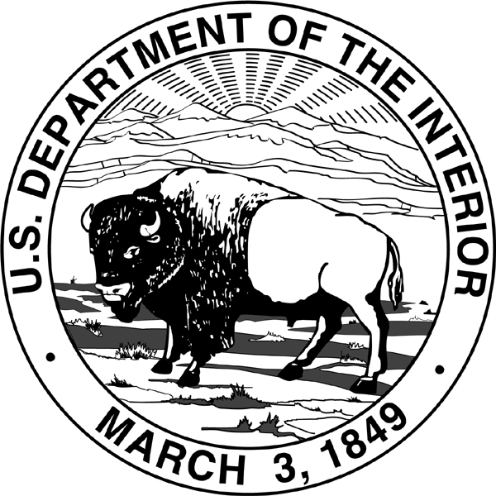
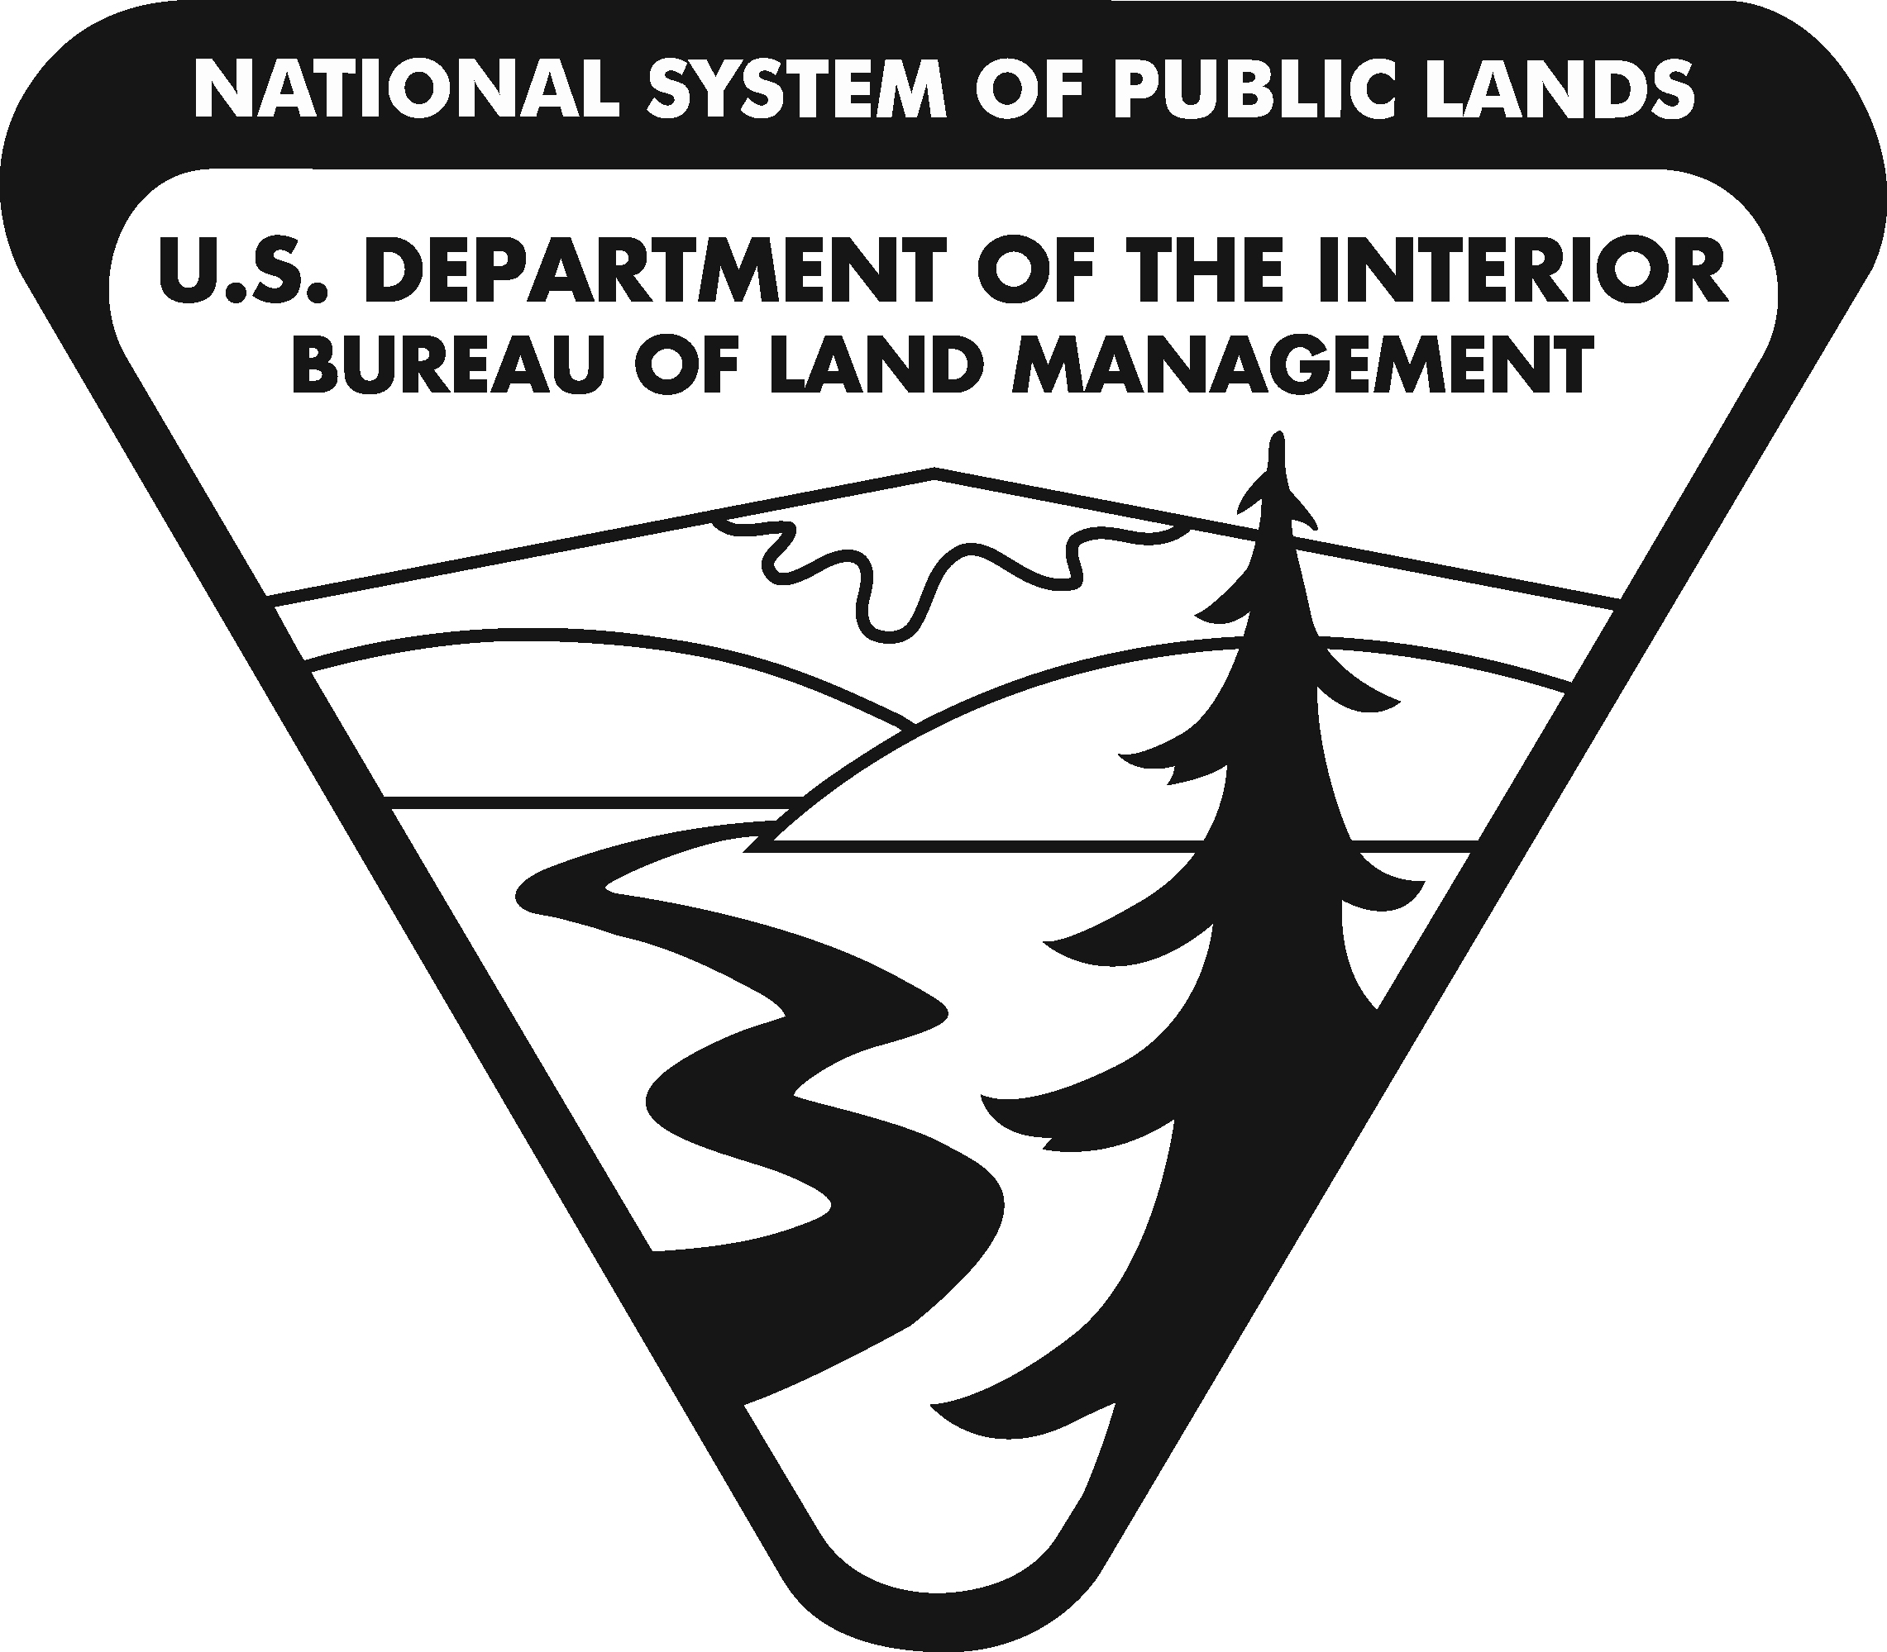
United States Department of the Interior
BUREAU OF LAND MANAGEMENT
Washington, DC 20240
http://www.blm.gov

In Reply Refer To:
2310 (930)
CACA-054196

Memorandum

To: Rhea S. Suh
Assistant Secretary – Policy, Management and Budget

Through: Tommy P. Beaudreau
Acting Assistant Secretary – Land and Minerals Management

From: Jamie Connell
Acting Deputy Director for Operations, Bureau of Land Management

Subject: Petition/Application for Proposed Withdrawal, Trinity Wild and Scenic River, California

We request your approval to file a petition/application to withdraw approximately 3,123 acres of public lands from location and entry under the United States mining laws, but not from leasing under the mineral or geothermal leasing laws, on behalf of the Bureau of Land Management. The proposed withdrawal would protect the cultural, recreational, and biological resources within the recreational segment of the Trinity Wild and Scenic River.

Your approval would temporarily segregate the lands for up to 2 years while various studies and analyses are prepared to support a final decision on the withdrawal application. Attached is the information required for submission of a petition/application. We recommend your approval.

Approved:

Rhea S. Suh Date
Assistant Secretary – Policy, Management and Budget

Attachment

cc: AS-LM(2):MIB, Rm. 6633
AS-PMB:MIB, Rm. 6110
LLM:350:MS 4th Floor MS:350 cf: 350 rf; 350 hold
LLM:OR936:MLBarnes:6/05/2013:503-808-6155:CA-54196 Sec Memo.doc

